

Indicator



**Index**

|  |  |  |
| --- | --- | --- |
| **S.No.** | **Indicator Name** | **Page No.** |
| 1 | Accumulation/Distribution | 3 |
| 2 | Advance/Decline | 4 |
| 3 | Arnaud Legoux Moving Average | 5 |
| 4 | Aroon | 7 |
| 5 | Average Directional Index | 8 |
| 6 | Average True Range | 10 |
| 7 | Awesome Oscillator | 11 |
| 8 | Balance Of Power | 13 |
| 9 | Bollinger Bands % B | 14 |
| 10 | Bollinger Bands Width | 16 |
| 11 | Chaikin Money Flow | 17 |
| 12 | Chaikin Oscillator | 18 |
| 13 | Chande Kroll Stop | 19 |
| 14 | Chande Momentum Oscillator | 20 |
| 15 | Choppiness Index | 22 |
| 16 | Commodity Channel Index | 23 |
| 17 | Coppock Curve | 24 |
| 18 | Correlation Coefficient | 25 |
| 19 | Directional movement index | 27 |
| 20 | Donchian Channels | 28 |
| 21 | Double Exponential Moving Average (DEMA) | 29 |
| 22 | Ease of Movement | 31 |
| 23 | The Elder Force Index (EFI) | 32 |
| 24 | Envelope | 33 |
| 25 | Fisher Transform | 35 |
| 26 | Historical Volatility | 37 |
| 27 | HULL MOVING AVERAGE (HMA) | 38 |
| 28 | Ichimoku Cloud | 39 |
| 29 | Keltner Channel | 43 |
| 30 | Klinger Oscillator | 45 |
| 31 | Know Sure Thing (KST) | 47 |
| 32 | Least Squares Moving Average | 49 |
| 33 | Linear Regression Curve | 51 |
| 34 | MA Cross | 53 |
| 35 | Moving Average Convergence Divergence (MACD) | 56 |
| 36 | Mass Index | 58 |
| 37 | McGinley Dynamic | 60 |
| 38 | Momentum | 61 |
| 39 | Money Flow | 63 |
| 40 | Moving Average (MA) | 67 |
| 41 | Exponential Moving Average | 70 |
| 42 | Weighted moving average | 72 |
| 43 | Net Volume | 74 |
| 44 | On Balance Volume | 75 |
| 45 | Parabolic SAR | 77 |
| 46 | Price Oscillator | 78 |
| 47 | Price Volume Trend Indicator | 79 |
| 48 | relative strength index | 81 |
| 49 | Relative Vigor Index | 82 |
| 50 | Relative Volatility Index | 84 |
| 51 | SMI Ergodic Indicator Oscillator | 86 |
| 52 | Smoothed Moving Average | 87 |
| 53 | Stochastic | 88 |
| 54 | Stochastic RSI | 89 |
| 55 | TRIX | 93 |
| 56 | Triple EMA | 97 |
| 57 | True Strength Indicator | 99 |
| 58 | Ultimate Oscillator | 103 |
| 59 | VWMA | 105 |
| 60 | Volume | 107 |
| 61 | Volume Oscillator | 108 |
| 62 | Vortex Indicator | 110 |
| 63 | Williams %R | 111 |
| 64 | Williams Alligator | 112 |
| 65 | Williams Fractal | 114 |
| 66 | Zig Zag | 118 |

**Technical Indicator: Accumulation/Distribution**

**What does it measure:** Accumulation/distribution is a cumulative indicator that uses volume and price to assess whether a stock is being accumulated or distributed.

**General info:**

Accumulation/distribution is a cumulative indicator that uses volume and price to assess whether a stock is being accumulated or distributed. The accumulation/distribution measure seeks to identify divergences between the stock price and volume flow. This provides insight into how strong a trend is. If the price is rising but the indicator is falling this indicates that buying or accumulation volume may not be enough to support the price rise and a price decline could be forthcoming.

**Parameters:**

No

**How to trade this signal:**

* The accumulation/distribution line gauges supply and demand by looking at where the price closed within the period's range, and then multiplying that by volume.
* The A/D indicator is cumulative, meaning one period's value is added or subtracted from the last.
* A rising A/D line helps confirm a rising price trend.
* A falling A/D line helps confirm a price downtrend.
* If the price is rising but A/D is falling, it signals underlying weakness and a potential decline in price.
* If the price of an asset is falling but A/D is rising, it signals underlying strength and the price may start to rise.

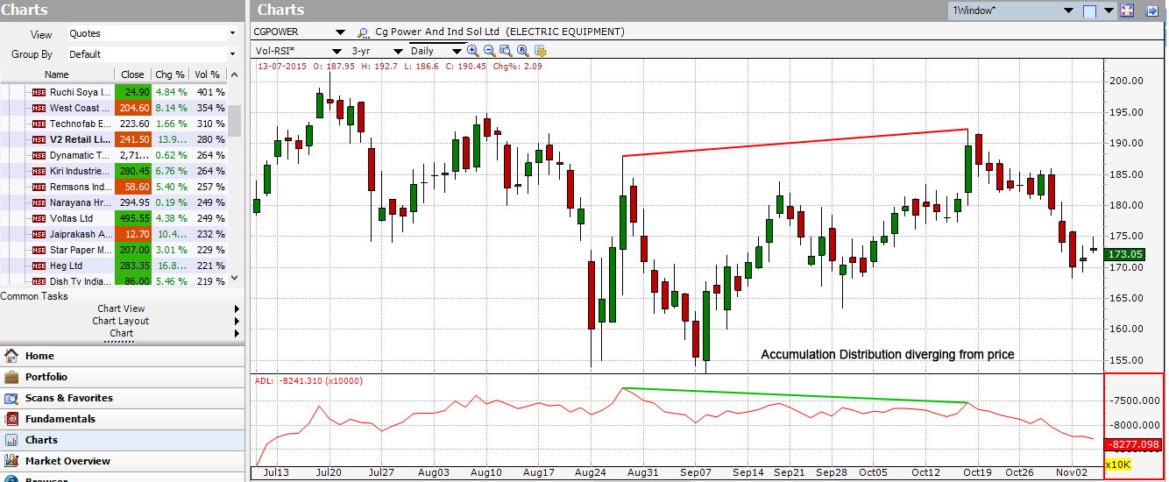

**Technical indicator: Advance/Decline**

**What does it measure:** The advance/decline (A/D) is a technical indicator that compares the number of stocks that closed higher against the number of stocks that closed lower than their previous day's closing prices.

**General information:**

The advance/decline (A/D) is a technical indicator that plots the difference between the number of advancing and declining stocks on a daily basis. The indicator is cumulative, with a positive number being added to the prior number, or if the number is negative it is subtracted from the prior number.

The A/D Bar is used to show market sentiment, as it tells traders whether there are more stocks rising or falling. It is used to confirm price trends in major indexes, and can also warn of reversals when divergence occurs.

**Parameters:**

Length

**How to trade this signal:**

* The advance/decline line (A/D) is a breadth indicator used to show how many stocks are
* participating in a stock market rally or decline.
* When major indexes are rallying, a rising A/D line confirms the uptrend showing strong participation.
* If major indexes are rallying and the A/D line is falling, it shows that fewer stocks are participating in the rally which means the index could be nearing the end of its rally.
* When major indexes are declining, a falling advance/decline line confirms the downtrend.
* If major indexes are declining and the A/D line is rising, fewer stocks are declining over time, which means the index may be near the end of its decline.

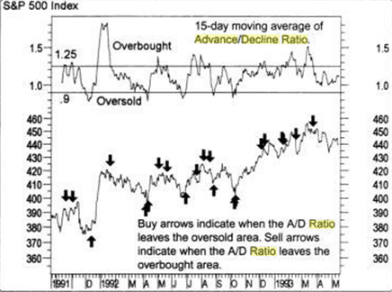

**Technical indicator: Arnaud Legoux Moving Average**

**What does it measure:** Arnaud Legoux Moving Average (ALMA) removes small price fluctuations and enhances the trend by applying a moving average twice, once from left to right, and once from right to left. At the end of this process the phase shift (price lag) commonly associated with moving averages is significantly reduced. Zero-phase digital filtering reduces noise in the signal. Conventional filtering reduces noise in the signal, but adds a delay.

**General information:**

What’s the point of any moving average? To smooth out the trend line and give the trader the general idea of the trend direction and strength. But why would anyone want just another moving average, don’t we already have plenty of them? Both yes and no. There are in fact numerous MA types, each of them calculated and applied slightly differently. ALMA was designed in order to address two issues, often spotted in different MA types: **smoothness and responsiveness**. When using, say, a simple moving average, you may notice that the smoother it is, the longer it takes to provide a signal. It may even be that when the signal is delivered, the move you’ve been waiting for is already over. On the other hand, a shorter-term MA, while being more responsive, can appear choppy. Therefore, when using a traditional moving average, you must choose between responsiveness and smoothness. Arnaud Legoux moving average was created with the purpose of solving this exact problem.

**Parameters:**

**Window size:** The Window Size is nothing but the look back period and this forms the basis of your ALMA settings. You can use the ALMA window size to any value that you like, although it is best to stick with the well followed parameters such as 200, 100, 50, 20, 30 and so on based on the time frame of your choosing.

**Offset**: The offset value is used to tweak the ALMA to be more inclined towards responsiveness or smoothness. The offset can be set in decimals between 0 and 1. A setting of 0.99 makes the ALMA extremely responsive, while a value of 0.01 makes it very smooth.

**Sigma:** The sigma setting is a parameter used for the filter. A setting of 6 makes the filter rather large while a smaller sigma setting makes it more focused. According to Mr. Legoux, a sigma value of 6 is said to offer good performance.

**How to trade this signal:**

1. The AD line is used as a confirming indication to validate the strength of the trend and also to ascertain the possibility of a reversal or a trend correction
2. The AD line can be used to confirm market tops based on increasing or decreasing market participation. When stocks posts a high but the AD line is not confirming this high (market participation), it signals that the highs in the security are coming off from just a few market participation and therefore increases the likelihood of a correction from the top
3. Technical traders will find that the AD line can be used as an indicator to confirm support or resistance levels.

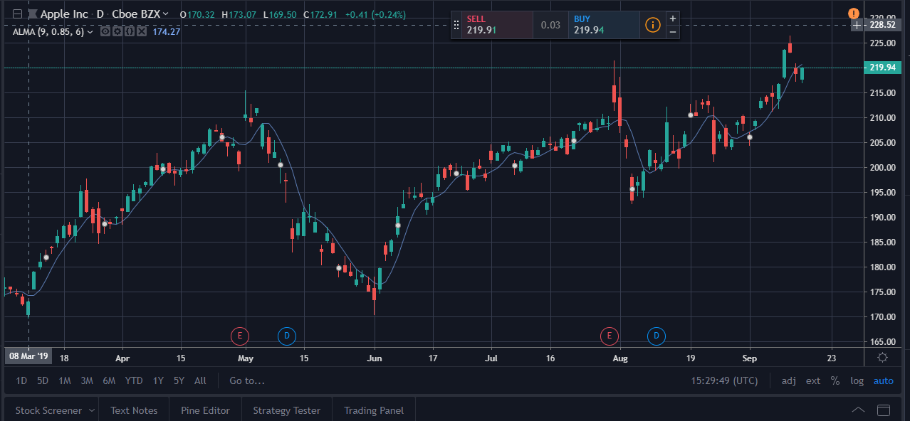

**Technical indicator: Aroon**

**What does it measure:** Aroon Oscillator is a trend-following indicator

**General information:**

Aroon is an indicator system that determines whether a stock is trending or not and how strong the trend is. Indicators are designed to reveal the beginning of a new trend. The Aroon indicators measure the number of periods since price recorded an x-day high or low.

**Parameters:**

Aroon Length (Standard 14)

**How to trade this signal:**

* The Arron indicator is composed of two lines. An up line which measures the number of periods since a High, and a down line which measures the number of periods since a Low.
* The indicator is typically applied to 25 periods of data, so the indicator is showing how many periods it has been since a 25-period high or low.
* When the Aroon Up is above the Aroon Down, it indicates bullish price behavior.
* When the Aroon Down is above the Aroon Up, it signals bearish price behavior.
* Crossovers of the two lines can signal trend changes. For example, when Aroon Up crosses above Aroon Down it may mean a new uptrend is starting.
* The indicator moves between zero and 100. A reading above 50 means that a high/low (whichever line is above 50) was seen within the last 12 periods.
* A reading below 50 means that the high/low was seen within the 13 periods.

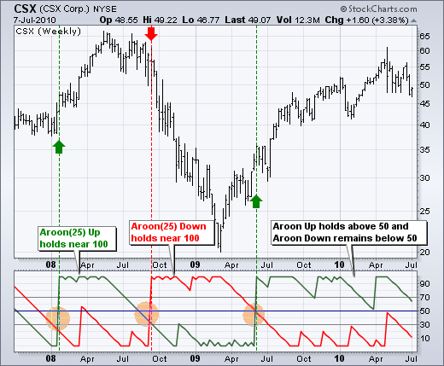

**Technical indicator: Average Directional Index**

**What does it measure:** The average directional index (ADX) is a technical analysis indicator used by some traders to determine the strength of a trend.

**General information:**

The average directional index (ADX) is a technical analysis indicator used by some traders to determine the strength of a trend. The trend can be either up or down, and this is shown by two accompanying indicators, the Negative Directional Indicator (-DI) and the Positive Directional Indicator (+DI). Therefore, ADX commonly includes three separate lines. These are used to help assess whether a trade should be taken long or short, or if a trade should be taken at all.

**Parameters:**

1. ADX Smoothing (Standard 14)
2. DI Length (Standard 14)

**How to trade this signal:**

1. Combine with other value indicator and trade crossovers
2. User can set a threshold let’s say ADX at 25

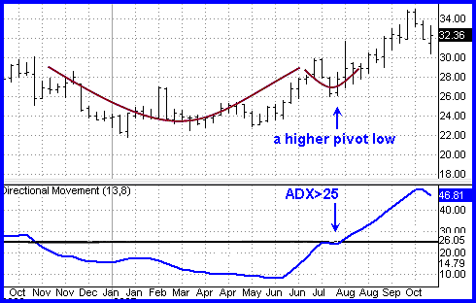

1. In trending conditions, entries are made on pullbacks and taken in the direction of the trend.
2. In range conditions, trend-trading strategies are not appropriate. However, trades can be made on reversals at support (long) and resistance (short).

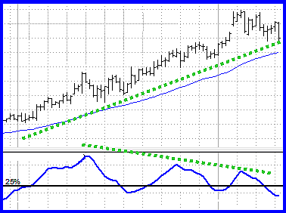

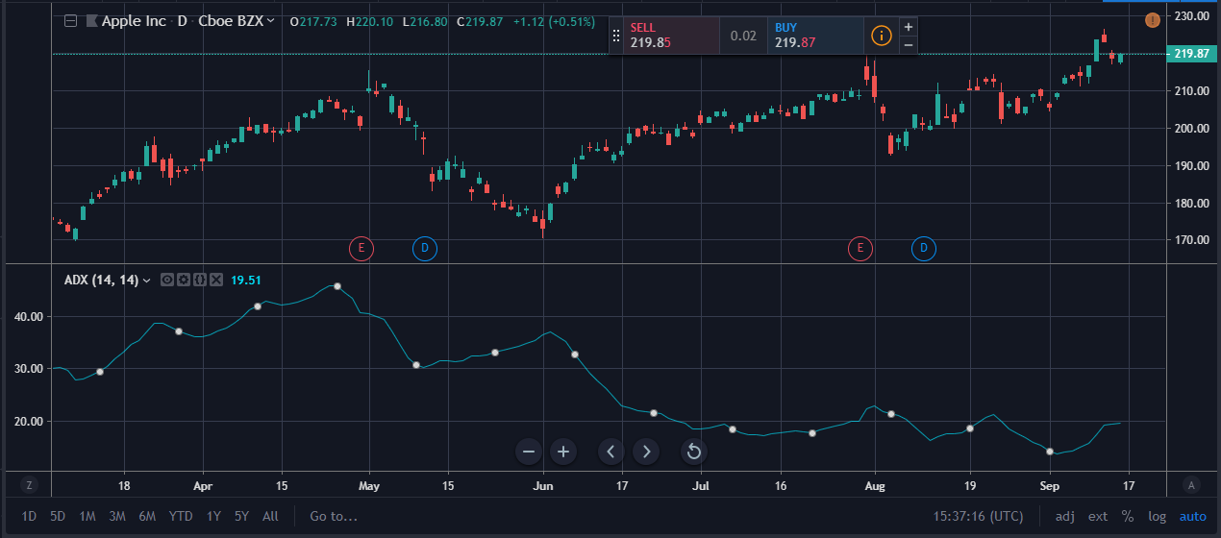

**Technical indicator: Average True Range**

**What does it measure:** ATR measures market volatility by decomposing the entire range of an asset price for that period.

**General information:**

The average true range (ATR) is a technical analysis indicator that measures market volatility by decomposing the entire range of an asset price for that period. Specifically, ATR is a measure of volatility introduced by market technician J. Welles Wilder Jr. in his book, "New Concepts in Technical Trading Systems."

The true range indicator is taken as the greatest of the following: current high less the current low; the absolute value of the current high less the previous close; and the absolute value of the current low less the previous close. The average true range is then a moving average, generally using 14 days, of the true ranges.

**Parameters:**

* Length
* Smoothing

**How to trade this signal:**

Traders can use shorter periods than 14 days to generate more trading signals, while longer periods have a higher probability to generate less trading signals. For example, assume a short-term trader only wishes to analyze the volatility of a stock over a period of five trading days. Therefore, the trader could calculate the five-day ATR. Assuming the historical price data is arranged in reverse chronological order, the trader finds the maximum of the absolute value of the current high minus the current low, absolute value of the current high minus the previous close and the absolute value of the current low minus the previous close. These calculations of the true range are done for the five most recent trading days and are then averaged to calculate the first value of the five-day ATR.

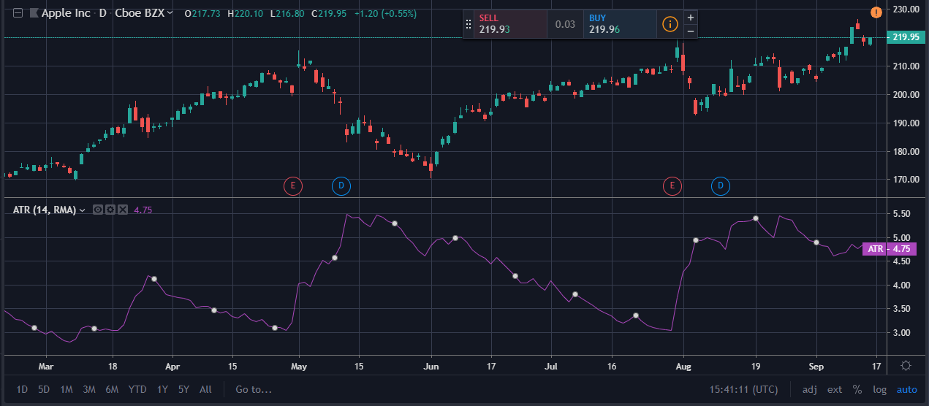

**Technical indicator: Awesome Oscillator**

**What does it measure:** The Awesome Oscillator (AO) is an indicator used to measure market momentum.

**General information:**

The Awesome Oscillator (AO) is an indicator used to measure market momentum. AO calculates the difference between a 34 Period and 5 Period Simple Moving Average. The Simple Moving Averages that are used are not calculated using closing price but rather each bar's midpoints. AO is generally used to affirm trends or to anticipate possible reversals.

**Parameters:**

No

**How to trade this signal:**

**Zero Line Crossover**

This is the most basic and straightforward signal a trader can get when using the Awesome Oscillator. When the AO crosses above the zero line, short-term momentum is rising faster than long-term momentum. In this case, a zero line crossover can be treated as a buying opportunity. When the AO crosses below the zero line, short-term momentum is falling faster than long-term momentum. This pattern is considered by some traders as a selling opportunity.

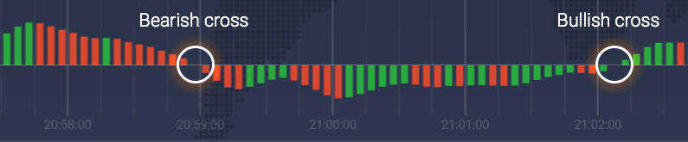

**Twin Peaks**

Two consecutive peaks can be used as a trading signal, as well. Twin Peaks take on the role of the bullish trend messengers when 1) both peaks are below the zero line, 2) the second peak is higher than the first one and is followed by the green bar, 3) the trough between the peaks stays below the zero line.

Twin Peaks become a signal of an upcoming bearish trend when 1) both of them are above the zero line, 2) the second peak is lower than the first one and is followed by the red bar, 3) the trough, in turn, remains above the zero line.

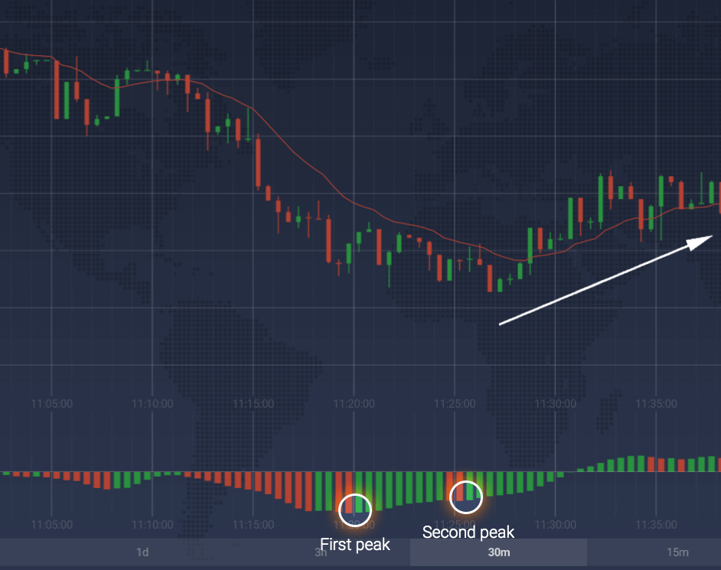

## **Saucer**

Saucer is another signal that can be used for early trend forecasting. It follows the changes in three consecutive bars. When the Awesome oscillator is above zero and two consecutive red bars are followed by a green one, the saucer is considered to be bullish.

**Technical indicator: Balance Of Power**

**What does it measure:** The Balance of Power indicator measures the market strength of buyers against sellers by assessing the ability of each side to drive prices to an extreme level.

**General information:**

Don Worden created the balance of power (BOP) indicator in the 1950’s to understand market activity between buyers and sellers.

**Parameters:**

No

**How to trade this signal:**

As you probably already know, oversold and overbought levels are used to determine those moments that can boast higher probability of a trend reversal. Indeed, no asset can grow forever. What has grown has to go back down, so is the law of the market. By identifying overbought/oversold positions you will identify periods when the trend reversal is more likely, thus getting an upper hand in trading.

However, it is worth remembering that the information provided by this indicator is not enough to use on its own. Buying and selling pressure, though helpful, is not directly connected to trend. Buyers can have an upper hand (according to BOP) and the asset will still lose in price. The opposite can also be true: sellers can have an upper hand (according to BOP), and the asset will still appreciate. Use this indicator carefully and combine it with other technical analysis tools: oscillators, trend-following and momentum indicators.

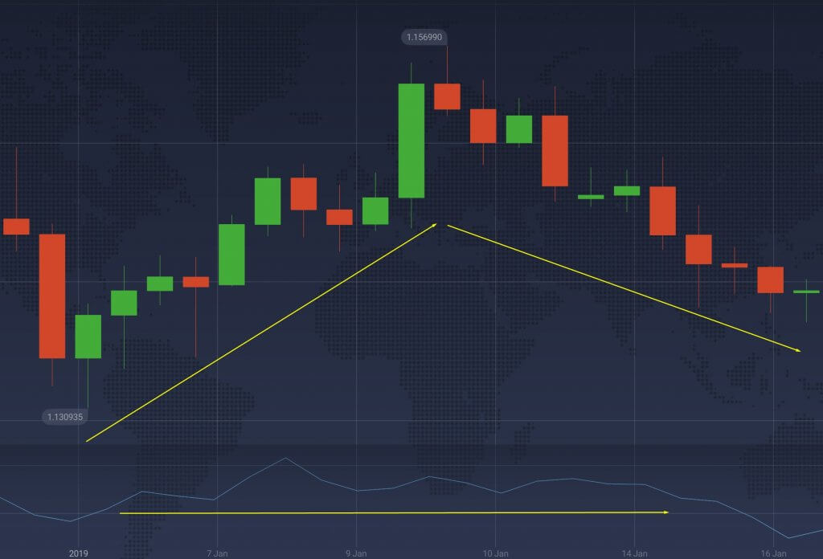

**Technical indicator: Bollinger Bands % B**

**What does it measure:** Bollinger Bands are a volatility indicator which creates a band of three lines which are plotted in relation to a security's price.

**General information:**

Bollinger Bands %B or Percent Bandwidth (%B) is an indicator derived from the standard Bollinger Bands (BB) indicator. Bollinger Bands are a volatility indicator which creates a band of three lines which are plotted in relation to a security's price. The Middle Line is typically a 20 Day Simple Moving Average. The Upper and Lower Bands are typically 2 standard deviations above and below the SMA (Middle Line). What the %B indicator does is quantify or display where price is in relation to the bands. %B can be useful in identifying trends and trading signals.

**Parameters:**

1. Length
2. Source
3. StdDev

**How to trade this signal:**

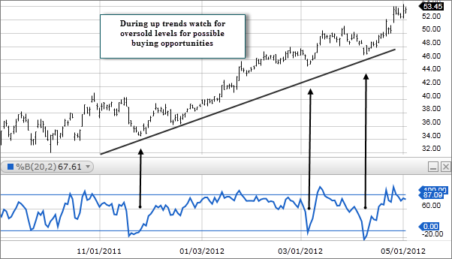

* If the closing price is equal to the upper Bollinger Band Opens in a new window value, Percent B would be 100 (percent).
* If the closing price is above the upper Bollinger Band, Percent B would be greater than 100.
* If the closing price is equal to the moving average, Percent B is 50 percent.
* If the closing price is equal to the lower Bollinger Band, Percent B would be zero.
* If the closing price is below the lower band, Percent B would be negative.
* During up trends watch for %B to reach oversold levels for possible buying opportunities.
* During down trends watch for %B to reach overbought levels for possible short sale opportunities.

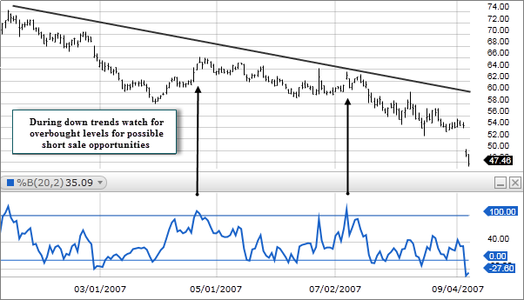

**Technical indicator: Bollinger Bands Width**

**What does it measure:**Bollinger Bands are a volatility indicator which creates a band of three lines which are plotted in relation to a security's price.

**General information:**

Bollinger Bands Width (BBW) is a technical analysis indicator derived from the standard Bollinger Bands indicator. Bollinger Bands are a volatility indicator which creates a band of three lines which are plotted in relation to a security's price. The Middle Line is typically a 20 Day Simple Moving Average. The Upper and Lower Bands are typically 2 standard deviations above and below the SMA (Middle Line). Bollinger Bands Width serve to quantitatively measure the width between the Upper and Lower Bands. BBW can be used to identify trading signals in some instances.

**Parameters:**

1. Length
2. Source
3. StdDev

**How to trade this signal:**

* During a period of rising price volatility, the distance between the two bands will widen and Bollinger Band Width will increase. Conversely, during a period of low market volatility, the distance between the two bands will contract and Bollinger Band Width will decrease. There is a tendency for bands to alternate between expansion and contraction.
* When the bands are relatively far apart, that is often a sign that the current trend may be ending. When the distance between the two bands is relatively narrow that is often a sign that a market or security may be about to initiate a pronounced move in either direction.

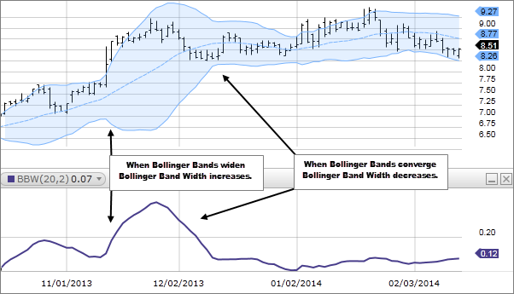

**Technical indicator: Chaikin Money Flow**

**What does it measure:** Chaikin Money Flow (CMF) is a technical analysis indicator used to measure Money Flow Volume over a set period of time.

**General information:**

Chaikin Money Flow (CMF) is a technical analysis indicator used to measure Money Flow Volume over a set period of time. Money Flow Volume (a concept also created by Marc Chaikin) is a metric used to measure the buying and selling pressure of a security for single period. CMF then sums Money Flow Volume over a user defined look-back period. Any look-back period can be used however the most popular settings would be 20 or 21 days. Chaikin Money Flow's Value fluctuates between 1 and -1. CMF can be used as a way to further quantify changes in buying and selling pressure and can help to anticipate future changes and therefore trading opportunities.

**Parameters:**

Length

**How to trade this signal:**

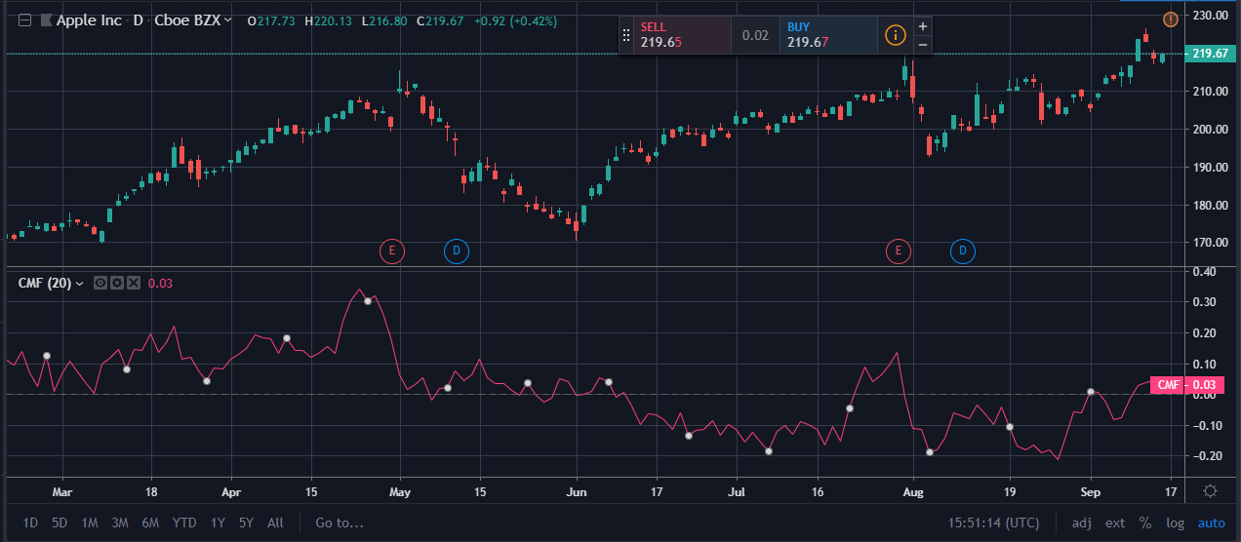

he Chaikin Money Flow should ideally be used in conjunction with a price chart and, if one so chooses, other indicators. It is predominantly used to confirm trending or breakout price behavior rather than elicit trade signals on its own.

The period of the CMF should be customized to each individual trader’s preferences. The 21-period default is more oriented toward shorter-term traders. This setting is most useful for those looking to capture shorter-term trends relative to the charting timeframe.

A 63-, 126-, or 252-day period would be more applicable for those looking at intermediate- and longer-term trends. However, the longer the time period, the longer it will take for new price trends to emerge because so much previous data is taken into account. Changes in the CMF are just as likely to be from old data dropping out from new data coming in.

For short-term traders, applying a 24-period CMF on a 5-minute chart would provide two hours of trend/momentum data.

**Technical indicator: Chaikin Oscillator**

**What does it measure:** The Chaikin Oscillator takes Accumulation/Distribution (ADL) and applies two Exponential Moving Averages of varying length to the line.

**General information:**

The Chaikin oscillator is named for its creator Marc Chaikin. The oscillator measures the accumulation-distribution line of moving average convergence-divergence (MACD). To calculate the Chaikin oscillator, subtract a 10-day exponential moving average (EMA) of the accumulation-distribution line from a 3-day EMA of the accumulation-distribution line. This measures momentum predicted by oscillations around the accumulation-distribution line.

**Parameters:**

1. Fast Length (3)
2. Slow Length (10)

**How to trade this signal:**

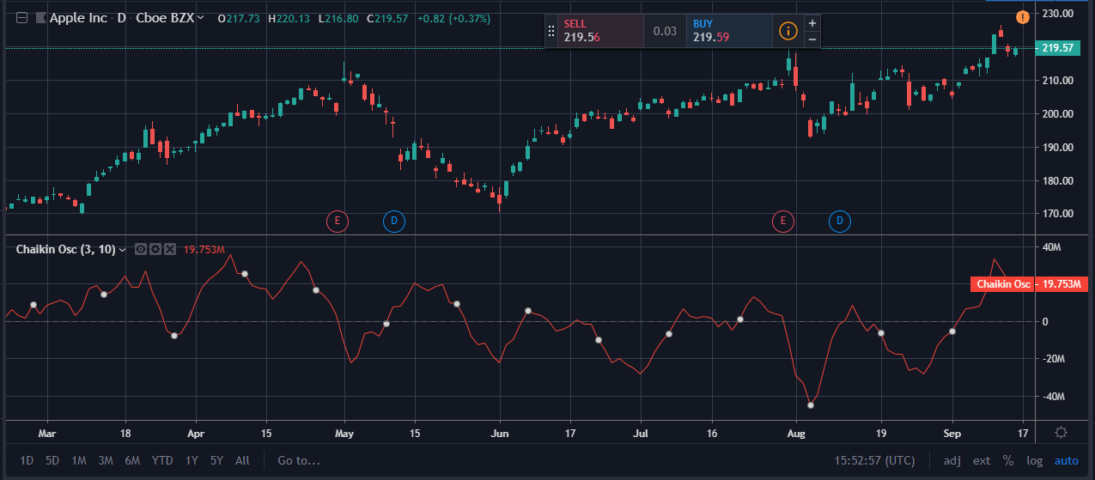

* The Chaikin Indicator applies MACD to the accumulation-distribution line rather than closing price.
* A cross above the accumulation-distribution line indicates that market players are accumulating shares, securities or contracts, which is typically bullish.

**Technical indicator: Chande Kroll Stop**

**What does it measure:** This is a trend-following indicator that identifies the stop loss for a long or short position by using a variation on directional movement.

**General information:**

This is a trend-following indicator that identifies the stop loss for a long or short position by using a variation on directional movement. It is calculated on the average true range of an instrument’s volatility. The stops are placed under (and on) the high (low) of the last “n” bars. The difference is proportional to the average True Range on “N” bars.

**Parameters:**

1. P (10)
2. X (1)
3. Q (9)

**How to trade this signal:**

You can use the Chande Kroll to trade in a number of ways:

* Sell when the price crosses below both lines.
* Buy when the price crosses above both lines.
* Trade when the two lines cross each other.

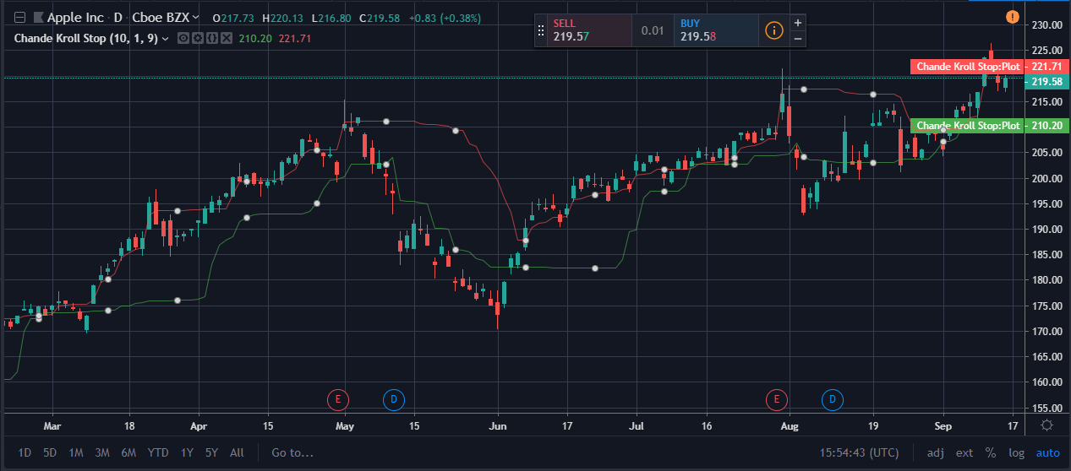

**Technical indicator: Chande Momentum Oscillator**

**What does it measure:** The oscillator ranges between limits of -100 and +100 and has a base value of 0.

**General information:**

The Chande Momentum Oscillator (CMO) was developed by Tushar Chande and gauges price momentum just like the Relative Strength Index (RSI). The oscillator ranges between limits of -100 and +100 and has a base value of 0. As a rule of thumb, overbought is usually set at 50 and oversold at -50. Crosses of the centerline be bullish signals (when the oscillator becomes positive) or bearish signals (when the oscillator becomes negative). The indicator is often used in combination with other signals.

**Parameters:**

1. Length
2. Price

**How to trade this signal:**

* CMO indicates overbought conditions when it reaches the 50 level and oversold conditions when it reaches −50. You can also look for signals based on the CMO crossing above and below a signal line composed of a 9-period moving average of the 20 period CMO.
* CMO measures the trend strength. The higher the absolute value of the CMO, the stronger the trend. Lower absolute values of the CMO indicate sideways trading ranges.

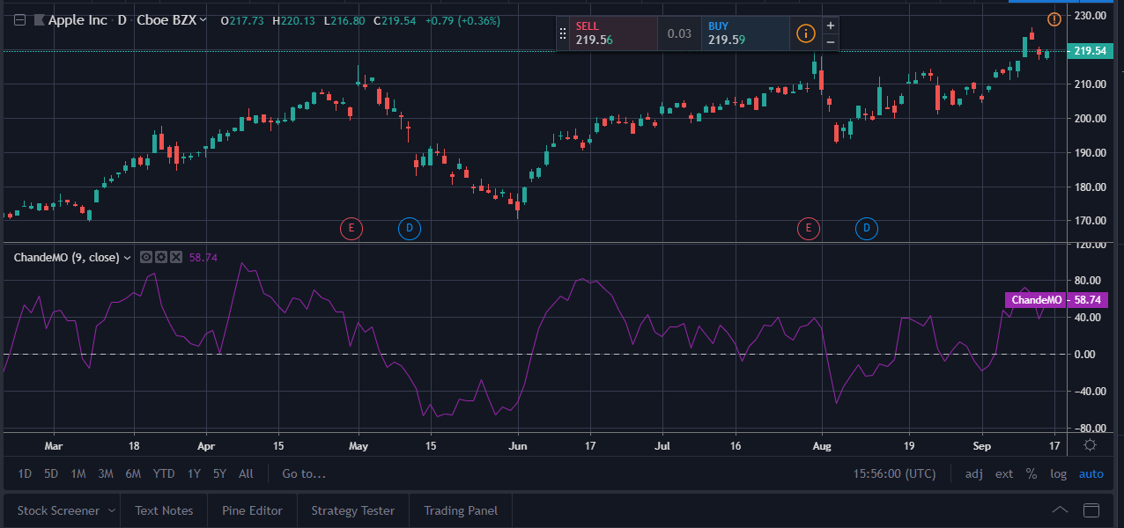

* CMO often forms chart patterns which may not show on the underlying price chart, such as double tops and bottoms and trend lines. Also look for support or resistance on the CMO.
* If underlying prices make a new high or low that is not confirmed by the CMO, the divergence can signal a price reversal.

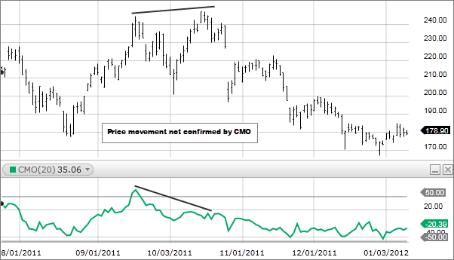

**Technical indicator: Choppiness Index**

**What does it measure:** The Choppiness Index (CHOP) is an indicator designed to determine if the market is choppy (trading sideways) or not choppy (trading within a trend in either direction).

**General information:**

The **Choppiness Index** is a volatility indicator developed by Australian commodity trader Bill Dreiss to indicate whether a market is trending or ranging. Values range between 0 and 100, with low values indicating a strong trend and high values signaling consolidation.

**Parameters:**

1. Length
2. Offset

**How to trade this signal:**

1. The value above 61.8 (higher threshold) indicates consolidation.
2. The value below 38.2 (lower threshold) signal a trend.

* Though Choppiness index measures the status of the current trend, but it often lags the actual trend.
* As long as Choppiness index stays above mid 50 line, the trend continues to be choppy.
* On the other hand, if it stays below the midline, it remains trending.

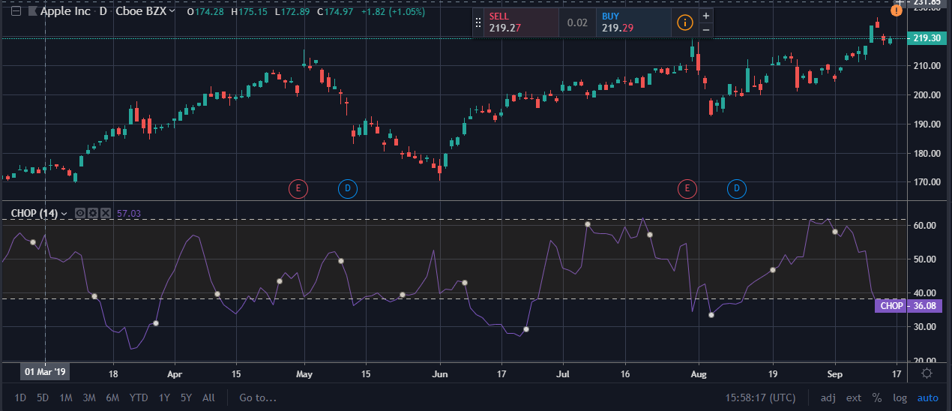

**Technical indicator: Commodity Channel Index**

**What does it measure:** The Commodity Channel Index​ (CCI) is a momentum-based oscillator used to help determine when an investment vehicle is reaching a condition of being overbought or oversold.

**General information:**

Developed by Donald Lambert, the Commodity Channel Index​ (CCI) is a momentum-based oscillator used to help determine when an investment vehicle is reaching a condition of being overbought or oversold. It is also used to assess price trend direction and strength. This information allows traders to determine if they want to enter or exit a trade, refrain from taking a trade, or add to an existing position. In this way, the indicator can be used to provide trade signals when it acts in a certain way.

**Parameters:**

1. Length
2. Source

**How to trade this signal:**

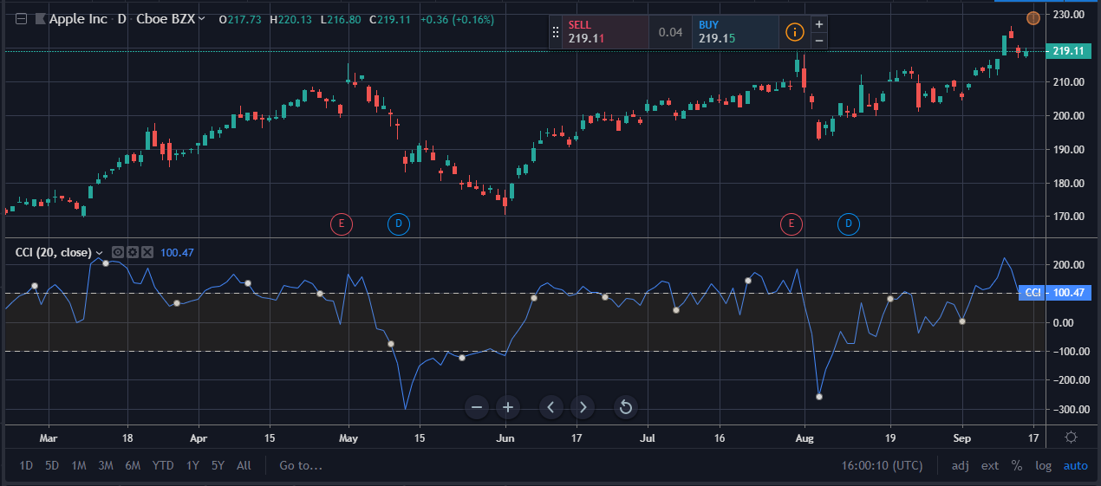

* The CCI measures the difference between the current price and the historical average price.
* When the CCI is above zero it indicates the price is above the historic average. When CCI is below zero, the price is below the historic average.
* High readings of 100 or above, for example, indicate the price is well above the historic average and the trend has been strong to the upside.
* Low readings below -100, for example, indicate the price is well below the historic average and the trend has been strong to the downside.
* Going from negative or near-zero readings to +100 can be used as a signal to watch for an emerging uptrend.
* Going from positive or near-zero readings to -100 may indicate an emerging downtrend.
* CCI is an unbounded indicator meaning it can go higher or lower indefinitely. For this reason, overbought and oversold levels are typically determined for each individual asset by looking at historical extreme CCI levels where the price reversed from.

**Technical indicator: Coppock Curve**

**What does it measure:** The Coppock Curve is a long-term price momentum indicator used primarily to recognize major bottoms in the stock market.

**General information:**

The Coppock Curve is a long-term price momentum indicator used primarily to recognize major bottoms in the stock market. It is calculated as a 10-month weighted moving average of the sum of the 14-month rate of change and the 11-month rate of change for the index; it is also known as the "Coppock Guide." The Coppock formula was introduced in Barron's in 1962 by Edwin Sedgwick Coppock.

**Parameters:**

1. **VMA Length**
2. **Long RoC Length**
3. **Short RoC Length**

**How to trade this signal:**

A cross above the zero line calls for a buy. Conversely, a break of zero triggers a sell.

If the indicator crosses zero and enters positive territory than a buy signal is generated.

If the indicator falls below zero and enters negative territory than a sell signal is generated.

Below is a chart of Amazon. Buy signals are in blue and sell in red.

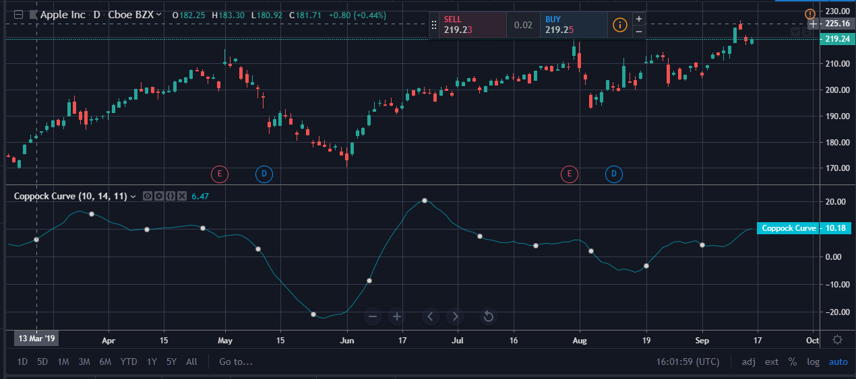

**Technical indicator: Correlation Coefficient**

**What does it measure:** Correlation Coefficient (CC) is used in statistics to measure the correlation between two sets of data.

**General information:**

Correlation Coefficient (CC) is used in statistics to measure the correlation between two sets of data. In the trading world, the data sets would be stocks, etf's or any other financial instrument. The correlation between two financial instruments, simply put, is the degree in which they are related. Correlation is based on a scale of 1 to -1. The closer the Correlation Coefficient is to 1, the higher their positive correlation. The instruments will move up and down together. The higher the Correlation efficient is to -1, the more they move in opposite directions. A value at 0 indicates that there is no correlation.

**Parameters:**

The indicator has five input parameters:

1. Symbol
2. Source
3. Length

**How to trade this signal:**

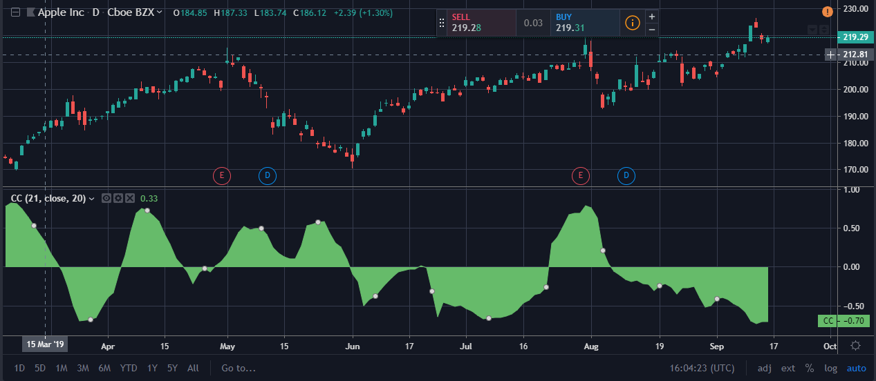

Even though The Correlation Coefficient (CC) moves within a band of 1 to -1, it is not considered an oscillator. Values fluctuate between positive and negative correlation, indicating how closely their prices move together. A Correlation Coefficient of +1 is perfect positive correlation and they move in perfect synch. A Correlation Coefficient of -1 is perfect negative correlation and they move in exact opposite directions. Both of these extremes are rare and the Correlation Coefficient will often fluctuate somewhere between the two. Correlation Coefficient of 0 is the middle point indicating that there is currently no correlation between the two instruments.

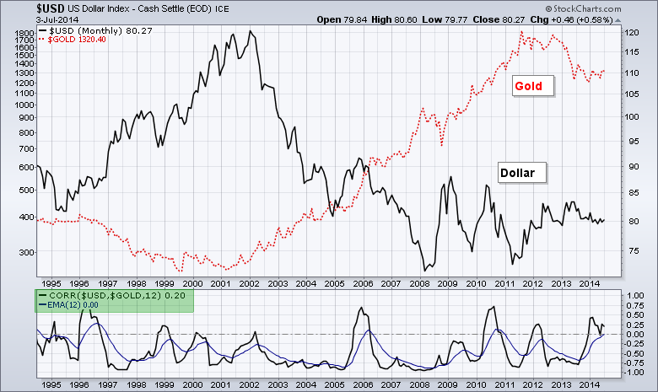

**Technical indicator: Directional movement index**

**What does it measure:** Directional movement index identifies in which direction the price of an asset is moving.

**General information:**

The Directional Movement Index, or DMI, is an indicator developed by J. Welles Wilder in 1978 that identifies in which direction the price of an asset is moving. The indicator does this by comparing prior highs and lows and drawing two lines: a positive directional movement line (+DI) and a negative directional movement line (-DI). An optional third line, called directional movement (DX) shows the difference between the lines. When +DI is above -DI, there is more upward pressure than downward pressure in the price. If -DI is above +DI, then there is more downward pressure in the price. This indicator may help traders assess the trend direction. Crossovers between the lines are also sometimes used as trade signals to buy or sell.

**Parameters:**

1. DI Length (14)
2. Smoothening (14)

**How to trade this signal:**

* The Directional Movement Index (DMI) is composed of two lines, and an optional one, showing selling pressure (-DI), showing buying pressure (+DI), and a third DX line showing the difference between the former positive and negative lines.
* A +DI line above the -DI line means there is more upward movement than downward movement.
* A -DI line above the +DI line means there is more downward movement than upward movement.
* Crossovers can be used to signal emerging trends. For example, the +DI crossing above the -DI may signal the start of an uptrend in price.
* The larger the spread between the two lines, the stronger the price trend. If +DI is way above -DI, the price trend is strongly up. If -DI is way above +DI, then the price trend is strongly down.
* The Average Directional Movement Index (ADX) is another indicator that can be added to the DMI.

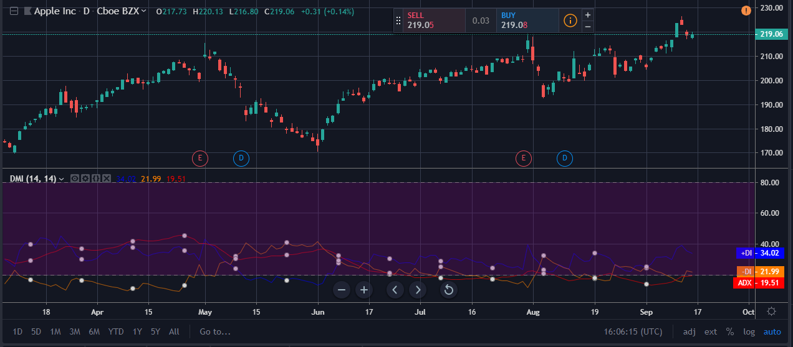

**Technical indicator: Donchian Channels**

**What does it measure:** Donchian Channels are three lines generated by moving average calculations that comprise an indicator formed by upper and lower bands around a mid-range or median band.

**General information:**

Donchian Channels are three lines generated by moving average calculations that comprise an indicator formed by upper and lower bands around a mid-range or median band. The upper band marks the highest price of a security over N periods while the lower band marks the lowest price of a security over N periods. The area between the upper and lower bands represents the Donchian Channel. Career futures trader Richard Donchian developed the indicator in the mid-twentieth century to help him identify trends. He would later be nicknamed "The Father of Trend Following".

**Parameters:**

Length

**How to trade this signal:**

* The indicator seeks to identify bullish and bearish extremes that favor reversals as well as breakouts, breakdowns and emerging trends, higher and lower.
* The middle band simply computes the average between the highest high over N periods and lowest low over N periods, identifying a median or mean reversion price.

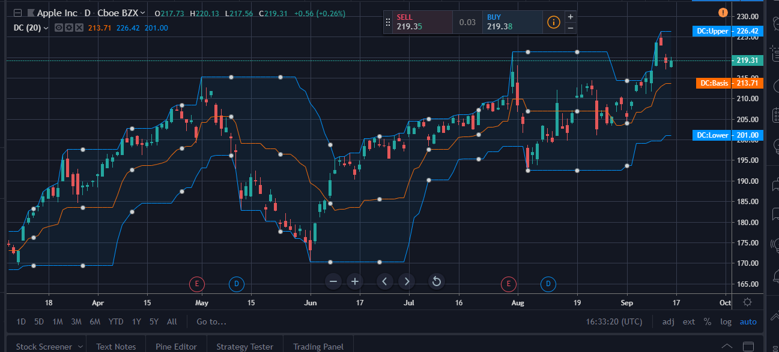

# Technical indicator: Double Exponential Moving Average (DEMA)

**What does it measure:** Its calculation and usage somewhat resemble the Hull Moving Average (HMA). It helps traders spot the prevailing trend and is often used in combination with other signals and analysis techniques.

**General info:**

The Double Exponential Moving Average is a technical indicator introduced by Patrick Mulloy in his January 1994 article "Smoothing Data With Faster Moving Averages" in Technical Analysis of Stocks & Commodities magazine.

The DEMA uses two exponential moving averages (EMAs) to eliminate lag, as some traders view lag as a problem. The DEMA is used in a similar way to traditional moving averages (MA). The average helps confirm uptrends when the price is above the average, and helps confirm downtrends when the price is below the average. When the price crosses the average that may signal a trend change. Moving averages are also used to indicate areas of support or resistance.

**Parameters:**

1. FastMMA
2. SlowMMA
3. LongTrend
4. Source

**How to trade this signal:**

* The DEMA responds quicker to price changes than a normal exponential moving average (EMA).
* The DEMA can be used in the same way as other MAs, as long as the trader understands the indicator will react quicker than traditional MAs. This may require some alteration of strategies.
* Less lag isn't always a good thing because lag helps filter out noise. An indicator with less lag is more prone to reacting to noise or small inconsequential price moves.
* A longer-term time frame DEMA, like 100 periods, will be slower to react than a shorter-term time frame DEMA, like 20 periods.
* 21-period DEMA (pink); 55-period DEMA (dark blue); 21-period MA (light blue); 55-period MA (light green).

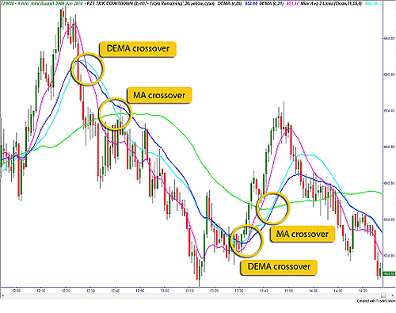

**Technical indicator: Ease of Movement**

**What does it measure:** This indicator calculates how easily a price can move up or down. The calculation subtracts yesterday's average price from today's average price and divides the difference by volume.

**General info:** Richard Arms' Ease of Movement indicator is a technical study that attempts to quantify a mix of momentum and volume information into one value. The intent is to use this value to discern whether prices can rise, or fall, with little resistance in the directional movement. Theoretically, if prices move easily, they will continue to do so for a period that can be traded effectively.

**Parameters:**

1. Length
2. Divisor

**How to trade this signal:**

This indicator calculates how easily a price can move up or down.

The calculation subtracts yesterday's average price from today's average price and divides the difference by volume. This generates a volume-weighted momentum indicator.

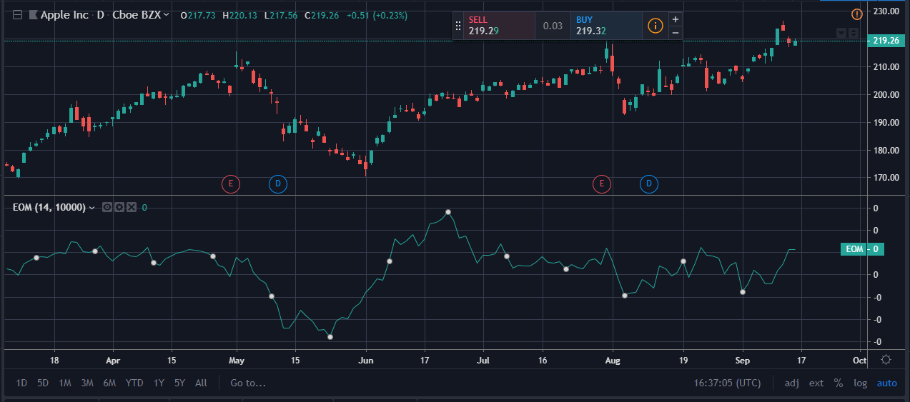

**Technical indicator: The Elder Force Index (EFI)**

**What does it measure:** Elder's Force Index (EFI) measures the power behind a price movement using price and volume.

**General info:**

The indicator can also be used to identify potential reversals and price corrections. The EFI is an oscillator that fluctuates between positive and negative values, above and below a Zero Line. Alexander Elder, the indicator's creator, believed that there are three components to a security's price movement. Those three components are; direction, extent and volume. All three of these components are combined by the EFI to generate the oscillator.

**Parameters:**Length (13)

### How to trade this signal:

* A rising force index, above zero, helps confirm rising prices.
* A falling force index, below zero, helps confirm falling prices.
* A breakout, or a spike, in the force index, helps confirm a breakout in price.
* If the force index is making lower swing highs while the price is making higher swing highs, this is bearish divergence and warns the price may soon decline.
* If the force index is making higher swing lows while the price is making lower swing lows, this is bullish divergence and warns the price may soon head higher.
* The force index is typically 13 periods, but this can be adjusted based on preference. The more periods used the smoother the movements of the index, typically preferred by longer-term traders.

The force index is used for trend and breakout confirmation, as well as spotting potential turning points by looking for divergences.

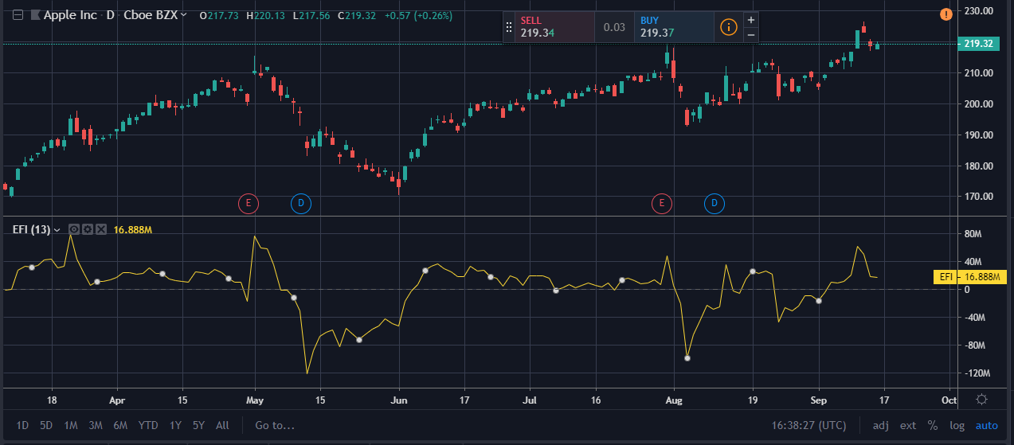

**Technical indicator: Envelope**

**What does it measure:** The most common example of an envelope is a moving average envelope, which is created using two moving averages that define upper and lower price range levels.

**General info:**

Envelopes are technical indicators that are typically plotted over a price chart with upper and lower bounds. The most common example of an envelope is a moving average envelope, which is created using two moving averages that define upper and lower price range levels. Envelopes are commonly used to help traders and investors identify extreme overbought and oversold conditions as well as trading ranges.

**Parameters:**

1. Length
2. Percent
3. Source

**How to trade this signal:**

* An envelope, in technical analysis, refers to trend lines plotted both above and below the current price.
* An envelope's upper and lower bands are typically generated by a simple moving average and a pre-determined distance above and below the moving average—but can be created using any number of other techniques.
* Many traders react to a sell signal when price reaches or crosses the upper band and a buy signal when price reaches or crosses the lower band of an envelope channel.

Moving average envelopes are the most common type of envelope indicator. Using either a simple or exponential moving average, an envelope is created by defining a fixed percentage to create upper and lower bounds.

Let's take a look at a five percent simple moving average envelope for the S&P 500 SPDR (SPY):

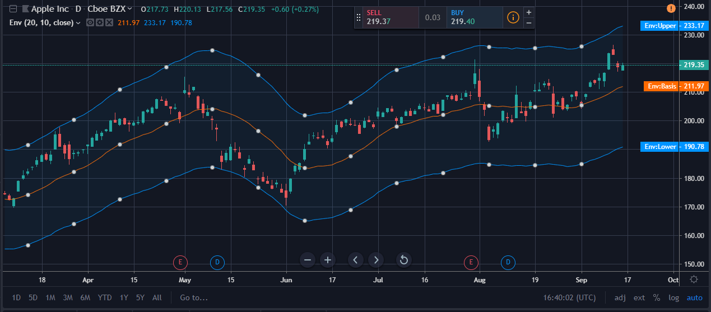

The calculations for this envelope are:

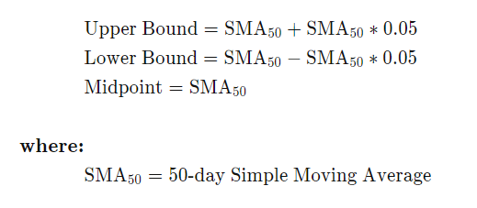

**Technical indicator: Fisher Transform**

**What does it measure:** The Fisher Transform is a technical indicator created by J.F. Ehlers that converts prices into a Gaussian normal distribution.

**General info:**

The Fisher Transform is a technical indicator created by J.F. Ehlers that converts prices into a Gaussian normal distribution. In this way, the indicator highlights when prices have moved to an extreme, based on recent prices. This may help in spotting turning points in the price of an asset. It also helps show the trend and isolate the price waves within a trend.

**Parameters:**

Length

**How to trade this signal:**

* The Fisher Transform attempts to normalize asset prices, thus making turning points in price clearer.
* Some traders look for extreme readings to signal potential price reversal areas, while others watch for a change in direction of the Fisher Transform.
* The Fisher Transform formula is typically applied to price, but it can also be applied to other indicators.
* Asset prices are not normally distributed, so attempts to normalize prices via an indicator may not always provide reliable signals.

The Fisher Transform indicator is unbounded, which means extremes can occur for a long time. An extreme is based on the historical readings for the asset in question. For some assets, a high reading may be seven or eight, while a low reading may be -4. For another asset, these values may differ.

An extreme reading indicates the possibility of a reversal. This should be confirmed by the Fisher Transform changing direction. For example, following a strong price rise and the Fisher Transform reaching an extremely high level, when the Fisher Transform starts to head lower that could signal the price is going to drop, or has already started dropping.

The Fisher Transform frequently has a signal line attached to it. This is a moving average of the Fisher Transform value, so it moves slightly slower than the Fisher Transform line. When the Fisher Transform crosses the trigger line it is used by some traders as a trade signal. For example, when the Fisher Transform drops below the signal line after hitting an extreme high, that could be used as a signal to sell a current long position.

As with many indicators, the Fisher will provide many trade signals. Many of these will not be profitable signals. Therefore, some traders prefer to use the indicator in conjunction with trend analysis. For example, when the price is rising overall, use the Fisher Transform for buy and sell signals, but not for short-sell signals. During a downtrend, use it for short-sell signals and ideas on when to cover.

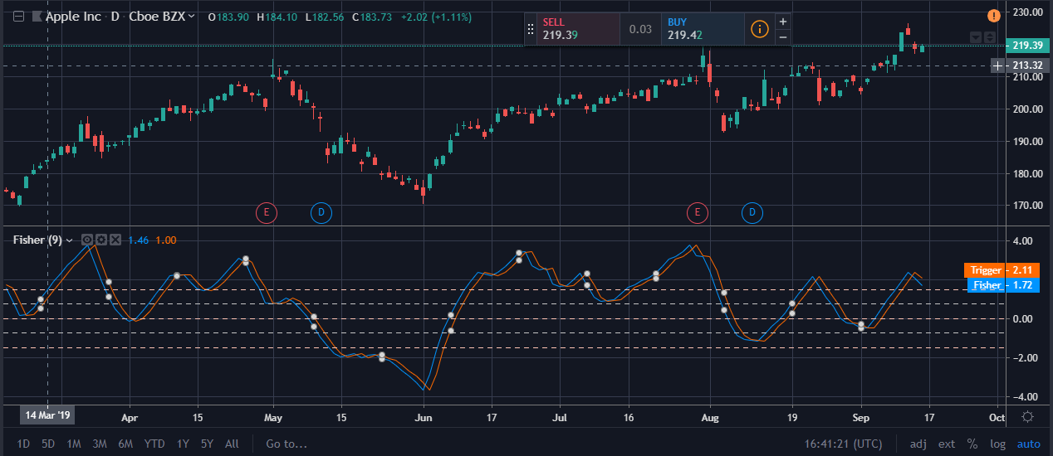

# Technical indicator: Historical Volatility

**What does it measure:** historical volatility measures past trading ranges of underlying securities and indexes.

**General info:**

Historical volatility (HV) is a statistical measure of the dispersion of returns for a given security or market index over a given period. Generally, this measure is calculated by determining the average deviation from the average price of a financial instrument in the given time period. Using standard deviation is the most common, but not the only, way to calculate historical volatility. The higher the historical volatility value, the riskier the security. However, that is not necessarily a bad result as risk works both ways - bullish and bearish.

**Parameters:**

Length of time

**How to trade this signal:**

* With historical volatility, traders use past trading ranges of underlying securities and indexes to calculate price changes.
* Calculations for historical volatility are generally based on the change from one closing price to the next.

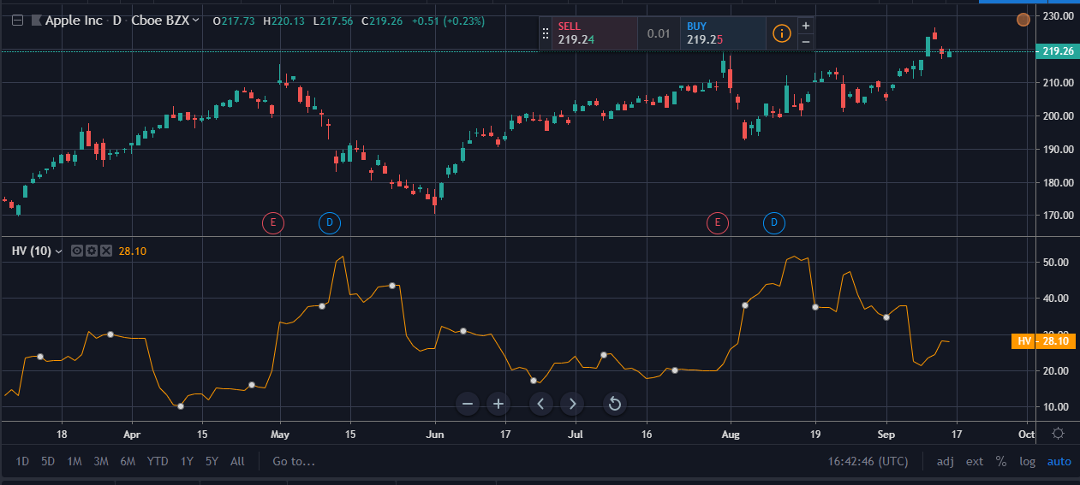

**Technical indicator: HULL MOVING AVERAGE (HMA)**

**What does it measure:** Its calculation is elaborate and makes use of the Weighted Moving Average (WMA). It emphasizes recent prices over older ones, resulting in a fast-acting yet smooth moving average that can be used to identify the prevailing market trend.

**General info:**

Alan Hull developed **Hull Moving Average** in 2005 in his quest to create a moving average that is "responsive to current price activity while maintaining curve smoothness". Hull claims that his moving average "almost eliminates lag altogether and manages to improve smoothing at the same time".

**Parameters:**

1. Length
2. Price

**How to trade this signal:**

Alan Hull recommends using his moving average for directional signals and not for crossovers which could be distorted by the lag.

* Go long when Hull Moving Average turns up; and
* Go short when Hull Moving Average turns down.

### Two Hull Moving Averages

It would make sense to introduce a longer-term moving average to signal trend direction, then only take trades in the direction of the trend.

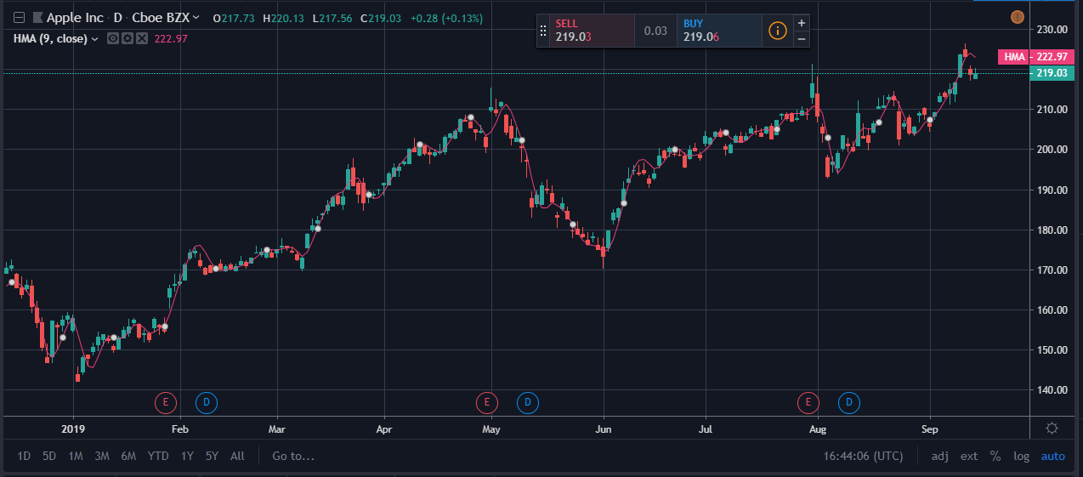

**Technical indicator: Ichimoku Cloud**

**What does it measure:** he Ichimoku Cloud is a collection of technical indicators that show support and resistance levels, as well as momentum and trend direction.

**General info:**

The Ichimoku Cloud is a collection of technical indicators that show support and resistance levels, as well as momentum and trend direction. It does this by taking multiple averages and plotting them on the chart. It also uses these figures to compute a "cloud" which attempts to forecast where the price may find support or resistance in the future.

The Ichimoku cloud was developed by Goichi Hosoda, a Japanese journalist, and published in the late 1960s. It provides more data points than the standard candlestick chart. While it seems complicated at first glance, those familiar with how to read the charts often find it easy to understand with well-defined trading signals.

**Parameters:**

1. Conversion Line Periods
2. Base Line Periods
3. Lagging Span 2 Periods
4. Displacement

**How to trade this signal:**

### The Cloud: Finding the Trend

* The trend is upward when price is above the Cloud.
* The trend is downward when price is below the Cloud.
* The trend is flat (undetermined) when price is in the Cloud.

The Cloud is green when Senkou Span A is above Span B. A predominantly green cloud indicates a strong up-trend (or weak down-trend), while a predominantly red cloud indicates a strong down-trend (or weak up-trend).

### Trading in an Up-trend

Signals above the Cloud where the latest Cloud color (ahead) is green are stronger than where the color is red.

* Go long when Tenkan-Sen (blue) crosses above Kijun-Sen (red).
* Go long when Price crosses above the Kijun-Sen (red) line.
* Exit when Price crosses below Kijun-Sen (red).
* Exit when Tenkan-Sen (blue) crosses below Kijun-Sen (red).

### Trading in a Down-trend

Signals below the Cloud where the latest Cloud color (ahead) is red are stronger than where the color is green.

* Go short when Tenkan-Sen (blue) crosses below Kijun-Sen (red).
* Go short when Price crosses below the Kijun-Sen (red) line.
* Exit when Price crosses above Kijun-Sen (red).
* Exit when Tenkan-Sen (blue) crosses above Kijun-Sen (red).

##### **Example 1**

The S&P 500 index is plotted on a weekly chart with Ichimoku Cloud.

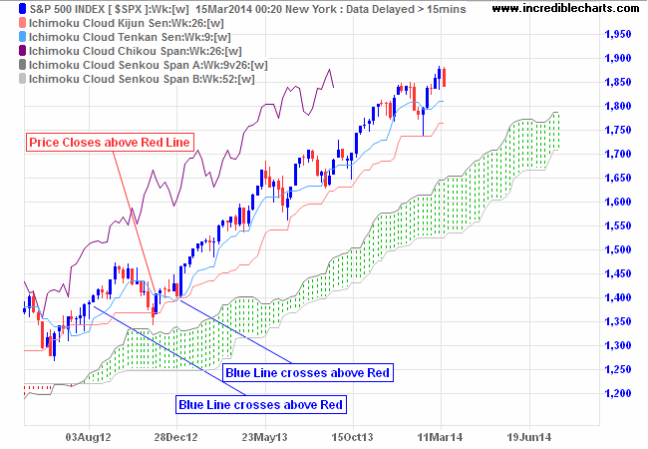

Price above the Cloud indicates an up-trend. The first buy signal is when the blue line (Tenkan-Sen) crosses above the red (Kijun-Sen), after the green Cloud indicates the trend is firmly established. The second long entry (if pyramiding) is when Price closes above the red (Kijun-Sen) line. Again, the green cloud indicates an established trend. A third entry signal is available when the blue line (Tenkan-Sen) again crosses above the red (Kijun-Sen). Exit if Price closes below the red line (Kijun-Sen) — or the blue line (Tenkan-Sen) crosses below the red.

##### **Example 2**

Etrade Financial Corporation [ETFC] is plotted on a daily chart with Ichimoku Cloud.

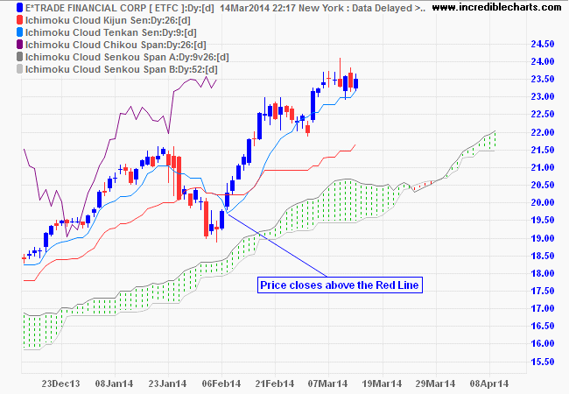

Price above the Cloud indicates an up-trend. Enter long when Price closes above the red (Kijun-Sen) line. The green cloud indicates an established trend. Exit if Price closes below the red line (Kijun-Sen) or the blue line (Tenkan-Sen) crosses below the red.

### In a Strong Trend

How to identify a strong trend: the blue line does not cross below the red.

In a strong trend, short-term traders may find that crosses of the red (Kijun-Sen) line are few and far between. Consider long entries where Price closes above the blue (Tenkan-Sen) line and short entries (in a down-trend only) when Price closes below the line.

##### **Example 3**

Netflix [NFLX] is plotted on a weekly chart with Ichimoku Cloud.

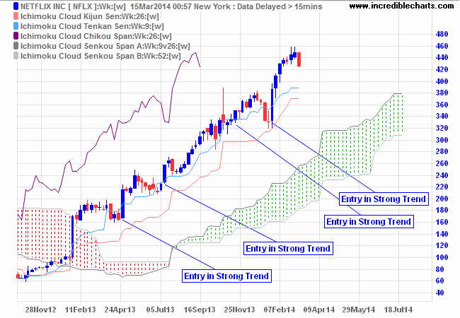

Price above the Cloud indicates an up-trend. The blue line (Tenkan-Sen) holding above the red (Kijun-Sen) indicates a strong trend. Enter when Price dips below and then closes back above the blue line. Exit if Price closes below the red line (Kijun-Sen) or the blue line (Tenkan-Sen) crosses below the red.

### Long-term Buy/Sell Signals

Not used as much, but if the purple line (Chikou) crosses above Price, that is a long-term buy signal, while a cross below Price is a long-term sell signal.

**Technical indicator: Keltner Channel**

**What does it measure: Keltner channel** is a technical analysis indicator showing a central moving average line plus channel lines at a distance above and below.

**General info:**

A Keltner Channel is a volatility based technical indicator composed of three separate lines. The middle line is an exponential moving average (EMA) of the price. Additional lines are placed above and below the EMA. The upper band is typically set two times the Average True Range (ATR) above the EMA, and lower band is typically set two times the ATR below the EMA. The bands expand and contract as volatility (measured by ATR) expands and contracts.

Since most price action will be encompassed within the upper and lower bands (the channel), moves outside the channel can signal trend changes or an acceleration of the trend. The direction of the channel, such as up, down, or sideways, can also aid in identifying the trend direction of the asset.

**Parameters:**

### Length

### Multiplier

### Source

### Bands style

**How to trade this signal:**

The usefulness of the Keltner Channels largely depends on the settings used. Traders first need to decide how they want to use the indicator and then set it up to help accomplish that purpose. Some of the uses of Keltner Channels, addressed above, won't work if the bands are too narrow or too far apart.

The bands may also not act as support or resistance, and they may seem to have little forecasting ability at all. This could be due to the settings chosen, but there is also no evidence that the price moving two ATRs or hitting one of the bands will result in a trading opportunity or something significant happening.

While Keltner Channels can help identify trend direction, and even provide some trade signals, they are best used in conjunction with price action analysis, fundamentals if trading for the long-term, and other technical indicators.

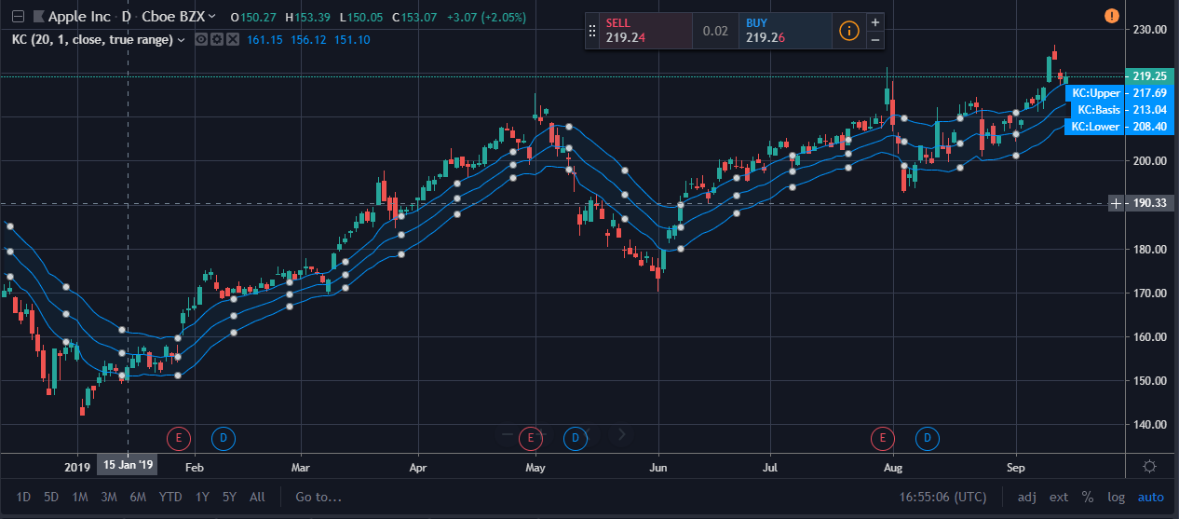

**Technical indicator: Klinger Oscillator**

**What does it measure:**

The indicator compares the volume flowing through securities with the security's price movements and then converts the result into an oscillator. The Klinger oscillator shows the difference between two moving averages which are based on more than price.

**General info:**

The Klinger oscillator was developed by Stephen Klinger to determine the long-term trend of money flow while remaining sensitive enough to detect short-term fluctuations. The indicator compares the volume flowing through securities with the security's price movements and then converts the result into an oscillator. The Klinger oscillator shows the difference between two moving averages which are based on more than price. Traders watch for divergence on the indicator to signal potential price reversals. Like other oscillators, a signal line can be added to provide additional trade signals.

Traders will use tools such as trendlines, moving averages, and other indicators to confirm trade signals. In addition, traders may use the oscillator in conjunction with chart patterns, such as price channels or triangles, as a way to confirm a breakout or breakdown. Crossovers occur frequently, as do divergences, so the indicator is best used in conjunction with these other technical trading methods.

**Parameters:**

NO

**How to trade this signal:**

Traders use the Klinger volume oscillator for identifying the bearish and bullish signals.

**Bullish Signals**

* When the 13-period EMA crosses above the oscillator while the stock is in a clear uptrend, traders go long.
* When the 34-period EMA is getting higher in value when compared to the 55-period EMA (oscillator is above zero), traders go long.
* When there is a bullish divergence between price and KVO, traders go long.
* Bearish Signals
* When the 13-period EMA crosses below the oscillator while the stock is in a clear downtrend, traders go short.
* Whenever the 34-period EMA is getting lower in value when compared to the 55-period EMA (oscillator is below zero), traders go short.
* When there is a bearish divergence between price and KVO, traders go short.

Note that many traders use the Klinger volume oscillator in combination with other tools like Stochastic Oscillator, parabolic SAR etc to eliminate false signals.

The figure below shows how to use KVO for buying and selling stocks.

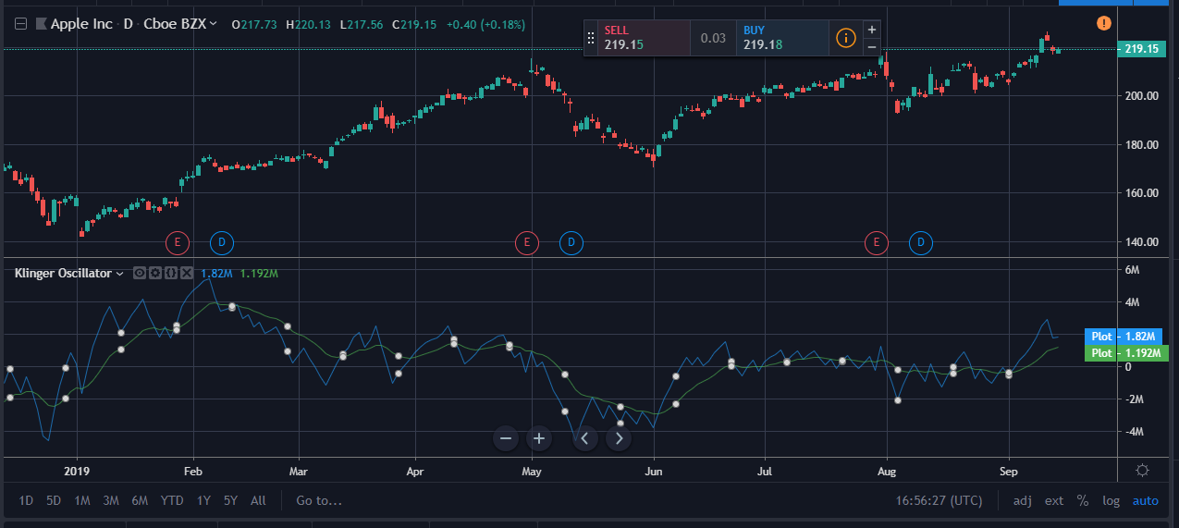

**Technical indicator: Know Sure Thing (KST)**

**What does it measure:** Know Sure Thing is calculated by taking the simple moving average (SMA) or four different rate-of-change (ROC) periods, adding them together to come up with the KST, and creating a signal line by taking the 9-period SMA of the KST.

**General info:**

Know Sure Thing, or KST, is a momentum oscillator developed by Martin Pring to make rate-of-change readings easier for traders to interpret. In a 1992 Stocks and Commodities article, Mr. Pring referred to the indicator as "Summed Rate of Change (KST)," but the KST term stuck with technical analysts. The indicator is relatively common among technical analysts preferring momentum oscillators to make decisions.

**Parameters:**

* ROCLen1
* ROCLen2
* ROCLen3
* ROCLen4
* SMALen1
* SMALen2
* SMALen3
* SMALen4

**How to trade this signal:**

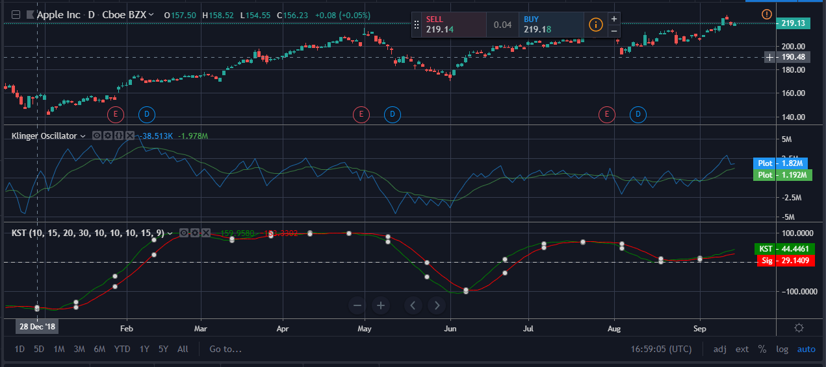

The KST indicator can be an effective tool for intraday traders.

In the below image, we have selected an intraday 2-minute chart of Alibaba from June 22nd. We have identified several crossover signals. For instance, the KST indicator is signaling a bullish trend in the morning session at around 10:15 am.

A long entry could have been initiated at $78.50 and held until a crossover to the downside at $79.

This would have resulted in a 50 cent per share profit in less than two hours.



*KST Morning Breakouts*

## Trading Double Bottoms with the KST

Now, let’s combine the Know Sure Thing indicator with a double bottom on the chart.

Let’s take a look at Ford’s 5-minute chart.

We have identified the first bottom in the morning session at nearly 9:35 am. We have confirmed the second double bottom at around 1:25 pm.

After half an hour, a bullish crossover develops in the KST confirming the bullish trend. Accordingly. We take a long position at $13.18. On June 23rd, Ford made a gap up and crossed $13.40. We get a bearish crossover from KST and sold our position at around $13.36. In this example, you would have held a position overnight.  I do not hold positions; however, you will need to determine if this makes sense for your trading style.

**Technical indicator: Least Squares Moving Average**

**What does it measure: L**east square moving average (LSMA) calculates the least squares regression line for the preceding time periods, thus leading to forward projections from the current period.

**General info:**

**Least Square Moving Average** is an indicator capable of predicting future behavior of the asset. Today we are taking a closer look at this indicator and discuss how and, most importantly, why to use it in trading. Least Square Moving Average (LSMA) relies on the use of the least squares method. The moving average will continue moving in the direction of the trend even after the trend has ceased. This indicator will, therefore, demonstrate what could possible happen should the trend continue.

**Parameters:**

1. Length
2. Offset
3. Source

**How to trade this signal:**

In order to use this indicator, you will have to follow both its readings and the price action. Since there is only one line, the signals this indicator is sending are quite straightforward. When the LSMA is moving up and the asset price remains above the moving average and is growing, traders consider opening a **BUY**position. When the LSMA is moving down and the asset price remains below the moving average and is collapsing, traders consider opening a **SELL**position. When using this technique, you will have to assess the behavior of the price chart in regard to the moving average, as both are moving quite differently.

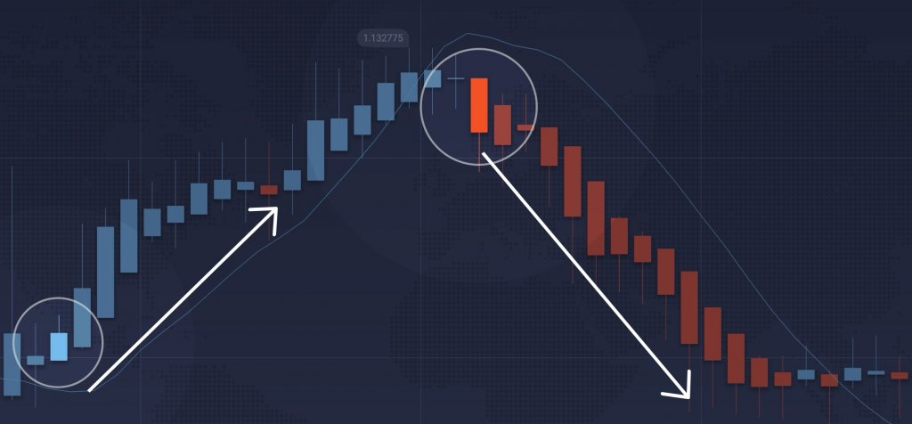BUY and SELL signals sent by LSMA and the price chart

Least Square Moving Average can also be used in a combination with other moving averages (e. g. SMA, EMA) or a second LSMA with different period. In this case, the two indicators would work as complementary indicators, providing a confirmation for each other’s signals. The crossover between the two can be treated as a bullish/bearish signal depending on the trend direction.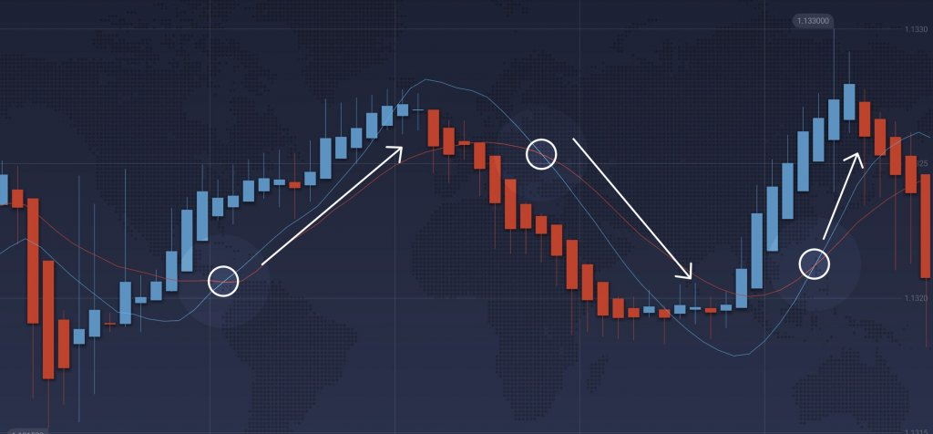

Finally, LSMA can be used as a part of a more complex trading system when independent indicators of different types are expected to simultaneously provide the entry and exit signals. In this case, LSMA can work as a regular moving average.

**Technical indicator: Linear Regression Curve**

**What does it measure:** The Linear Regression Curve is used mainly to identify trend direction and might sometimes be used to generate buy and sell signals.

**General info:**

Linear regression works by taking various data points in a sample and providing a “best fit” line to match the general trend in the data. Even if markets are up over a certain period, a linear regression line may still point down (and vice versa). This is due to the fact that most forms of linear regression are based on the mean (average) and are sensitive to outliers.

For example, if we look at the crude oil market over the past 50 periods, we can see that based on where the linear regression line starts and stops, the market is actually up in price over this time. However, when we plot the line, it is actually slightly negatively sloped.

**Parameters:**

With this, we’ll use a 100-period SMA. This gives us a picture of the broader trend.

Our rules will be as follows:

#### Long Trades

1. 20-period moving linear regression line above the 100-period line
2. “Aroon up” above “Aroon down”
3. SMA positively sloped

#### Short Trades

1. 20-period moving linear regression line below the 100-period line
2. “Aroon up” below “Aroon down”
3. SMA negatively sloped

#### Trade Exits

1. When either of the above three rules pertinent to the trade become untrue

**How to trade this signal:**

For trade exits, we can take a touch of the middle band of the Keltner channel. (This can be plotted by going into the settings portion of the indicator on one’s charting software platform.)

Therefore, we can list out our rules as the following:

***Long Trades***

1. 5-period moving linear regression line above the 20-period line
2. Recent touch of the bottom band of the Keltner channel

#### Short Trades

1. 5-period moving linear regression line below the 20-period line
2. Recent touch of the top band of the Keltner channel

#### Trade Exits

1. Touch of the middle band of the Keltner channel, or
2. Subsequent moving linear regression line crossover, invalidating the signal

### Price Reversal Example

Here we have a price reversal opportunity on the **AUD/USD**currency pair that fulfills the criteria of this system.

Price begins to challenge the top band of the Keltner channel, but the fast moving linear regression line remains above the slow (denoting no reversal in the trend). Price continues along the top band until the slow line moves above the fast. At this point we can enter into a short trade. (The red arrow identifies the entry while the white arrow identifies the trade exit.)

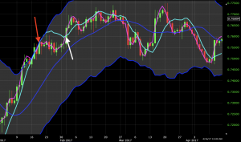

We did see a shallow move down following this entry but the uptrend continued after this point and never made it down to the midline of the channel. Once the fast line moved above the slow (representing an official resumption of the uptrend), this trade was closed out at a small loss.

**Technical indicator: MA Cross**

**What does it measure:** A **moving average** (**MA**) is a widely used **indicator** in technical analysis that helps smooth out price action by filtering out the “noise” from random short-term price fluctuations.

**General info:**

A moving average (MA) is a widely used indicator in technical analysis that helps smooth out price action by filtering out the “noise” from random short-term price fluctuations. It is a trend-following, or lagging, indicator because it is based on past prices.

The two basic and commonly used moving averages are the simple moving average (SMA), which is the simple average of a security over a defined number of time periods, and the exponential moving average (EMA), which gives greater weight to more recent prices.

**Parameters:**

No

**How to trade this signal:**

* A moving average is a technique often used in technical analysis that smooths price histories by averaging daily prices over some period.
* Simple moving averages (SMA) takes the arithmetic mean of a given set of prices over the past number of days, for example over the previous 15, 30, 100, or 200 days.
* Exponential moving averages (EMA) uses a weighted average that gives greater weight to more recent days to make it more responsive to new information.
* When asset prices cross their moving averages, it may generate a trading signal for technical traders.

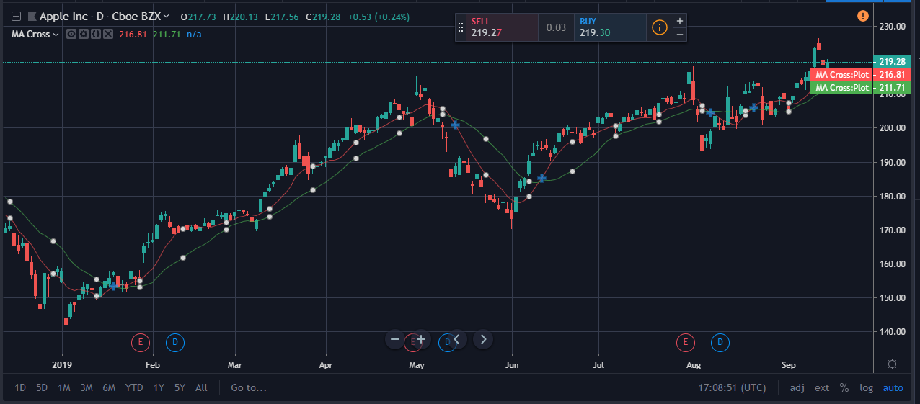

## **How do traders use move averages?**

## Using MAs can be fundamental for technical analysis strategies, and using a combination of techniques can result in long and short-term forecasts. MAs can be calculated manually and used in any chart analysis simply by following the formula.

As discussed above, MAs can be used to determine levels of support and resistance. IG charts feature MAs, as well as other technical tools like Bollinger bands and relative strength index (RSI), in order to help traders with technical analysis. It can be used by clicking the ‘technical’ tab at the top of the chart.

It’s also important to note that there are two main types of MAs; exponential moving averages (EMA) and simple moving averages (SMA).

## **Exponential moving average**

The EMA is calculated by placing greater weight on the most recent data points. It can sometimes be referred to as the exponentially 'weighted' moving average. This is because EMAs react significantly to the most recent price changes.

The most popular EMAs are 12 and 26-day EMAs for short-term averages, whereas the 50 and 200-day EMAs are used as long-term trend indicators. When used in conjunction with other indicators, EMAs can help traders confirm significant market moves and gauge their legitimacy.

## **Simple moving average (SMA)**

The SMA formula is calculated by taking the average closing price of a security over any period desired. To calculate a moving average formula, the total closing price is divided by the number of periods.

For example, if the last five closing prices are:

28.93+28.48 +28.44+28.91+28.48 = 143.24

The five-day SMA is: 142.24/5= 28.65.

## **SMA vs EMA**

Both the SMA and the EMA are commonly used formulas. The two are very similar, but have a significant point of difference; the sensitivity each one shows to changes in data. The EMA gives a higher significance to recent prices, while the SMA gives significance to all values.

Both are used in technical analysis and can be interpreted in the same manner to even out price variations.

While some might argue it is more common to see the SMA used by technical analysts, others might say that using EMAs can be more significant to analysis because of their nature and the significance they give to recent data. EMAs tend to be timelier and therefore can be favoured by some analysts, also tending to respond to price changes faster than SMAs.

## **How to trade using moving averages**

Using MAs while trading can help identify trends and become significant in building trading strategies. If price action is above a moving average it can be indicative of long positions, while if the price action is below the moving average, it can be an indication that short positions should be taken.

Traders can also use the moving average crossover method as a trigger into new positions. This method is one that is commonly used in trading strategies.

### Day trading using moving averages

Using MAs for day trading can be extremely beneficial. It can be a clean and simple way to understand when a stock is trending and to analyse the market. Day traders would benefit from using MAs because they need to make quick decisions without having to do complicated calculations - often they’re required to make decisions within short periods of time, making the MA formulas a common go-to for day traders.

MAs can provide a simple yet effective way to know what side of the market you should be trading that day. If it’s trading below the moving average point, then this can be a clear indicator to take the short position. While using MAs can be useful, it is important to note that nothing in financial markets is for certain when using technical indicators, and things can change quickly. While MAs can be helpful and provide great analysis, they’re not a magic formula that can predict which way to trade.

If you think of MAs as a useful tool, used in conjunction with other indicators, they can provide useful information to aid in your day-to-day trading decisions.

**Technical indicator: Moving Average Convergence Divergence (MACD)**

**What does it measure:** a trend-following momentum indicator that shows the relationship between two moving averages of a security's price.

**General info:**

Moving average convergence divergence (MACD), invented in 1979 by Gerald Appel, is one of the most popular technical indicators in trading. The MACD is appreciated by traders the world over for its simplicity and flexibility, as it can be used either as a trend or momentum indicator.

Trading divergence is a popular way to use the MACD histogram (which we explain below), but unfortunately, the divergence trade is not very accurate, as it fails more than it succeeds. To explore what may be a more logical method of trading the MACD divergence, we look at using the MACD histogram for both trade entry and trade exit signals (instead of only entry), and how currency traders are uniquely positioned to take advantage of such a strategy.

**Parameters:**

1. FastLength
2. SlowLength
3. SignalLength

**How to trade this signal:**

Trading divergence is a classic way in which the MACD histogram is used. One of the most common setups is to find chart points at which price makes a new swing high or a new swing low, but the MACD histogram does not, indicating a divergence between price and momentum.

Figure: illustrates a typical divergence trade.

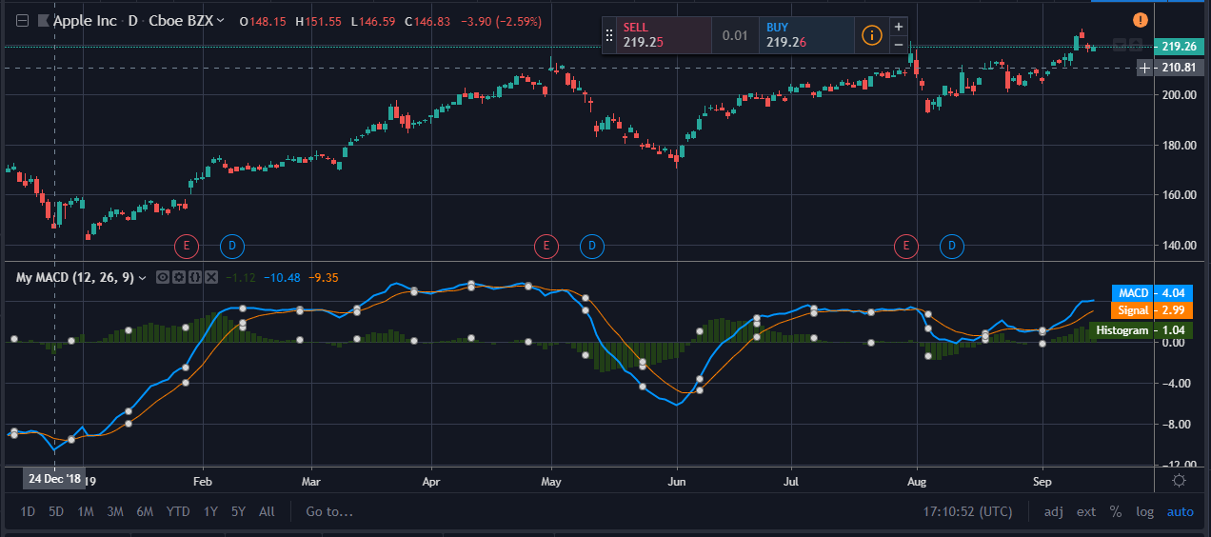

Unfortunately, the divergence trade is not very accurate, as it fails more times than it succeeds. Prices frequently have several final bursts up or down that trigger stops and force traders out of position just before the move makes a sustained turn and the trade becomes profitable.  
Figure 3 demonstrates a typical divergence fake out, which has frustrated scores of traders over the years.

 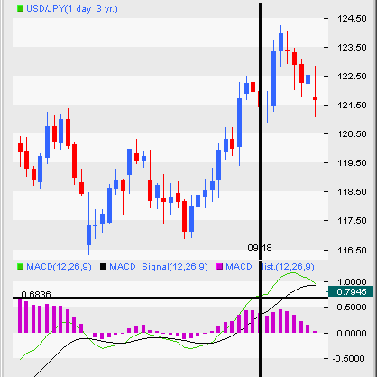

**Technical indicator: Mass Index**

**What does it measure:** Mass index is a form of technical analysis that examines the range between high and low stock prices over a period of time

**General info:**

To get a better idea of what mass index truly does, consider driving a car and the mass index calculator, which shows volatility of the stock, is your speedometer. The speedometer of the car will only show how fast or how slow you are going, so you will probably need to use a compass to figure out if you are driving towards the north or the south – the compass being another technical indicator for determining direction. In other words, if you don't know what direction you're going, it matters very little how fast you're going.

**Parameters:**

Length

**How to trade this signal:**

Let’s say we apply the Mass Index using the default settings. The Mass Index should not be used in isolation, so must be used as part of a broader system. Therefore, let’s use it in the context of pairing it with a moving average crossover technique in order to generate our trade signals.

We will use a 50-period simple moving average (SMA) and a 21-period SMA to generate signals.

* When the 21-period (“fast”, orange line) SMA is above the 50-period (“slow”, blue line) SMA this will define for us an uptrend.
* When the 50-period (“slow”, blue line) SMA is above the 21-period (“fast”, orange line) SMA, this will define a downtrend.

Therefore, if we receive a confirmation signal from the Mass Index, we would wait until the SMAs cross over in order to produce our trade entry signal.

To ensure that our signal is still reliable, we could institute a rule saying that any trade needs to be taken with the trend, as denoted by both the fast and slow SMAs.

Namely, if both are positively sloped, we would be biased toward long trades. If both are negatively sloped, we would be biased toward short trades.

For simplicity, we will only take these trades upon the original rules delineated by the indicator’s developer. Namely, if the Mass Index moves above 27 and subsequently falls below 26.5, we will take a trade in whichever direction is dictated by the SMAs as described above.

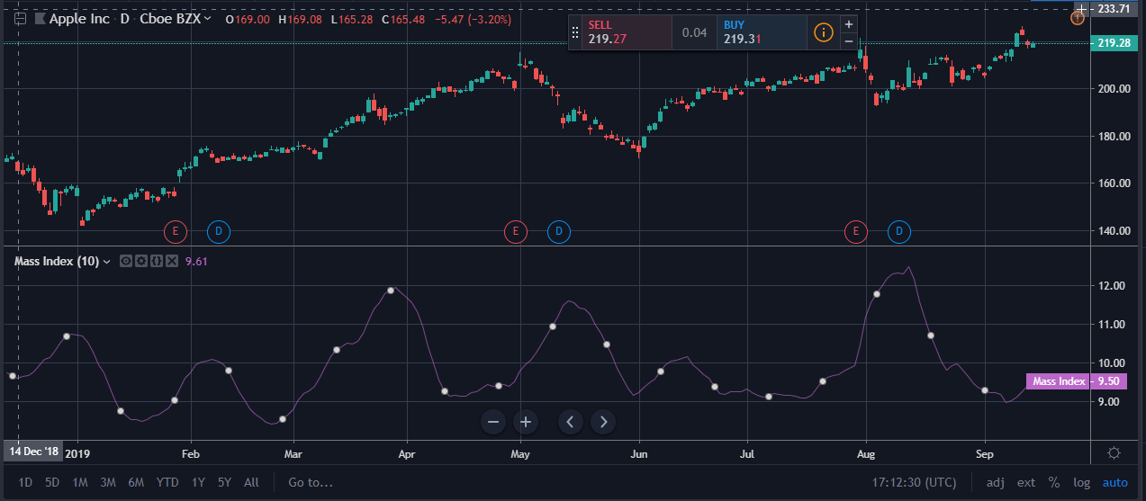

**Technical indicator: McGinley Dynamic**

**What does it measure:** McGinley Dynamic indicator is a type of moving average that was designed to track the market better than the existing moving average indicators.

**General info:**

The McGinley Dynamic indicator attempts to solve a problem inherent in moving averages that use fixed time lengths. The basic problem is that the market, being the great discounting mechanism that it is, reacts to events at a speed that a moving average will not be able to cope with. This issue is called the lag, and there is not a type of moving average, whether it be a simple, exponential, or weighted moving average, that is not affected by this. Understandably, this will call into question the reliability of that moving average. The McGinley Dynamic indicator takes into account speed changes in a market (hence, 'dynamic') to show a smoother, more responsive, moving average line.

**Parameters:**

Length

**How to trade this signal:**

* McGinley Dynamic Indicator is a type of moving average that was designed to track the market better than the existing moving average indicators.
* The McGinley Dynamic indicator solves the issue of varying market speeds by incorporating an automatic adjustment factor into its formula which speeds, or slows, the indicator in trending, or ranging, markets.
* The McGinley Dynamic indicator improves upon conventional moving averages by minimizing price separations and volatile whipsaws so that price action is more accurately reflected.

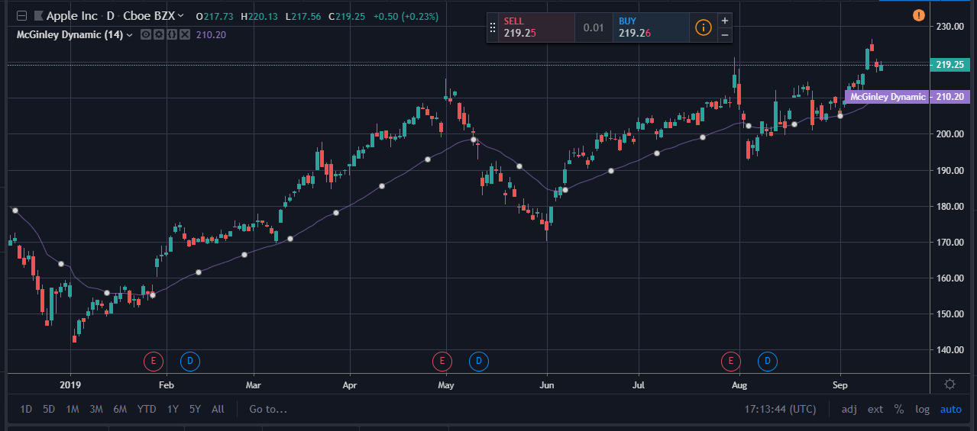

**Technical indicator: Momentum**

**What does it measure:** Market momentum is measured by continually taking price differences for a fixed time interval. To construct a 10-day momentum line, simply subtract the *closing price* 10 days ago from the last closing price. This positive or negative value is then plotted around a zero line

**General info:**

Momentum measures the rate of the rise or fall in stock prices. From the standpoint of trending, momentum is a very useful indicator of strength or weakness in the issue's price. History has shown us that momentum is far more useful during rising markets than during falling markets; the fact that markets rise more often than they fall is the reason for this. In other words, bull markets tend to last longer than bear markets.

**Parameters:**

1. Length
2. Source

**How to trade this signal:**

The momentum indicator can be used to provide trade signals, but it is better used to help confirm the validity of trades based on price actions such as breakouts or pullbacks.

**100 Line Cross**: When the price crosses above or below the 100 line (or the zero line if the indicator in a chart is based on the first type of calculation), it can represent a buy or sell signal respectively. If the price crosses above the 100 line, the price is starting to gain momentum higher. A drop below the 100 line shows the price is losing momentum.

The 100 line cross is prone to "whipsaws," meaning the price could move above the line but then right back below it. Traders may wish to filter signals based on the current trend. For example, if a stock is trending higher, buy only when the indicator falls below the 100 line and then rallies back above it. If a stock is trending lower, do a short sale—selling borrowed shares of a stock with the intention of buying them back and returning them later at a lower price—only when it drops back below the line.

**Crossover**: To buy or sell on a crossover, first add a moving average line to your indicator. The moving average is the average closing price over a previous number of days you select.

Buy when the momentum indicator crosses above the moving average from below, and sell when the momentum indicator crosses below the moving average from above.

This strategy has its problems, too, mainly that same whipsaw issue. That problem can be somewhat alleviated by once again responding only to trade signals in the trending direction. In this case, if the trend is down, make a short trade only after the indicator has moved above the moving average and then drops below. Exit the short trade when the indicator moves above the moving average.

You should test various moving average lengths and momentum indicator settings to find a combination that works for your trading style.

**Divergence:** A bullish divergence occurs when the price is moving lower but the lows on the momentum indicator are moving higher. It shows that while the price is dropping, the momentum behind the selling is slowing. If you get a buy signal, this bullish divergence can help confirm it.

If the price is moving higher but the highs on the momentum indicator are moving lower, this is a bearish divergence. It shows that while the price is rising, the momentum behind the buying is slowing. If you get a sell signal, this bearish divergence can help confirm it.

Divergence should never be used as a trading signal on its own; it should only be used to help confirm trade signals produced by other strategies.

You should also be aware of the quirks of this indicator. For example, if the price rises strongly but then moves sideways, the momentum indicator will rise and then start dropping. This is not a bad sign. The indicator is just showing, in a different way, what is visible on the price chart: The price had a lot of momentum and now it doesn't. But that does not necessarily mean the price is going to drop.

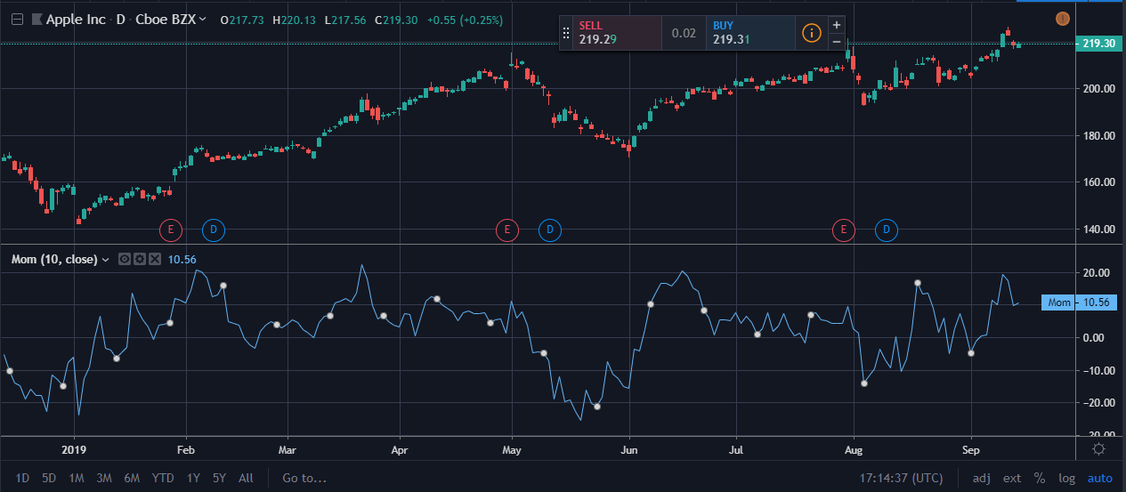

**Technical indicator: Money Flow**

**What does it measure:** The Money Flow Index (MFI) is a technical oscillator that uses price and volume for identifying overbought or oversold conditions in an asset

**General info:**

One of the primary ways to use the Money Flow Index is when there is a divergence. A divergence is when the oscillator is moving in the opposite direction of price. This is a signal of a potential reversal in the prevailing price trend.

For example, a very high Money Flow Index that begins to fall below a reading of 80 while the underlying security continues to climb is a price reversal signal to the downside. Conversely, a very low MFI reading that climbs above a reading of 20 while the underlying security continues to sell off is a price reversal signal to the upside.

**Parameters:**

Length

**How to trade this signal:**

The following provide some trade examples of how the money flow index might be used to identify potential trading opportunities. I have paired it with Keltner channels, which is another price reversal indicator.

The MFI is used with a 14-period setting, while the Keltner channels are set with a 20-period setting and a 3.0x average true range multiple. (The higher the average true range multiple the wider the bands will be, and therefore the more conservative the trade signals will be.)

Given that both the MFI and Keltner channels are price reversal indicators, it doesn’t make sense to plot trend following indicators on the chart in conjunction with them (other than for perhaps general information).

We can form a basic trading system around this.

Long trades will be taken when the following are true:

1. Security is oversold based on the money flow index running below 20
2. Touch of the bottom band of the Keltner channels.

Short trades will be taken when the following are true:

1. Security is overbought based on the money flow index running above 80
2. Touch of the top band of the Keltner channels

Exit trades when:

1. When price touches the middle band of the Keltner channels (a middle band can be plotted on this indicator by going into the settings on your charting software)

This is simply an example of a basic system that uses technical indicators only. It ignores price action, chart patterns, and fundamental analysis.

### Money Flow Index + Keltner Channels Work Best on Volatile Securities

All of the following trade examples will be used on Kinder Morgan (KMI) stock. For the money flow index and Keltner channels to initiate signals, the security needs to exhibit a sufficient amount of volatility.

Some assets, like short-term investment-grade/sovereign bonds and diversified stock indexes, rarely exhibit enough volatility to trigger signals when using the money flow index and Keltner channels on the settings listed above.

One option is to simply relax the settings to trigger more signals. For example, one could use a smaller period on the MFI (e.g., 7-day, 10-day) to generate more signals or use a 25-75 band instead of 20-80 band for oversold/overbought readings. Moreover, on the Keltner channels, one could also use a shorter period or lower the average true range multiple. The issue with doing this, however, is that if the criteria is relaxed too heavily, then the signals may become less statistically significant in terms of finding quality reversal points in the market.

With a volatile stock like KMI, one should be able to generate potential trade setups based on the stipulated criteria. **Trade #1**

The first example is a long trade where we see both a move below 20 on the money flow index, denoting “oversold” and a touch of the bottom band of the Keltner channels. 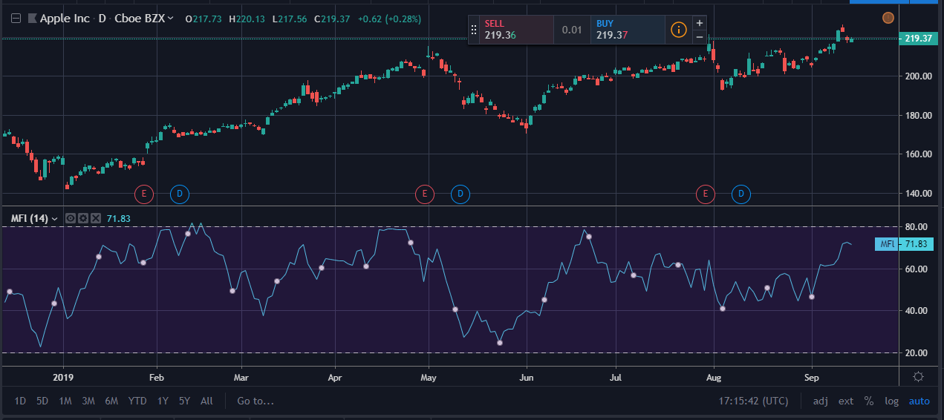

Here this trade ended up nailing the bottom of the ongoing down move. Trade entry is identified by the upward pointing green arrow. The touch of the middle band of the Keltner channels represents the trade’s exit, which is defined by the white arrow. This trade made about a 4.2% profit. **Trade #2** This is a similar setup to the first where we are betting on a reversal in the trend. Price comes down to a point where it triggers an “oversold” reading in the MFI and a touch of the bottom band of the Keltner channel. We enter at that point for about a 3% profit once the trade is exited on a touch of the channel middle band.

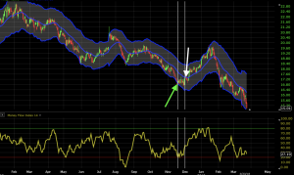

### Trade #3 Here we get probably our best trade setup of the ones listed. It’s a short trade in the context of the broader downtrend.

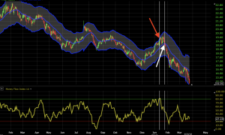

Price came up to the point of being both overbought according to the MFI and touched the top band of the Keltner channel. Once again, the trade was exited upon a touch of the middle band of the channel. This made a little over a 3% profit.

### Trade #4

Here we took a third long trade. However, after a slight initial bounce, we did not get our exit signal (touch of the middle band). It fell a bit before eventually closing out according to this rule at a loss of 2.3%.

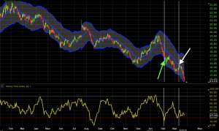

Overall, this system would have produced a net gain when aggregating the results of all four trades.

# Technical indicator: Moving Average (MA)

**What does it measure:** that helps smooth out price action by filtering out the “noise” from random short-term price fluctuations.

**General info:**

A moving average (MA) is a widely used indicator in technical analysis that helps smooth out price action by filtering out the “noise” from random short-term price fluctuations. It is a trend-following, or lagging, indicator because it is based on past prices.

The two basic and commonly used moving averages are the simple moving average (SMA), which is the simple average of a security over a defined number of time periods, and the exponential moving average (EMA), which gives greater weight to more recent prices.

**Parameters:**

1. Length
2. Source
3. Offset

**How to trade this signal:**

* A moving average is a technique often used in technical analysis that smooths price histories by averaging daily prices over some period of time.
* Simple moving averages (SMA) takes the arithmetic mean of a given set of prices over the past number of days, for example over the previous 15, 30, 100, or 200 days.
* Exponential moving averages (EMA) uses a weighted average that gives greater weight to more recent days to make it more responsive to new information.
* When asset prices cross their moving averages, it may generate a trading signal for technical traders.

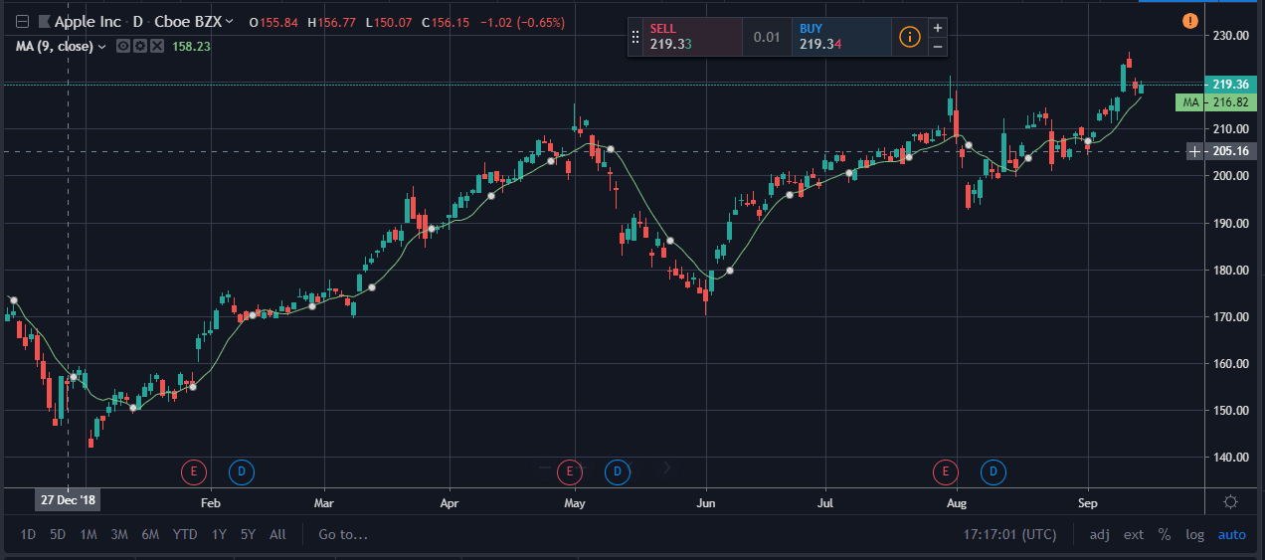

## **How do traders use moving averages?**

## Using MAs can be fundamental for technical analysis strategies, and using a combination of techniques can result in long and short-term forecasts. MAs can be calculated manually and used in any chart analysis simply by following the formula.

As discussed above, MAs can be used to determine levels of support and resistance. IG charts feature MAs, as well as other technical tools like Bollinger bands and relative strength index (RSI), in order to help traders with technical analysis. It can be used by clicking the ‘technical’ tab at the top of the chart.

It’s also important to note that there are two main types of MAs; exponential moving averages (EMA) and simple moving averages (SMA).

## **Exponential moving average**

The EMA is calculated by placing greater weight on the most recent data points. It can sometimes be referred to as the exponentially 'weighted' moving average. This is because EMAs react significantly to the most recent price changes.

The most popular EMAs are 12 and 26-day EMAs for short-term averages, whereas the 50 and 200-day EMAs are used as long-term trend indicators. When used in conjunction with other indicators, EMAs can help traders confirm significant market moves and gauge their legitimacy.

## **Simple moving average (SMA)**

The SMA formula is calculated by taking the average closing price of a security over any period desired. To calculate a moving average formula, the total closing price is divided by the number of periods.

For example, if the last five closing prices are:

28.93+28.48 +28.44+28.91+28.48 = 143.24

The five-day SMA is: 142.24/5= 28.65.

## **SMA vs EMA**

Both the SMA and the EMA are commonly used formulas. The two are very similar, but have a significant point of difference; the sensitivity each one shows to changes in data. The EMA gives a higher significance to recent prices, while the SMA gives significance to all values.

Both are used in technical analysis and can be interpreted in the same manner to even out price variations.

While some might argue it is more common to see the SMA used by technical analysts, others might say that using EMAs can be more significant to analysis because of their nature and the significance they give to recent data. EMAs tend to be timelier and therefore can be favoured by some analysts, also tending to respond to price changes faster than SMAs.

## How to trade using moving averages

Using MAs while trading can help identify trends and become significant in building trading strategies. If price action is above a moving average it can be indicative of long positions, while if the price action is below the moving average, it can be an indication that short positions should be taken.

Traders can also use the moving average crossover method as a trigger into new positions. This method is one that is commonly used in trading strategies.

### Day trading using moving averages

Using MAs for day trading can be extremely beneficial. It can be a clean and simple way to understand when a stock is trending and to analyse the market. Day traders would benefit from using MAs because they need to make quick decisions without having to do complicated calculations - often they’re required to make decisions within short periods of time, making the MA formulas a common go-to for day traders.

MAs can provide a simple yet effective way to know what side of the market you should be trading that day. If it’s trading below the moving average point, then this can be a clear indicator to take the short position. While using MAs can be useful, it is important to note that nothing in financial markets is for certain when using technical indicators, and things can change quickly. While MAs can be helpful and provide great analysis, they’re not a magic formula that can predict which way to trade.

If you think of MAs as a useful tool, used in conjunction with other indicators, they can provide useful information to aid in your day-to-day trading decisions.

**Technical indicator: Exponential Moving Average**

**What does it measure:** An exponentially weighted moving average reacts more significantly to recent price changes than a simple moving average (SMA), which applies an equal weight to all observations in the period.

**General info:**

The **exponential moving average** is the oldest form of technical analysis. It is one of the most popular trading indicators used by thousands of traders. In this step-by-step guide, you’ll learn a simple exponential moving average strategy. Use what you learn to turn your trading around and become a successful, long-term trader! A moving average can be a very effective indicator. Many traders use exponential moving averages, an effective type of **moving average indicator**, to trade in a variety of markets.

**Parameters:**

* Length
* Source
* Offset

### Calculating the EMA

To calculate an EMA, you must first compute the simple moving average (SMA) over a particular time period. The calculation for the SMA is straightforward: it is simply the sum of the stock's closing prices for the number of time periods in question, divided by that same number of periods. So, for example, a 20-day SMA is just the sum of the closing prices for the past 20 trading days, divided by 20.

Next, you must calculate the multiplier for smoothing (weighting) the EMA, which typically follows the formula: [2 ÷ (selected time period + 1)]. So, for a 20-day moving average, the multiplier would be [2/(20+1)]= 0.0952.

Finally, to calculate the current EMA, the following formula is used: [Closing price-EMA (previous day)] x multiplier + EMA (previous day)

The EMA gives a higher weighting to recent prices, while the SMA assigns equal weighting to all values. The weighting given to the most recent price is greater for a shorter-period EMA than for a longer-period EMA. For example, an 18.18% multiplier is applied to the most recent price data for a 10-period EMA, whereas for a 20-period EMA, only a 9.52% multiplier weighting is used. There are also slight variations of the EMA arrived at by using the open, high, low or median price instead of using the closing price.

**How to trade this signal:**

Look out for when two EMA lines cross. It's a trading signal.

In the XRP/USD 15-minute chart below, there are two EMA lines: EMA20 in yellow and EMA40 in red.

The yellow arrow highlights the point where the EMA20 crossed over the EMA40.

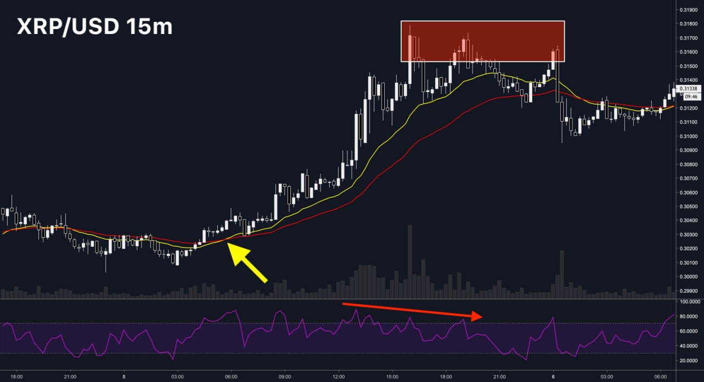

An EMA crossover indicates a change in momentum and trend.

A shorter period EMA crossing over a longer period EMA is a bullish signal, while the opposite is a bearish signal. In this particular example, EMA20 crossing over EMA40 is a bullish signal for XRP. This chart below shows the EMA cross up close.

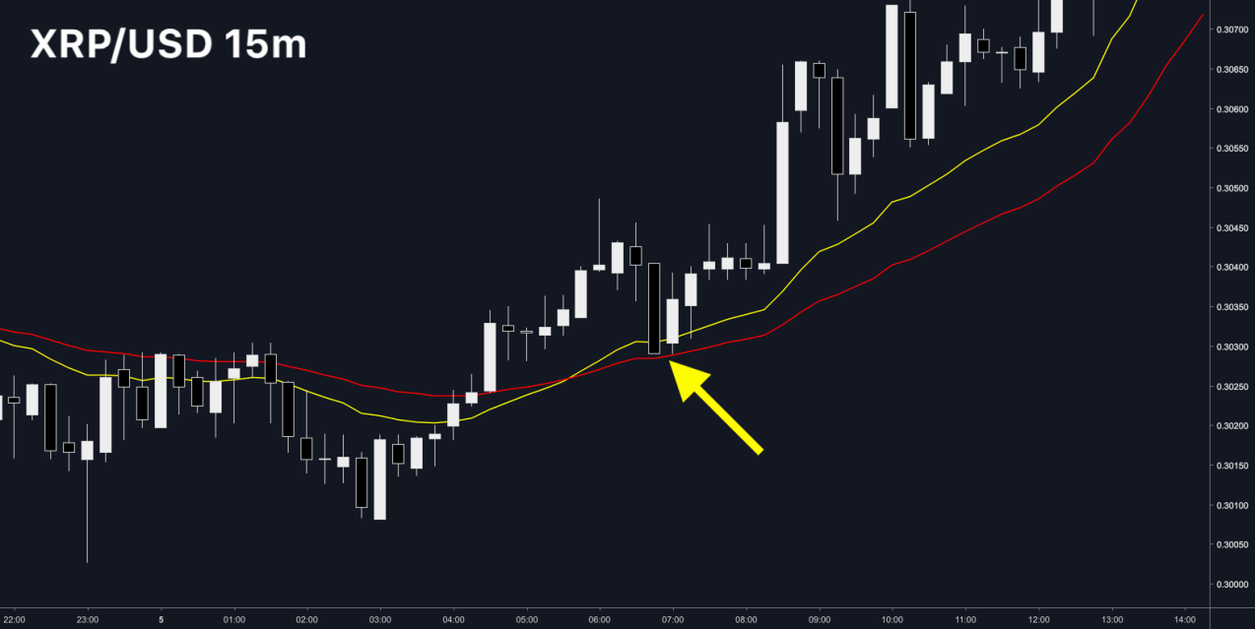

In many cases, the price of an asset will retest the EMA line that is farther away after a successful EMA cross.

In this chart above, you can see XRP testing EMA40 after a successful EMA cross (yellow line over red line).

The area between the two EMAs is typically a good place to enter a position in the direction of the trend.

**Technical indicator: Weighted moving average**

**What does it measure:** Weighted moving averages assign a heavier weighting to more current data points since they are more relevant than data points in the distant past. The sum of the weighting should add up to 1 (or 100 percent).

**General info:**

The weighted moving average (WMA) gives you a weighted average of the last **n** prices, where the weighting decreases with each previous price. This works similarly to the EMA, but you calculate the WMA differently.

**Parameters:**

1. Length
2. Source
3. Offset

**How to trade this signal:**

Moving averages can be used for both analysis and trading signals. For analysis, all the moving averages help highlight the trend. When the price is above its MA it shows that the price is trading higher than it has, on average, over the period being analyzed.

That helps confirm an uptrend. When the price sits below its MA this shows that the price is trading lower than it has, on average, over the period being analyzed, helping to confirm a downtrend.

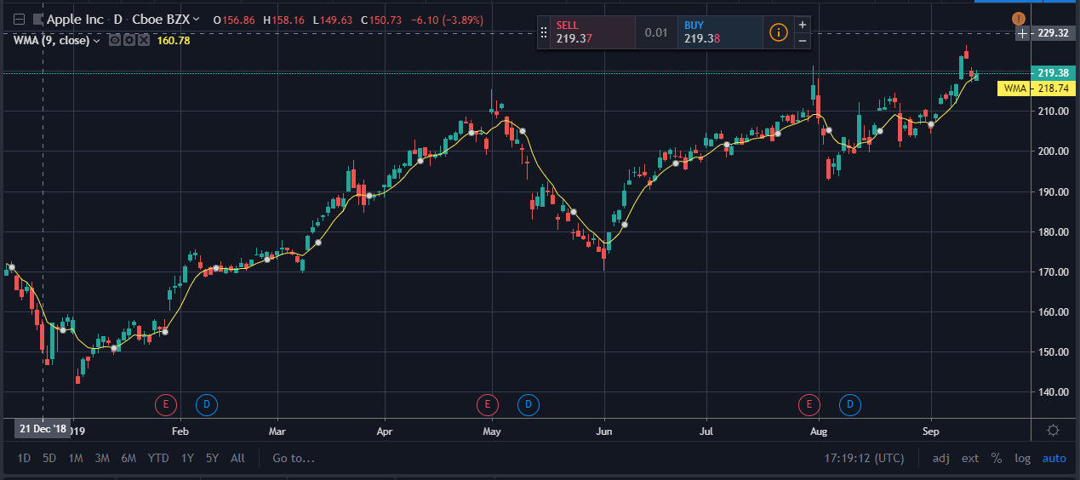

When the price crosses above its MA, this shows the price is getting stronger relative to where it was in the past because the most recent price now sits higher than the average. If the price crosses below its MA it shows the price is getting weaker relative to where it was in the past.

One longer- and one shorter-term MA—for example, 20 and 50 periods—can be added to a chart simultaneously. When the 20-period MA crosses above the 50, it indicates that short-term price momentum is moving to the upside. When the 20-period MA crosses below the 50 it indicates that the short-term price momentum is moving to the downside.

MAs can also be incorporated with other indicators to provide trade signals. An EMA can provide buy signals when combined with Keltner Channels. A strategy may include buying near the EMA when the trend is up and the price is pulling back from the top of the Keltner Channel.

One type of MA isn't better than other; they just calculate the average price differently. Depending on the strategy you’re using, one type of MA may work better than another. Try out different MA combinations and see which provides you with the best results.

You may find that for each market you need to adjust your settings slightly. A 50-period SMA may provide great signals on one stock, but doesn't work well on another. Or a 20-period EMA may help isolate the trend on one futures contract, but not another. All the MAs are just tools, and interpreting them is up to the trader because no indicator works well all the time or in all market conditions.

**Technical indicator: Net Volume**

**What does it measure:** Net volume is a technical indicator calculated by subtracting a security's uptick volume by its downtick volume over a specified period of time.

**General information:**

Net volume is a technical indicator calculated by subtracting a security's uptick volume by its downtick volume over a specified period of time. Unlike standard volume, the indicator differentiates whether the market sentiment is leaning bullish or bearish. Net volume is typically plotted below the price chart with bars for each period indicating the net volume reading for that period.

**Parameters:**

No

**How to trade this signal:**

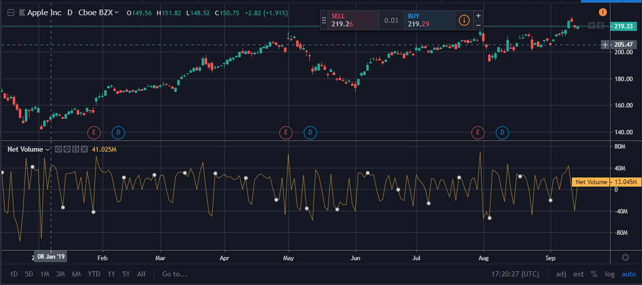

Many traders use net volume in conjunction with other forms of technical analysis, including technical indicators and chart patterns, when looking for potential opportunities. For instance, traders might determine that a stock broke out from a key resistance level and then look at net volume to determine how much buying pressure is behind the move and if there's enough momentum moving forward.

**Technical indicator: On Balance Volume**

**What does it measure:** n-balance volume (OBV) is a technical trading momentum indicator that uses volume flow to predict changes in stock price.

**General information:**

On-balance volume (OBV) is a technical trading momentum indicator that uses volume flow to predict changes in stock price. Joseph Granville first developed the OBV metric in the 1963 book Granville's New Key to Stock Market Profits.

Granville believed that volume was the key force behind markets and designed OBV to project when major moves in the markets would occur based on volume changes. In his book, he described the predictions generated by OBV as "a spring being wound tightly." He believed that when volume increases sharply without a significant change in the stock's price, the price will eventually jump upward or fall downward.

**Parameters:**

No

**How to trade this signal:**

Many traders who use OBV will be less interested in its value but rather its rate of change to help generate trade ideas. If the OBV is moving notably in one direction, it could give credence to the idea that a big move could be coming in that direction in price.

For example, in the chart below (daily chart of the S&P 500), OBV moves down faster than the correspondent move in price. This could tell a trader that a bigger move down in price could be forthcoming. The areas are marked below.

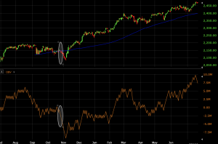

For traders who want to stay with the trend, one could use the OBV in conjunction with a trend following system. For matters of simplicity, I’ve added just a 50-period simple moving average to the price chart. This will provide a basic trend indicator. If the moving average is sloped upward, price will be considered in an uptrend and those trading with the trend will be biased toward long trades. Likewise, if the moving average is sloped downward, price will be considered in a downtrend and may bias one’s trades in favor of short selling.

In the example below, we see a market in an uptrend as identified by the 50-period simple moving average. On the OBV chart below, we see a notable move up, beyond the rate at which price is rising.

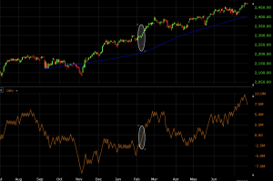

**Technical indicator: Parabolic SAR**

**What does it measure:** The parabolic SAR, or parabolic stop and reverse, is a popular indicator that is mainly used by traders to determine the future short-term momentum of a given asset.

**General information:**

The parabolic SAR, or parabolic stop and reverse, is a popular indicator that is mainly used by traders to determine the future short-term momentum of a given asset. The indicator was developed by the famous technician J. Welles Wilder Jr. and can easily be applied to a trading strategy, enabling a trader to determine where stop orders should be placed. (The calculation of this indicator is rather complex and goes beyond the scope of how it is practically used in trading.)

**Parameters:**

1. Start
2. Increment
3. Max Value

**How to trade this signal:**

The basic use of the Parabolic SAR is to buy when the dots move below the price bars (signaling an uptrend) and sell/short-sell when the dots move above the price bars (signaling a downtrend).

This will result in constant trade signals, though, as the trader will always have a position. That can be good if the price is making big swings back and forth—producing a profit on each trade—but when the price is only making small moves in each direction, these constant trade signals can produce many losing trades in a row.

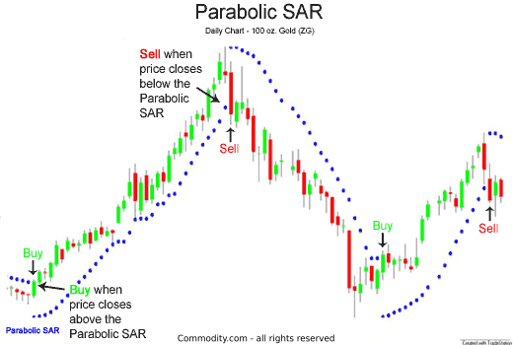

**Technical indicator: Price Oscillator**

**What does it measure:** The Price Oscillator uses two moving averages, one shorter-period and one longer-period, and then calculates the difference between the two moving averages.

**General information:**

The Price Oscillator indicator (PPO) is a technical analysis tool, used for measuring momentum that is very similar to the MACD. The MACD employs two Moving Averages of varying lengths (which are lagging indicators) to identify trend direction and duration. Then, MACD takes the difference in values between those two Moving Averages (MACD Line) and an EMA of those Moving Averages (Signal Line) and plots that difference between the two lines as a histogram which oscillates above and below a center Zero Line.  
PPO is exactly the same, however it then takes the same values as the MACD and calculates them as a percentage. The purpose of this, is that it makes value comparisons much simpler and more straightforward over longer durations of time.

**Parameters:**

1. Short length
2. Long Length
3. Source

**How to trade this signal:**

* The PO is used for measuring the distance between peaks and troughs in the price/indicator.
* If troughs have historically been about two months apart, that may help a trader make future decisions as they can locate the most recent trough and determine that the next one may occur in about two months.
* Traders can use the estimated future peaks as selling opportunities or the estimated future troughs as buying opportunities.
* The indicator is typically set to look back over 20 to 30 periods.

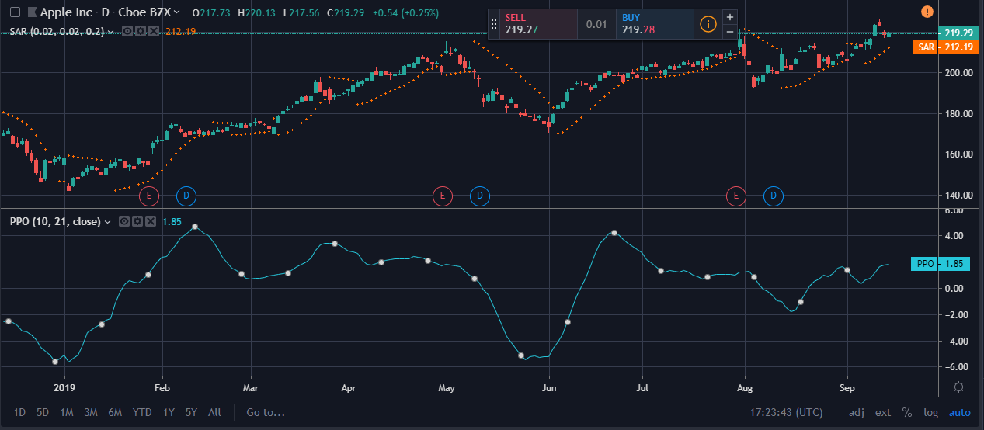

**Technical indicator: Volume Price Trend Indicator**

**What does it measure:** The volume price trend indicator is used to determine the balance between a security’s demand and supply. The percentage change in the share price trend shows the relative supply or demand of a particular security, while volume indicates the force behind the trend.

**General info:**

The volume price trend (VPT) indicator helps determine a security’s price direction and strength of price change. The indicator consists of a cumulative volume line that adds or subtracts a multiple of the percentage change in a share price’s trend and current volume, depending upon the security’s upward or downward movements.

**Parameters:**

No

**How to trade this signal:**

Signal Line Crossovers: A signal line, which is just a moving average of the indicator, can be applied and used to generate trading signals. For example, a trader may buy a stock when the VPT line crosses above its signal line and sell when the VPT line passes below its signal line.

Confirmations: The VPT indicator can be used in conjunction with moving averages and the average directional index (ADX) to confirm trending markets. For instance, a trader could buy a stock if the 20-day moving average is above the 50-day moving average and accompanied by rising VPT indicator values. Conversely, the trader may decide to sell if the 20-day moving average is below the 50-day moving average and the indicator’s values are falling.

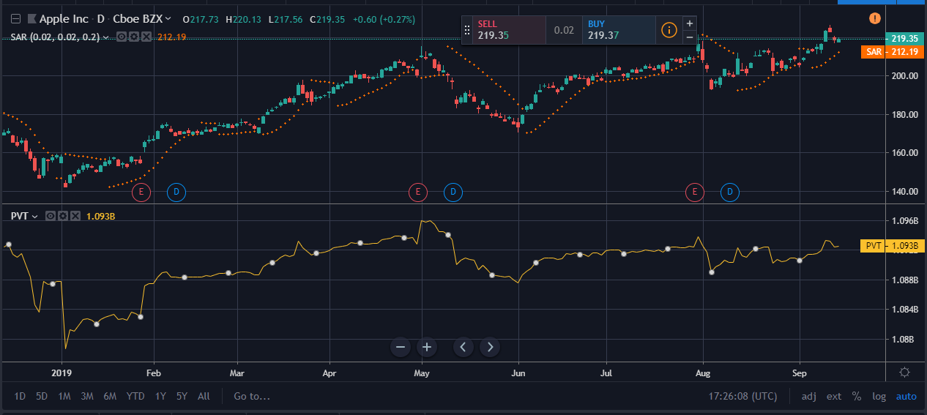

The ADX also measures trend and momentum and can be used with the VPT indicator to confirm that a market is trending. ADX readings above 25 indicate that a security is trending, while readings below 25 indicate sideways price action. Therefore, a trader could buy when the ADX is above 25 and the VPT line is above its signal line. They could sell when the ADX has a value below 25 and the VPT line is below its signal line.

Divergence: Traders can use the VPT indicator to spot technical divergence. Divergence occurs when the indicator makes a higher high or a lower low, but the security’s price makes a lower high or a higher low. Traders should place a stop-loss order above the most recent swing high or below the most recent swing low to minimize risk.

**Technical indicator: relative strength index**

**What does it measure:** The relative strength index (RSI) is a momentum indicator that measures the magnitude of recent price changes to evaluate overbought or oversold conditions in the price of a stock or other asset.

**General info:**

The RSI is displayed as an oscillator (a line graph that moves between two extremes) and can have a reading from 0 to 100. The indicator was originally developed by J. Welles Wilder Jr. and introduced in his seminal 1978 book, New Concepts in Technical Trading Systems.

Traditional interpretation and usage of the RSI are that values of 70 or above indicate that a security is becoming overbought or overvalued and may be primed for a trend reversal or corrective pullback in price. An RSI reading of 30 or below indicates an oversold or undervalued condition.

**Parameters:**

1. Length
2. Source

**How to trade this signal:**

Relative strength is not a strategy in and of itself. It is a tool to help you find good trade candidates for your already tested and established trading strategy. Focus on buying relatively strong stocks with your strategy, and selling/shorting relatively weak stocks with your strategy.

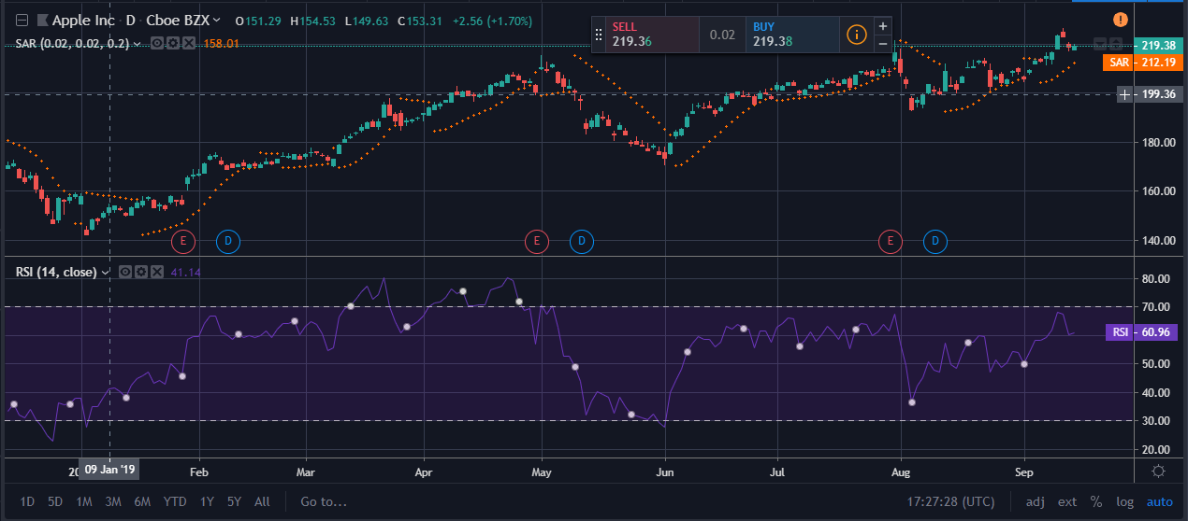

What is strong or weak now, may not be an hour from now. Monitoring relative strength is a constant task, but can be lucrative since the trader who masters it will always be trading in stocks and sectors which are moving the most, seeing the biggest gains (for longs) and losses (for shorts). .

**Technical indicator: Relative Vigor Index**

**What does it measure:** The strength of a trend by comparing a security's closing price to its trading range and smoothing the results.

**General info:**

The Relative Vigor Index (RVI) is a technical analysis indicator that measures the strength of a trend by comparing a security's closing price to its trading range and smoothing the results. It's based on the tendency for prices to close higher than they open in uptrends and to close lower than they open in downtrends.

**Parameters:**

1. Length
2. offset

**How to trade this signal:**

The relative vigor index formula is as follows: RVI = (Close – Open) / (High – Low) for each period.

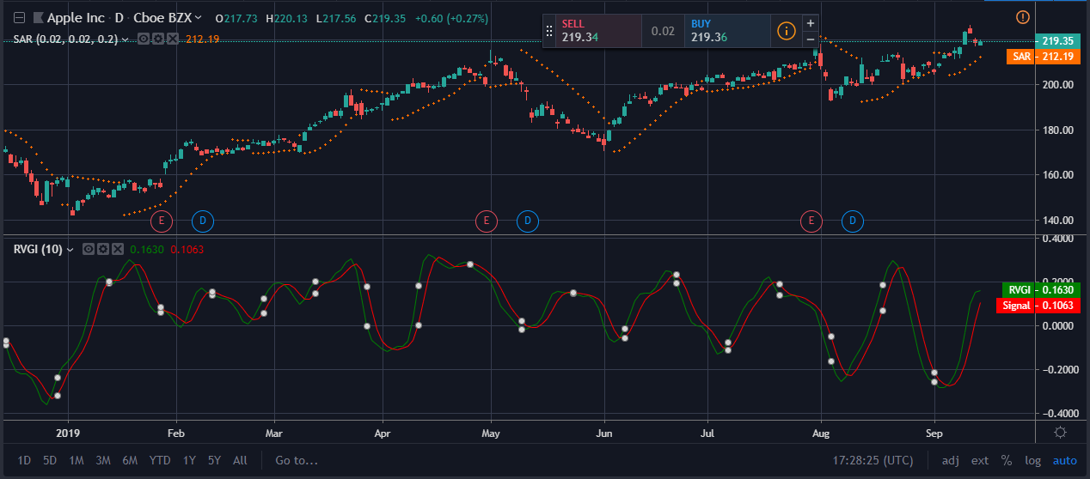

Green Lines and Red Lines

You are probably thinking, “But wait! How do I calculate these two lines?”

* Green Line

The green line is a standard simple moving average of the Relative Vigor Index calculation. Although you can adjust the green line, the default value is 10-periods.

* Red line

The red line is a 4-period volume weighted moving average.  The red line is the "trigger line" because it provides trade signals when it crosses above or below the green line.

Types of RVI Trade Signals

* Overbought/Oversold market

A low value indicates an oversold market and a high value signals an overbought one.

* Crossovers

Entry and exit signals are triggered when the short moving average crosses the long moving average.

* Divergence

Divergences between price action and RVI often lead countertrend moves.

* Chart Patterns

The RVI can plot formations such as double bottoms, double tops, head, and shoulders, etc.

The picture below illustrates a double bottom formation of the RVI indicator:

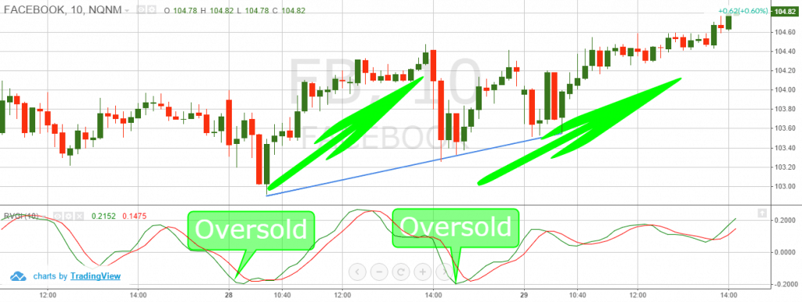

This is a 10-minute chart of Facebook, where the relative vigor index develops into a clear double bottom signal. After creating the "W" bottom, Facebook's price took off!

**Technical indicator: Relative Volatility Index**

**What does it measure:** The RVI is calculated in the same way as the RSI but using standard deviation of high and low prices rather than the absolute change in price.

**General info:**

The relative volatility index (RVI) is a volatility indicator that was developed by Donald Dorsey to indicate the direction of volatility. It is like the Relative Strength Index (RSI), except that it measures the standard deviation of prices changes over a period rather than the absolute price changes. The RVI is plotted in a range from 0 to 100 and is often used as a confirmation for other indicators, and is often used in conjunction with moving average (MA) crossover signals.

**Parameters:**

1. Length
2. Offset

**How to trade this signal:**

In this RVI system, we are going to watch for potential Fibonacci retracement levels and trade bounces/breakouts that are confirmed by the RVI.

We will place our stop loss order at the next Fibonacci level, in order to limit or losses.

Lastly, we will use simple price action techniques to take profits (chart patterns, candle patterns, support and resistance, trends, etc.). We can also exit the trade based on a contrary signal from the RVI indicator or from the Fibonacci levels.

The image below will show you how this trading strategy works:

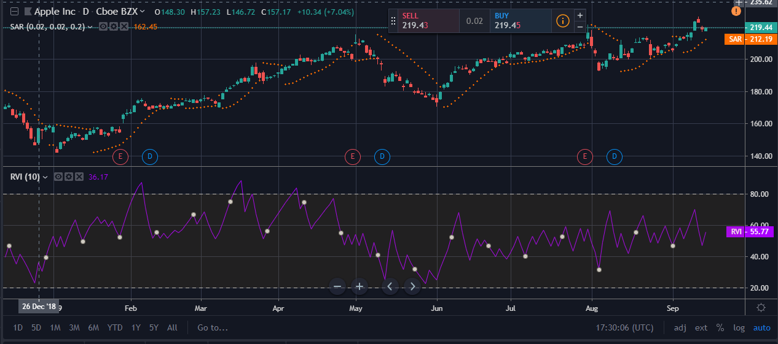

This is the 2-minute chart of McDonald’s from Aug 26, 2015. In the bottom of the image, you will see the relative volatility index indicator, which we use to confirm Fibonacci signals.

We have identified a trend and the corresponding 61.8% retracement of this price action. Then, we notice the price beginning to bounce in a bullish direction.

At this time, the RVI indicator is still below the 50 level, but it quickly starts moving upwards. Seven periods after the bounce from the 61.8% retracement level, the RVI climbs above 50. This is our confirmation signal and we buy McDonald’s at $92.62. A stop loss order is then placed between the 61.8% and the 76.4% Fibonacci levels in the event McDonald’s loses steam.

**Technical indicator: SMI Ergodic Indicator Oscillator**

**What does it measure:** SMI Ergodic is calculated the same as the True Strength Index. It also includes a signal line (in cyan below) that is an exponential moving average of the SMI Ergodic plot.

**General info:**

The SMI Ergodic Indicator is the same as the True Strength Index (TSI) developed by William Blau, except the SMI includes a signal line. The SMI uses double moving averages of price minus previous price over 2-time frames. The signal line, which is an EMA of the SMI, is plotted to help trigger trading signals. Adjustable guides are also given to fine tune these signals. The user may change the input (close), method (EMA), period lengths and guide values. This indicator’s definition is further expressed in the condensed code given in the calculation below.

**Parameters:**

1. Long Period
2. Short Period
3. Signal Line Period

**How to trade this signal:**

Adjust the top and bottom guides to control the quantity and quality of the trading signals. In addition to the guides, if the SMI crosses the signal line a change in trend is predicted. If the SMI is above the top guide and crosses below the signal line a sell signal will be generated. Conversely, if the SMI is below the bottom guide and crosses above the signal line a buy signal will be given. The 0 line divides the bulls (above) from the bears (below).

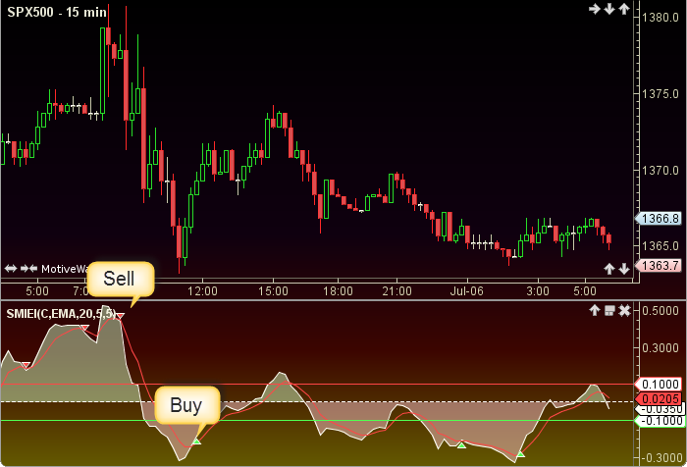

**Technical indicator: Smoothed Moving Average**

**What does it measure:** An exponentially smoothed moving average is computed over all the data accumulated so far instead of being chopped off after some number of days.

**General info:**

Moving averages are amongst the most widely used tools by participants in the currency markets. The strength of a moving average is its ability to filter out price noise reducing what can be extremely volatile price series into more discernible trends, thereby allowing traders to ascertain the strength and direction of the trend. Moving averages smooth past price data to form trend following indicators and are a component in many other technical indicators including the MACD, the DeMarker and the Directional Movement System amongst many others.

The SMMA gives recent prices an equal weighting to historic prices. The calculation takes all available data series into account rather than referring to a fixed period. This is achieved by subtracting the prior periods SMMA from the current periods price. Adding this result to yesterday’s Smoothed Moving Average gives today’s Moving Average.

**Parameters:**

1. Length
2. Source

**How to trade this signal:**

The Smoothed Moving Average is a lagging trend indicator and may be used in conjuction with other studies. No trading signals are calculated.

The Smoothed Moving Average displays data for a given period of time (N). The formula for calculating this average is as follows: SMMA(i) = (SUM(i-1) – SMMA(i-1) INPUT(i))/N where the first period is a simple moving average.

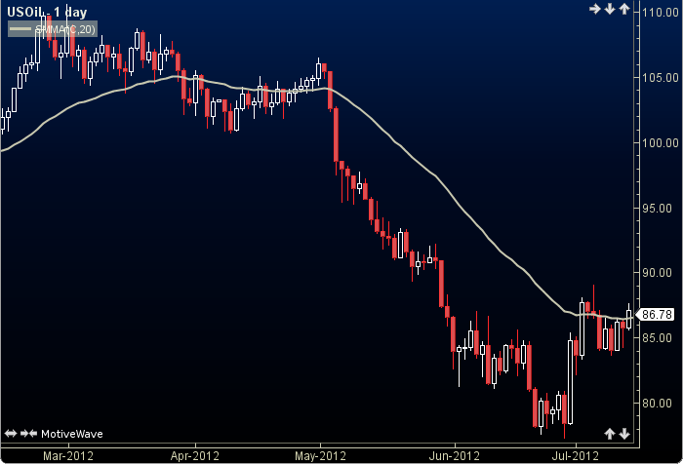

**Technical indicator: Stochastic**

**What does it measure:** The relationship between an issue's closing price and its price range over a predetermined period of time.

**General info:**

In the late 1950s, George Lane developed stochastics, an indicator that measures the relationship between an issue's closing price and its price range over a predetermined period.

Fourteen is the mathematical number used in the time mode. Depending on the technician's goal, it can represent days, weeks, or months. The chartist may want to examine an entire sector. For a long-term view of a sector, the chartist would start by looking at 14 months of the entire industry's trading range.

**Parameters:**

1. K
2. D
3. Smooth

**How to trade this signal:**

The K line is faster than the D line—the slower of the two. The investor needs to watch as the D line and the price of the issue begin to change and move into either the overbought (over the 80 line) or the oversold (under the 20 line) positions. The investor needs to consider selling the stock when the indicator moves above the 80 level. Conversely, the investor needs to consider buying an issue that is below the 20 line and is starting to move up with increased volume.

Over the years, many articles have explored "tweaking" this indicator. But new investors should concentrate on the basics of stochastics.

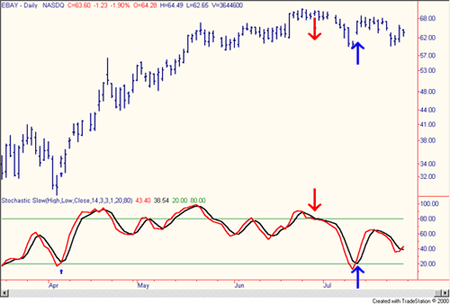

In the chart of eBay above, a number of clear buying opportunities presented themselves over the spring and summer months of 2001. There are also a number of sell indicators that would have drawn the attention of short-term traders. The strong buy signal in early April would have given both investors and traders a great 12-day run, ranging from the mid $30 area to the mid $50 area.

**Technical indicator: Stochastic RSI**

**What does it measure:** RSI relative to its own high/low range over a user defined period of time

**General info:**

The Stochastic RSI indicator (Stoch RSI) is essentially an indicator of an indicator. It is used in technical analysis to provide a stochastic calculation to the RSI indicator. This means that it is a measure of RSI relative to its own high/low range over a user defined period of time. The Stochastic RSI is an oscillator that calculates a value between 0 and 1 which is then plotted as a line. This indicator is primarily used for identifying overbought and oversold conditions.

**Parameters:**

K

The time period to be used in calculating the %K. 3 is the default.

D

% D = Percent of Deviation between price and the average of previous prices (Momentum). The time period to be used in calculating the %D. 3 is the default.

You can read more about K & D calculation here: Stochastic_(STOCH)

RSI Length

The time period to be used in calculating the RSI

Stochastic Length

The time period to be used in calculating the Stochastic

RSI Source

Determines what data from each bar will be used in calculations. Close is the default.

**How to trade this signal:**

We know that “divergence between price and an oscillator or other market indicator can often signal an imminent trend reversal in the near future.”

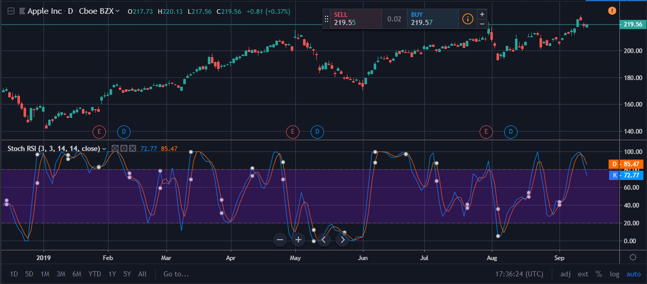

This principle applies to divergence between price action and Stoch RSi as well.

In the 1-hour BTC/USD chart below, the price of BTC makes a higher high while the Stoch RSI indicator prints a lower high.

Following the divergence, BTC retraces 7% to the downside to seek equilibrium.

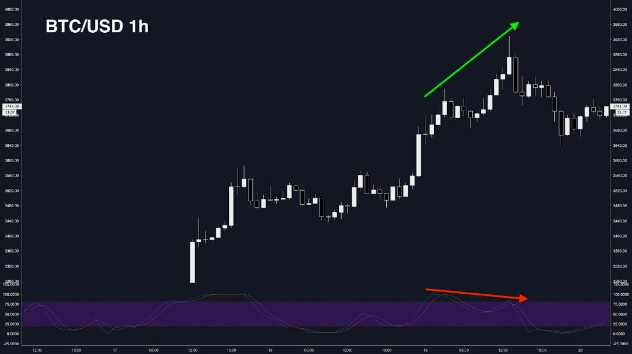

In the 4-hour chart XRP/USD chart below, a bullish divergence between price action and Stoch RSI can be observed.

Notice how price makes a lower low, while Stock RSI makes a higher low.

What follows is an explosive 40% move to the upside for XRP.

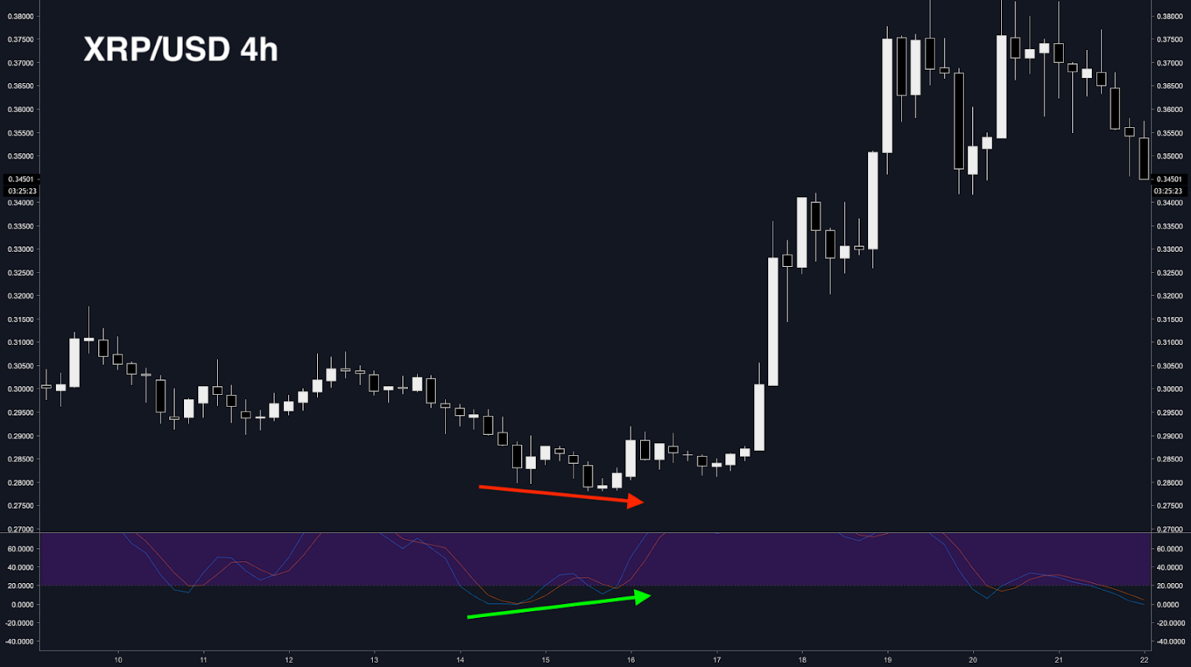

Stoch RSI can be a useful tool when used in conjunction with trendlines, candlestick patterns and other trading indicators.

Using Stoch RSI by itself is not recommended because it’s a second-order indicator that is two steps away from real-time market price action.

On this ETH/USD 1D chart, a huge bullish divergence can be observed.

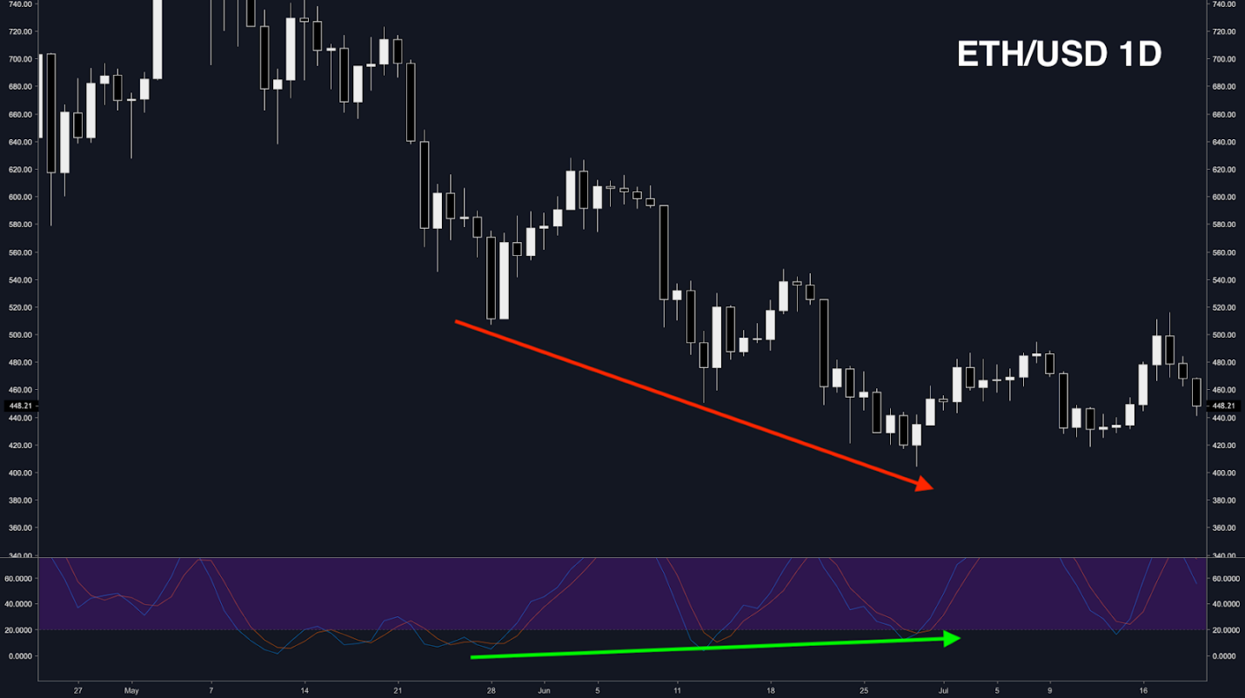

Remember, RSI, and thus the Stoch RSI, can show oversold or overbought readings for an extended period of time.

Don’t blindly enter trades on the first or even second sign of divergence. It’s almost always better to wait for a cross back up or down to normal RSI ranges and confluence from other trading indicators like MACD, OBV, candlestick patterns, and more.

**Technical indicator: TRIX**

**What does it measure:** TRIX is a versatile technical analysis tool that combines trend and momentum into one indicator

**General info:**

The TRIX indicator is a versatile technical analysis tool that combines trend and momentum into one indicator. It is comprised of the rate of change of a triple exponentially smoothed moving average. The key signals generated by TRIX are divergences and signal line crossovers.

**Parameters:**

**Length**

**How to trade this signal:**

The simplest signal triggers when +VI and -VI cross. The example below shows the Nasdaq 100 ETF (QQQ) using weekly bars and a 26-period VTX, which amounts to around six months. There were over a dozen crossovers in a six-and-a-half-year period. The yellow areas show bullish crossovers that lasted more than six months. This is what happens in a strong uptrend. There was also a significant bearish crossover in the second half of 2008. Even though there were plenty of good signals, there were also whipsaws. This is simply the nature of of indicators. The blue circles show periods of indecision when both trend indicators hovered around 1 and the S&P 500 consolidated.

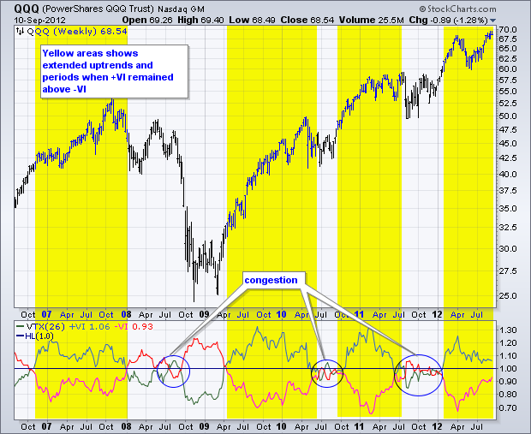

The second example shows Baxter (BAX) using daily charts and the 23-period VTX, which covers around one month. Not every crossover results in a clear trend signal. Notice how VTX traded in a narrow range around 1 from October to early November (yellow area). This marked a consolidation as prices formed a triangle. There were some whipsaws at the beginning of 2012 (blue circle) and then a few good signals later in the year. It sometimes helps to qualify a signal by waiting for confirmation with a move above 1. A bullish crossover is further validated when +VM moves above 1 and a bearish crossover is validated when -VM moves above 1.

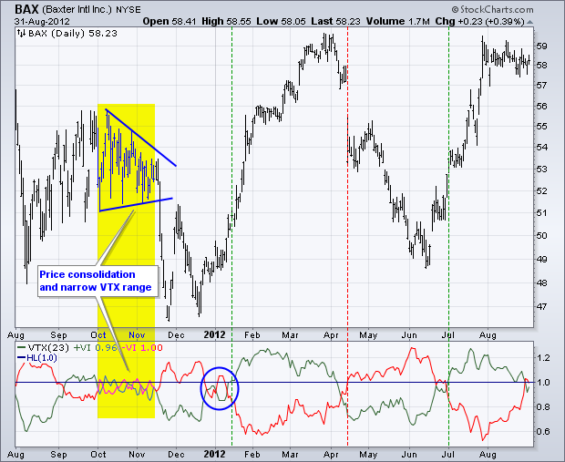

**VM Thresholds**

Traders can reduce whipsaws by setting signal thresholds just above and below 1. A bullish signal can be divided into two parts. First, downward trend movement weakens. Second, upward trend movement strengthens. -VI often weakens and moves below .90 before an uptrend starts. After this weakening in downward trend movement, upward movement strengthens as +VI moves above 1.10 to complete the bullish signal. This bullish signal remains in play until countered by a bearish signal. The reverse logic can be applied to generate bearish signals. First, upward trend movement weakens with a move below .90. Second, downward trend movement strengthens with a move above 1.10.

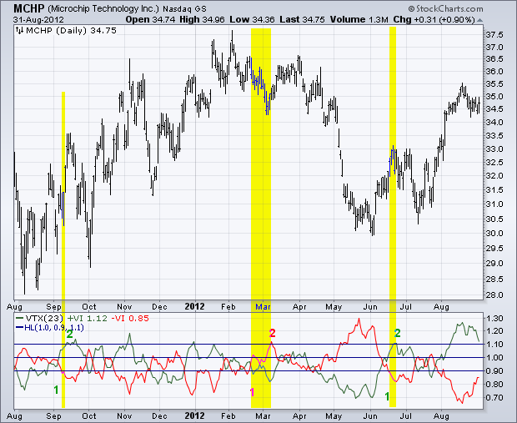

The chart above shows Microchip Technology using a daily chart and 23-period VTX. Despite numerous crosses of the two oscillators, there were only three “threshold” signals over a twelve-month period. First, -VM moved below .90 in early September and +VI crossed above 1.1 a few days later. Even though +VM moved below .90 several times, this bullish signal was not completely reversed because -VI never confirmed with a move above 1.10. The second signal occurred when +VI moved below .90 in late February and -VI crossed above 1.1 in early March. The third signal occurred when -VI dipped below .90 in mid-June and +VI crossed above 1.1 a few days later.

Decreasing the look-back period will increase sensitivity and result in more threshold crosses. The chart below shows Cummins (CMI) using daily bars and a 14-period VTX. This indicator is much more sensitive (volatile) than the 23-period version. The yellow highlights mark the bullish signals and the orange highlights mark the bearish signals.

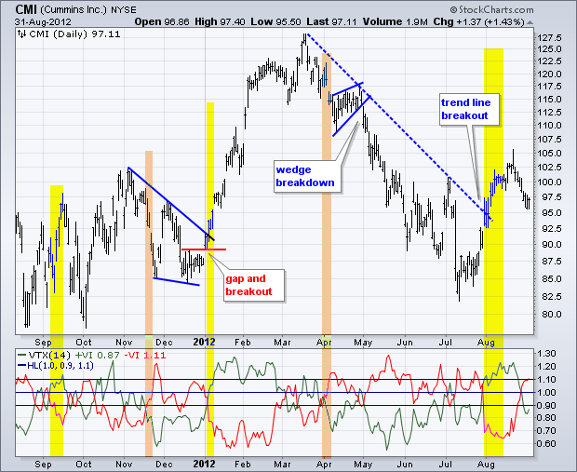

Keep in mind that VTX is not designed as a standalone indicator. Chartists should use other aspects of technical analysis to confirm VTX, improve the reward-to-risk ratio for a trade setup, or derive buy-sell signals. The bullish VTX signal in early January was confirmed by a wedge breakout. After the bearish VTX signal in April, CMI formed a rising wedge and broke wedge support with a sharp decline in early May. VTX provided the alert and the price chart provided the signals.

**Technical indicator: Triple EMA**

**What does it measure:** The TEMA reacts to price changes quicker than a traditional MA or EMA will.

**General info:**

The triple exponential moving average was designed to smooth price fluctuations, thereby making it easier to identify trends without the lag associated with traditional moving averages (MA). It does this by taking multiple exponential moving averages (EMA) of the original EMA and subtracting out some of the lag.

The TEMA is used like other MAs. It can help identify trend direction, signal potential short-term trend changes or pullbacks, and provide support or resistance.

**Parameters:**

Length

**How to trade this signal:**

Long or short signals are generated when 10 and 100 EMA’s interact. However, this is not a signal to immediately enter the trade. A perfect 10/100 crossover buy signal occurs when all three EMA’s are previously bearish (or bullish in case of a sell). Then, the 10 EMA makes a bullish crossover on the 100 EMA (but the 50 EMA is still below 100).

Look to the chart below which illustrates a false sell signal and a perfect buy signal.

[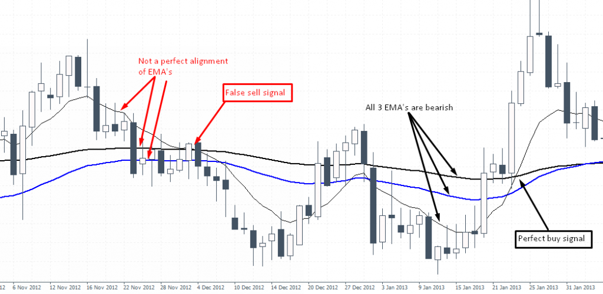](https://www.orbex.com/blog/wp-content/uploads/2016/10/2-10_100_Crossover.png)10/100 Crossover: Difference between correct and false signals

Now that you have identified a perfect (buy) signal, the next step is to plot the highs and lows of the candle which triggered the 10/100 crossover. Then, wait for the 50/100 (bullish) crossover and wait for price to breakout or close above the range high that you have selected.

Go for a 1:1, 1:2 and 1:3 RR set ups and move your stop losses accordingly.

[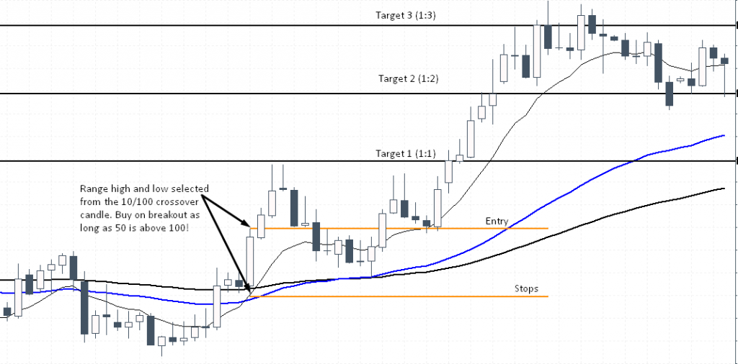](https://www.orbex.com/blog/wp-content/uploads/2016/10/3-buy-Signal.png)

There is a bit of flexibility that you can allow for yourself. The next example shows a sell signal where we go short before the 50/100 crossover. The reasoning behind this sell set up is due to the nature of the slope of the 50 and 100 EMA. If you had to wait for the 50/100 crossover you would have missed an entry (although there would have been other ways to trade).

[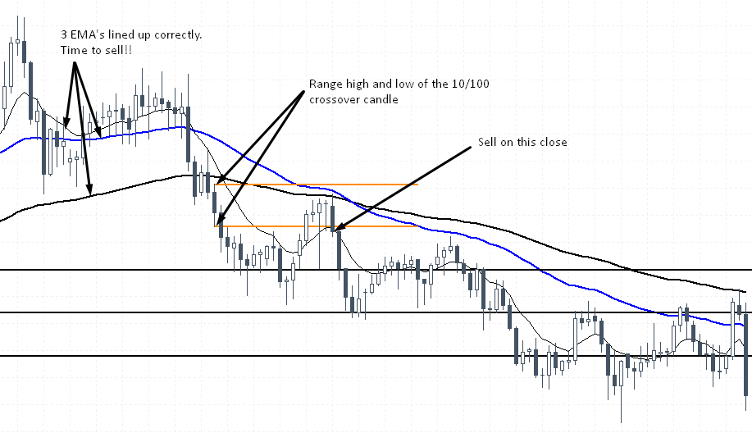](https://www.orbex.com/blog/wp-content/uploads/2016/10/4-sell-Signal.png)

In the above example, we go short on the breakout from the candles’ range low. At the time of entry there was to 50/100 crossover, but the slope of the EMA’s suggested that there would be bearish crossover. In this example however, the trade would have reached T1, T2 but T3 would have been stopped out near T1. Still, the set up offered a very good RR.

**Technical indicator: True Strength Indicator**

**What does it measure:** The indicator may be useful for determining overbought and oversold conditions, indicating potential trend direction changes via centerline or signal line crossovers, and warning of trend weakness through divergence.

**General info:**

The true strength index (TSI) is a technical indicator used in the analysis of financial markets that attempts to show both trend direction and overbought/oversold conditions. It was first published William Blau in 1991. The indicator uses moving averages of the underlying momentum of a financial instrument. Momentum is considered a leading indicator of price movements, and a moving average characteristically lags behind price. The TSI combines these characteristics to create an indication of price and direction more in sync with market turns than either momentum or moving average. The TSI is provided as part of the standard collection of indicators offered by various trading platforms

**Parameters:**

1. Long Length
2. Short Length
3. Signal Length

**How to trade this signal:**

TSI also plots a histogram which shows the difference between the TSI Line and the Signal line. This histogram crosses above or below the centerlines, histogram levels above the centerline shows a bullish crossover signal, while centerline levels below the centerline shows a bearish crossover signal

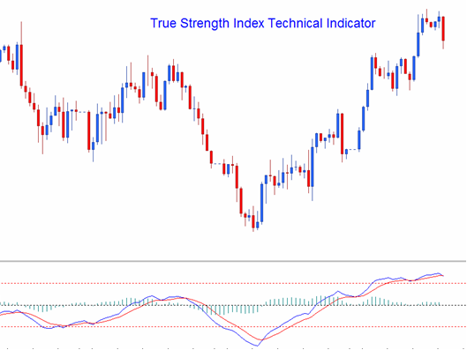

**Technical Analysis of True Strength Index (TSI) Technical Indicator**

The TSI uses various methods to generate Forex trading signals. The TSI indicator can be used in the same way as the RSI indicator to determine general trend direction of the Forex markets. Overbought and oversold levels can also be shown using this technical indicator. The most common methods of generating trading signals are:

  Zero line Crossover (Histogram crossover not Lines crossover)

* Buy Signal- when the TSI histogram crosses above 0 a buy signal is generated
* Sell Signal- when the TSI histogram crosses below 0 a sell signal is generated

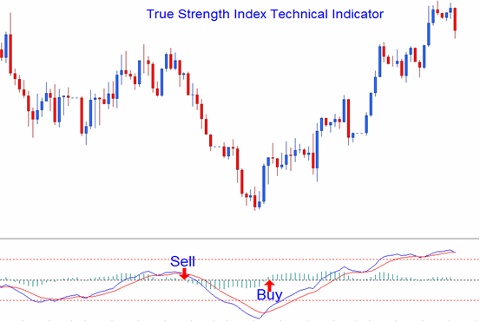

TSI Signal line Crossover

* A buy signal is generated when the TSI line crosses above the Signal line
* A sell signal is generated when the TSI line crosses below the Signal line

This signal is the same as the one above and the timing corresponds to the time when the histogram crossovers happen.

**Divergence Trading**

Divergence trading is used to look for potential trend reversal point of a currency pair. The reversal divergence trading setups are:

Classic Divergence/Regular Divergence

Classic Bullish Divergence: Lower lows in price and higher lows on the TSI indicator

Classic Bearish Divergence: Higher highs in price and lower highs on the TSI indicator

Divergence trading can also be used in identifying potential trend continuation points in price action direction. The continuation divergence trading setups are:

Hidden Divergence

Hidden Bullish Divergence: higher lows in price and lower lows in TSI indicator

Hidden Bearish Divergence: lower highs in price and higher highs in TSI indicator

**Divergence Trading Setups**

Overbought/Oversold Levels

The TSI indicator can be used to identify overbought and oversold conditions in price action movements.

* Overbought condition - TSI levels being greater than the +25 level
* Oversold condition- TSI levels being less than the -25 level

Trades can be generated when the TSI crosses these levels.

Buy signal- when the TSI indicator crosses above -25 level a buy signal is given.

Sell signal- when the TSI indicator crosses below +25 level a sell signal is given.

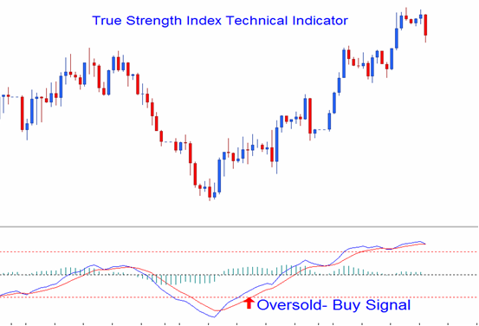

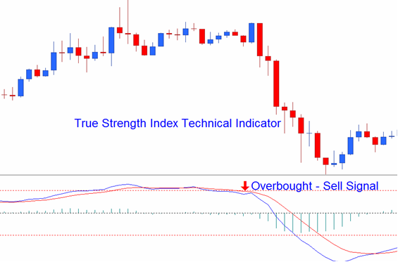

**Technical indicator: Ultimate Oscillator**

**What does it measure:** The price momentum of an asset across multiple timeframes.

**General info:**

The Ultimate Oscillator is a technical indicator that was developed by Larry Williams in 1976 to measure the price momentum of an asset across multiple timeframes. By using the weighted average of three different timeframes the indicator has less volatility and fewer trade signals compared to other oscillators that rely on a single timeframe. Buy and sell signals are generated following divergences. The Ultimately Oscillator generates fewer divergence signals than other oscillators due to its multi-timeframe construction.

**Parameters:**

1. Length1
2. Length2
3. Length3

**How to trade this signal:**

The indicator oscillates between 0 and 100. When the indicator is said to have a high reading over 70 and a low reading below 30.

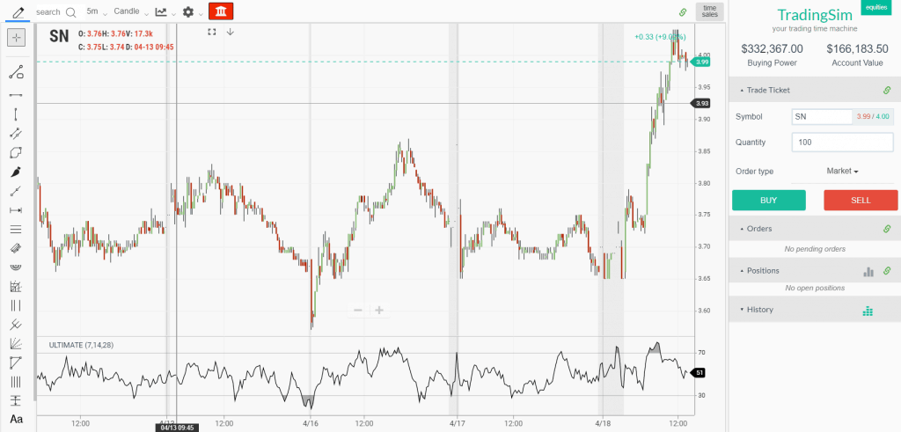

Above is a 5-minute chart and you can see the clear overbought and oversold readings on the chart. Seems simple enough right?

A stock could give a sell signal as the indicator goes well above 70, but this does not mean the stock is going to roll over immediately. A stock can remain in an overbought state for an extended period of time.

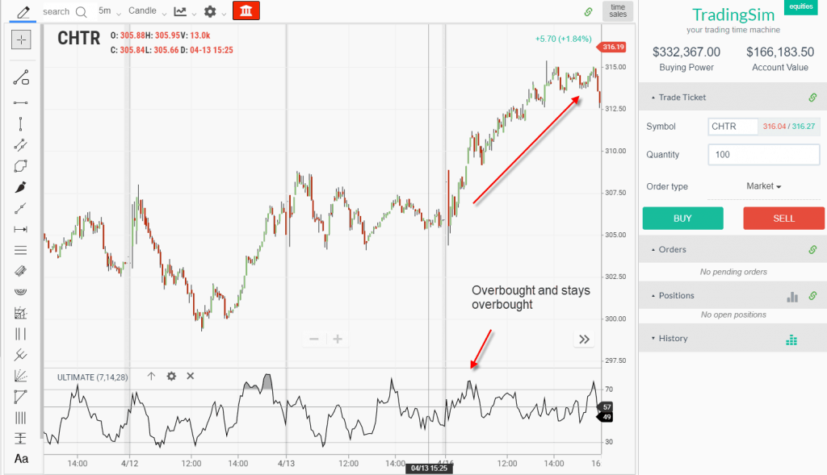

This is where oscillators can really get you in trouble. An overbought stock can stay just that - overbought. Now in defense of the ultimate oscillator, you are going to face this reality regardless of your oscillator of choice. It's just the nature of the beast.

The reason is that a stock can oscillate from overbought to the midline around 50 indefinitely. This is great if you are long and riding the trend higher.

However, if you are short, it can lead to the death of a thousand cuts as the stock drags higher, slowly draining your account value.

**Technical indicator: VWMA**

**What does it measure:** The indicator can be used to identify and trade trends.

**General info:**

The Volume-weighted Moving Average (VWMA) emphasizes volume by weighing prices based on the amount of trading activity in a given period of time. Users can set the length, the source and an offset. Prices with heavy trading activity get more weight than prices with light trading activity. In periods of low market volume, the SMA and the VWMA are close in value. The indicator can be used to identify and trade trends. Price crossing it could point to a directional change. The VWMA is often used in combination with other signals and analysis techniques.

**Parameters:**

A Simple Moving Average (SMA) is an average of the past N closing prices. It give the same weight to every closing price.

3-Day SMA = (C1 + C2 + C3) / 3

A Volume-Weighted Moving Average (VWMA) is the same, except that it gives different weight to each closing price. The closing price of a day with high volume will have a greater weight.

3-Day VWMA = (C1*V1 + C2*V2 + C3*V3) / (V1+ V2+ V3)

**How to trade this signal:**

To fully make use of the VWMA, compare it with a SMA that does not include volume.

The SMA is a benchmark. This means that you should choose the same look-back period for both the SMA and the VWMA. The only difference between the two moving averages is volume weighting.

What matters here is the gap between the VWMA and the SMA. Their difference shows the effect of volume weighting.

Generally, volume should increase along with the trend and decrease against it. Hence, generally, if the VWMA is above the SMA, it means that volume has been higher on up days. When the VWMA is below the SMA, it shows that down days had higher volume.

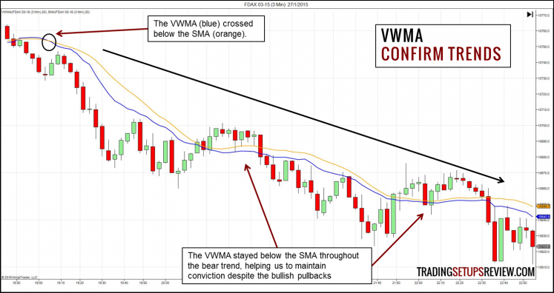

The chart above shows the FDAX futures contract in a 3-minute chart. The blue VWMA stayed below the orange SMA and confirmed the bearish trend. This assurance is helpful for traders who are trying to let their profits run.

**Technical indicator: Volume**

**What does it measure:** Volume is a measure of how much of a given financial asset has been traded in each period, or how many times the asset has been bought or sold over a particular span.

**General info:**

Volume indicators are mathematical formulas that are visually represented in most commonly used charting platforms. Each indicator uses a slightly different formula, and therefore, traders should find the indicator that works best for their market approach. Indicators are not required, but they can aid in the trading decision process. There are many volume indicators, and the following provides a sampling of how several of them can be used.

**Parameters:**

MA Legth

**How to trade this signal:**

Signal Line Crossovers: A signal line, which is just a moving average of the indicator, can be applied and used to generate trading signals. For example, a trader may buy a stock when the VPT line crosses above its signal line and sell when the VPT line passes below its signal line.

Confirmations: The VPT indicator can be used in conjunction with moving averages and the average directional index (ADX) to confirm trending markets. For instance, a trader could buy a stock if the 20-day moving average is above the 50-day moving average and accompanied by rising VPT indicator values. Conversely, the trader may decide to sell if the 20-day moving average is below the 50-day moving average and the indicator’s values are falling.

The ADX also measures trend and momentum and can be used with the VPT indicator to confirm that a market is trending. ADX readings above 25 indicate that a security is trending, while readings below 25 indicate sideways price action. Therefore, a trader could buy when the ADX is above 25 and the VPT line is above its signal line. They could sell when the ADX has a value below 25 and the VPT line is below its signal line.

Divergence: Traders can use the VPT indicator to spot technical divergence. Divergence occurs when the indicator makes a higher high or a lower low, but the security’s price makes a lower high or a higher low. Traders should place a stop-loss order above the most recent swing high or below the most recent swing low to minimize risk.

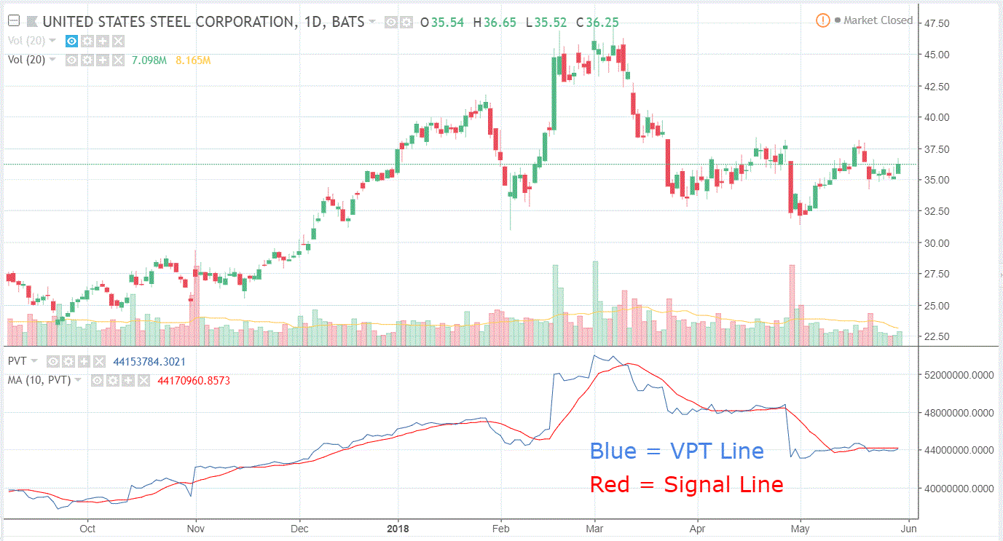

**Technical indicator:** **Volume Oscillator**

**What does it measure:** A volume oscillator measures volume by measuring the relationship between two moving averages

**General info:**

The volume oscillator indicator calculates a fast and slow volume moving average. The difference between the two (fast volume moving average minus slow volume moving average) is then plotted as a histogram. The fast volume moving average is usually over a period of 14 days or weeks. The slow volume moving average is usually 28 days or weeks. Analysts regularly argue about the applicability of these time periods -- some say that 14 and 28 are too conservative, while others argue these numbers are not conservative enough.

Here we use 5/20, as would a short-term trader. The histogram, like an oscillator, fluctuates above and below a zero line. Volume can provide insight into the strength or weakness of a price trend. This indicator plots positive values above the zero line and negative values below the line. A positive value suggests enough market support exists to continue driving price activity in the direction of the current trend. A negative value suggests a lack of support, indicating that prices may become stagnant or reverse.

**Parameters:**

1. Shortlen
2. Longlen

**How to trade this signal:**

The volume oscillator displays the relative strength of a shorter volume moving average to a longer one. To keep things super simple, whenever there is a positive reading for the volume oscillator, there is strength on the short-term in the direction of the primary trend. If the volume oscillator is in the negative territory, volume is lacking and a change in trend is likely.

In this article, I will cover 4 strategies for how to trade with the volume oscillator. If you are looking for how to calculate the volume oscillator and more of a technical definition of the indicator, please visit the TA-Guru.

From a guy that believes that volume is the key to identifying the strength of a trend and where the smart money is placing their bets, the volume oscillator provides an interesting perspective for how to view market activity.

We all have seen the volume bars at the bottom of the chart which shows trading activity like the chart below:

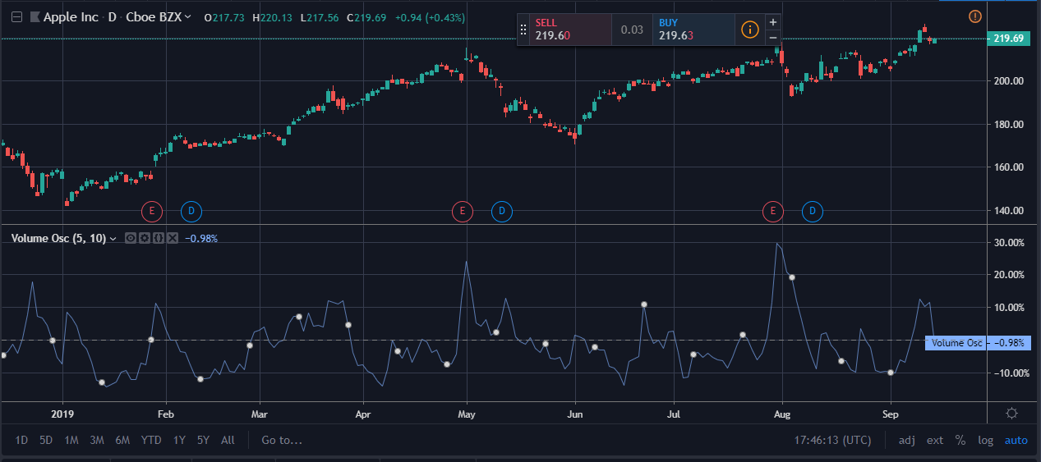

As a trader, you will look for when volume is drying up and when volume is accelerating. The red and green volume bars provide us an indication of how the price closed. Nevertheless, what is the volume actually telling you about the future direction of the trend?

**Technical indicator: Vortex Indicator**

**What does it measure:** The start of a new trend or the continuation of an existing trend within financial markets.

**General info:**

The Vortex Indicator is a volatility-adjusted trending indicator that helps traders determine the short-term trend, spot trading opportunities, and isolate when a trend is not present. It is composed of two lines, and has a relatively straight forward application. Before using the vortex indicator for trading purposes traders should understand how the indicator works, its uses, strategies, and limitations.

**Parameters:**

Period (14)

**How to trade this signal:**

The Vortex Indicator was created by Douglas Siepman and Etienne Botes and is composed of two lines, +VI and -VI. +VI represents up trending momentum and -VI represents down trending momentum.

The indicator borrows aspects from other indicators, such as Average True Range and Average Directional Index.

The two indicator lines fluctuate above and below 1.0, spreading further apart during very strong trends and moving close together during weak trends or sideways markets.

When the +VI crosses above -VI, it signals a potential uptrend, and as long as +VI stays above -VI it helps confirm the uptrend.

When -VI crosses above +VI it signals a potential downtrend, and as long as -VI stays above +VI it helps confirm the downtrend.

When +VI and -VI are very close together and hovering near the 1.0 mark, it indicates a short-term lack of trend, and a potential consolidation phase in the stock price.

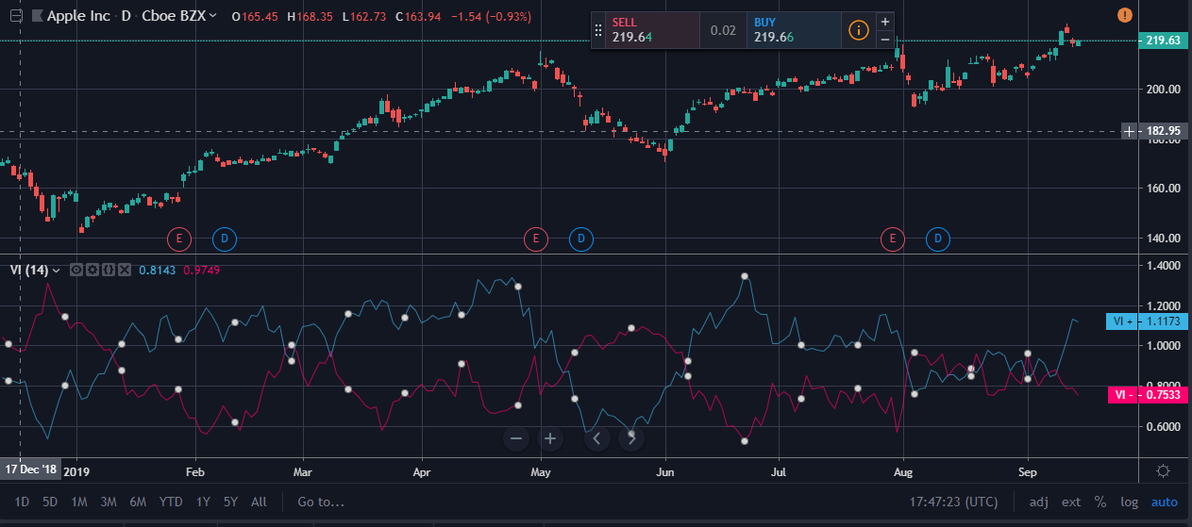

**Technical indicator: Williams %R**

**What does it measure:** It measures overbought and oversold levels

**General info:**

Williams %R, also known as the Williams Percent Range, is a type of momentum indicator that moves between 0 and -100 and measures overbought and oversold levels. The Williams %R may be used to find entry and exit points in the market. The indicator is very similar to the Stochastic oscillator and is used in the same way. It was developed by Larry Williams and it compares a stock’s closing price to the high-low range over a specific period, typically 14 days or periods.

**Parameters:**

1. Length
2. Source

**How to trade this signal:**

Williams %R is an overbought and oversold technical indicator that may offer potential buy and sell signals. Williams %R is very similar to the Stochastic Fast indicator (see: Stochastics) as the chart below will illustrate:

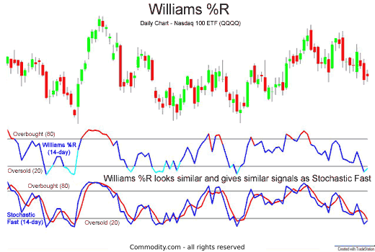

Like Stochastics, the Williams %R indicator attempts to give buy and sell signals, as is demonstrated in the chart below of the Nasdaq 100 exchange-traded fund QQQQ:

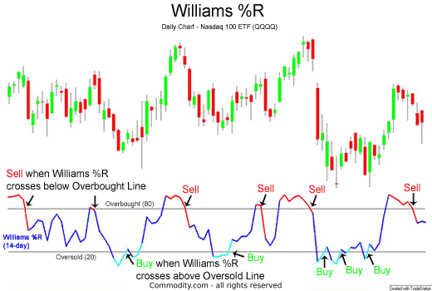

**Technical indicator: Williams Alligator**

**What does it measure:** Helps the trader confirm the presence of a trend and its direction

**General info:**

Bill Williams introduced the Alligator indicator in 1995. The Alligator is as much a metaphor as it is an indicator. It consists of three lines, overlaid on a pricing chart, that represent the jaw, the teeth and the lips of the beast, and was created to help the trader confirm the presence of a trend and its direction. The Alligator indicator can also help traders designate impulse and corrective wave formations, but the tool works best when combined with a momentum indicator.

The “traits” of the Alligator are numerous. If the three lines are entwined, then the Alligator’s mouth is closed and he is said to be sleeping. As he sleeps, he gets hungrier by the minute, waiting for a breakout from his slumber when he will eat. When the trend takes shape, the Alligator wakes and starts eating. Once satiated, the Alligator closes his mouth once again and goes to sleep.

**Parameters:**

1. Jaw Length
2. Teeth Length
3. Lips Length
4. Jaw Offset
5. Teeth Offset
6. Lips Offset

**How to trade this signal:**

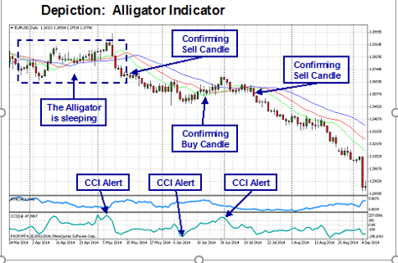

The Alligator indicator, with a period settings of “13, 8, 5” and shift settings of “8, 5, 3”, is presented in combination with the candlesticks on the above “Daily” chart for the “EUR/USD” currency pair. In the example above, the “Blue” line is the Alligator’s jaw, the “Red”, his teeth, and the “Green”, his lips. The “CCI” indicator, or “Aqua” line, has been added to assist in reading the signals generated. One must remember that the Alligator, since it consists of moving average crossovers and is shifted ahead, will lag more than the CCI. The CCI will send the first alert, followed by the Alligator crossover and a closing candle above or below the three moving averages (See annotations).

The key points of reference are when the lines are entwined, when they are “open”, and when the red and green lines cross. When entwined, the Alligator is said to be sleeping. Patience is the message given here. When the lines are apart, the Alligator is eating. Stay in the trade as long as the candlesticks ride above or below the Alligator. When the lines converge or cross, it is time to consider entering or exiting, although a momentum indicator will fix a better exit point. Traders are also attentive to closing Candles. In the above example, an exit signal occurs when a Candle closes above the center Red line or teeth of the Alligator. During the second downward move, the Alligator, for this reason, would have kept you in the trade a little while longer for more profit.

As with any technical indicator, an Alligator chart will never be 100% correct. False signals can occur, but the positive signals are consistent enough to give a forex trader an “edge”. Skill in interpreting and understanding Alligator signals must be developed over time, and complementing the Alligator tool with another indicator or pattern of pricing behavior is always recommended for further confirmation of potential trend changes.

**Technical indicator: Williams Fractal**

**What does it measure:** The Williams Fractal indicator helps users determine in which direction price will develop.

**General info:**

The Williams Fractal is an indicator, developed by Bill Williams, that aims to detect reversal points (highs and lows) and marks them with arrows. Up fractals and down fractals have specific shapes. The Williams Fractal indicator helps users determine in which direction price will develop. It is often used in combination with the Alligator Indicator with specific rules on when to enter and exit trades. A long signal would be if the fractal is above the alligator’s teeth and a short signal would be if the fractal is below the alligator’s teeth.

**Parameters:**

No

**How to trade this signal:**

Most charting platforms now provide fractals as a trading indicator. This means traders don't need to hunt for the pattern. Apply the indicator to the chart, and the software will highlight all the patterns. Upon doing this, traders will notice an immediate problem: this pattern occurs frequently.

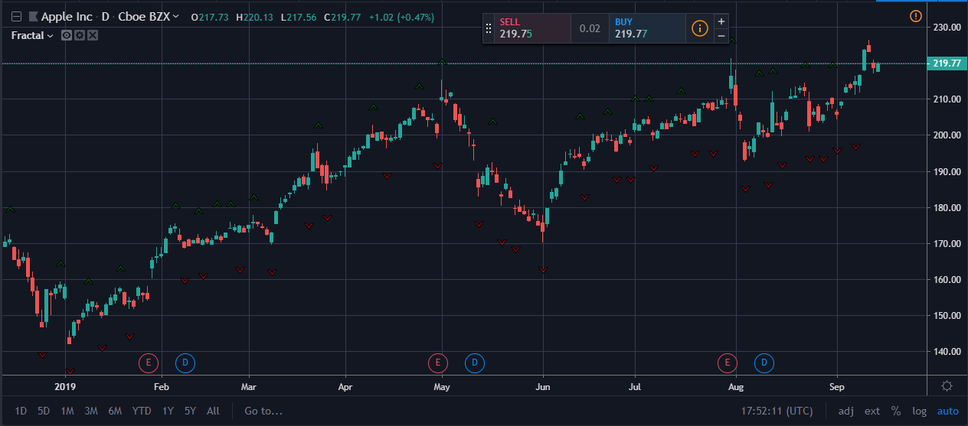

Fractals are best used in conjunction with other indicators or forms of analysis. A common confirmation indicator used with fractals is the alligator. It's a tool created by using multiple moving averages. On the chart below is a long-term uptrend with the price staying predominantly above the alligator's teeth (middle moving average). Since the trend is up, bullish signals could be used to generate buy signals. (See also: Exploring the Williams Alligator Indicator.)

While slightly confusing, a bearish fractal is typically drawn on a chart with an up arrow above it. Bullish fractals are drawn with a down arrow below them. Therefore, if using fractals in an overall uptrend, look for the down fractal arrows (if using a fractal indicator provided in most charting platforms). If looking for bearish fractals to trade in a larger downtrend, look for up fractal arrows.

Sometimes switching to a longer time frame will reduce the number fractal signals, allowing for a cleaner look to the chart, making it easier to spot trading opportunities.

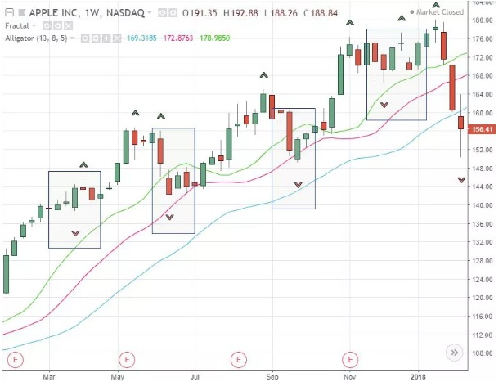

This system provides entries, but it is up to the trader to control risk. In the case above, the pattern isn't recognized until the price has started to rise off a recent low. Therefore, a stop loss could be placed below a recent low once a trade is a taken. If going short, during a downtrend, a stop loss could be placed above the recent high. This is just one example of where to place a stop loss.

Another strategy is to use fractals with Fibonacci retracement levels. One of the issues with fractals is which one of the occurrences to trade. And one of the problems with Fibonacci retracement levels is which retracement level to use. By combining the two, it will narrow down the possibilities, since a Fibonacci level will only be traded if a fractal reversal occurs off that level.

Traders also tend to focus on trades at certain Fibonacci ratios. This may vary by trader, but say a trader prefers to take long trades, during a larger uptrend, when the price pulls back to the 61.8% retracement level. Fractals could be added to the strategy: the trader only takes trades if a fractal reversal occurs near the 61.8% retracement, with all the other conditions being met. (For more, see: Strategies for Trading Fibonacci Retracements.)

The chart below shows this in action. The price is in an overall uptrend, and then pulls back. The price forms a bullish fractal reversal near the 0.618 level of the Fibonacci retracement tool. Once the fractal is visible (two days after the low), a long trade is initiated in alignment with the longer-term uptrend.

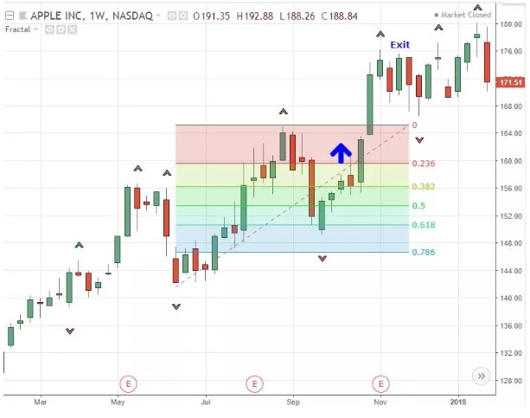

Taking profits could also involve the use of fractals. For example, if going long on a bullish fractal, a trader could exist the position once a bearish fractal occurs. Other exits methods could also be used, such as profit targets or a trailing stop loss.

Further Considerations on Using Fractals

Here are a few things to remember when using fractals.

* They are lagging indicators.
* Since fractals are very common, they are best combined with other indicators or strategies. They are not to be relied on in isolation.
* The longer the time period of the chart, the more reliable the reversal. It's also important to note that the longer the time period, the lower the number of signals generated.
* It is best to plot fractals in multiple time frames. For example, only trade short-term fractals in the direction of the long-term ones. As discussed, focus on long trade signals during larger uptrends, and focus on short trade signals during larger downtrends.
* Most charting platforms now include fractals in the indicator list.

The Bottom Line

Fractals may be useful tools when used in conjunction with other indicators and techniques. Fractals can be used in many different ways, and each trader may find their own variation. Using an alligator indicator is one option, and another is using Fibonacci retracement levels. While some traders may like fractals, others may not. They are not a requirement for successful trading and shouldn't be relied on exclusively.

**Technical indicator: Zig Zag**

**What does it measure:** The Zig Zag is a technical indicator that measures the swing highs and swing lows of a market.

The Zig Zag indicator is often used in conjunction with Elliot Wave Theory to determine the positioning of each wave in the overall cycle. Traders can experiment with different percentage settings to see what gives the best results. For example, a setting of 4% may define waves more clearly than a setting of 5%. Stocks have their own patterns, so it is likely that traders will need to optimize the Zig Zag indicator’s percentage setting to suit those securities.

Although the Zig Zag indicator does not predict future trends, it helps to identify potential support and resistance zones between plotted swing highs and swing lows. Zig Zag lines can also reveal reversal patterns, i.e. double bottoms and head and shoulders tops. Traders can use popular technical indicators like relative strength index (RSI) and Stochastics oscillator to confirm the price of a security is overbought or oversold when the Zig Zag line changes direction.

A momentum investor might use the indicator to stay in a trade until the Zig Zag line confirms in the opposite direction. For example, if the investor holds a long position, they would not sell until the Zig Zag line turns downward.

**Parameters:**

* Depth – it refers to how far back in the chart bar series it will look. In order to get the highs and lows defined you need to make sure you have enough “Depth.”
* Deviation – what percentage in price change does it take to change the trendline from positive to negative.

**How to trade this signal:**

Step #1: Set the ZigZag indicator settings at 20 for the Depth and 5% Deviation

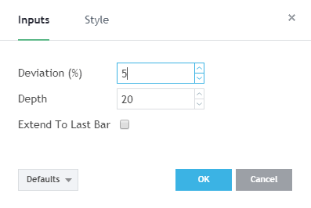First, we want to make sure the ZigZag tool will only show the more significant swing high and swing low points in the market. For this, we have to use at least 20 periods for the Depth and 5% deviation to accurately display the market swings.

Step #2: Plot the Fibonacci Extension line once the first two swing waves are established.

In order to plot the Fibonacci Extension line, we need three points of reference. As soon as the first two waves of the Zig Zag pattern are developed, we’re offered three swing levels. We’re going to use them to draw the Fibonacci extension levels.

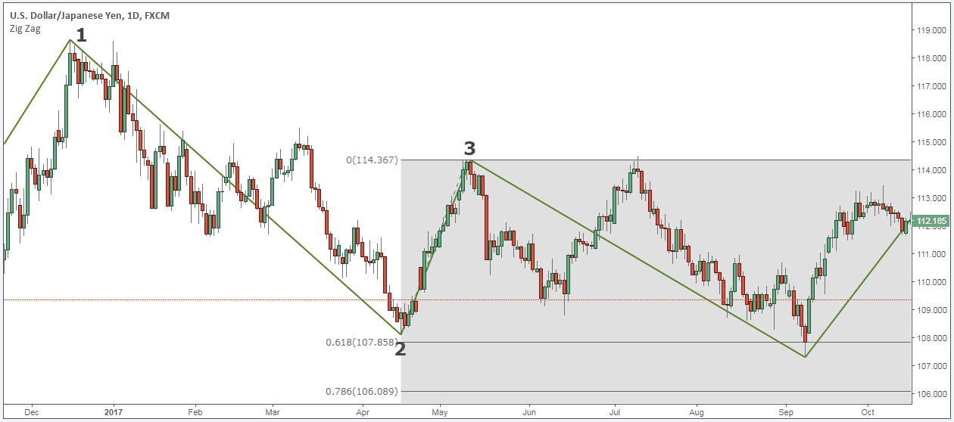

The reason why we use the Fib extension levels is to try to anticipate where the last swing wave of the Zig Zag pattern will form.

The zigzag indicator will only mark the swing low as being formed too late for us to rely and base our trades alone on this indicator. This is the main reason we employ different trade tactics. The tactics are used to anticipate where it’s more likely for the zigzag pattern to end.

Step #3: Wait for the third wave to terminate between 0.618 – 0.786 or between 1.0 – 1.272

The reality is that market symmetry doesn’t happen often. The AB=CD pattern requires a lot of precision in order to have all the conditions for this pattern to be valid.

Throughout our backtesting software, we have found out that the third wave of the zigzag pattern ends between. 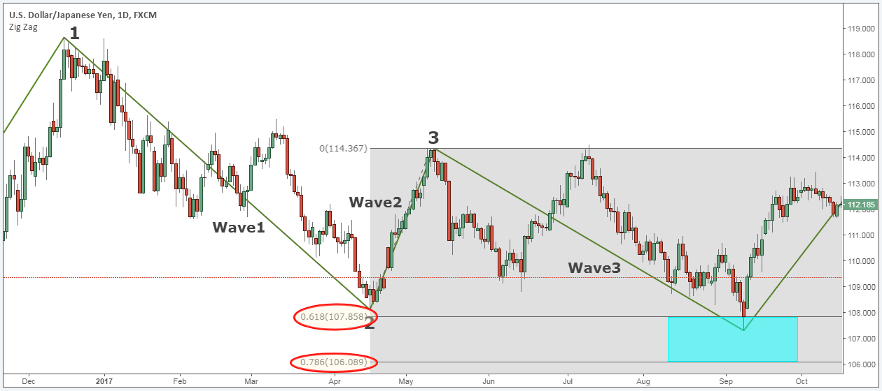

Since we can’t know for sure where the third wave will end, we’re going to employ one of our favorite trade techniques to spot a swing point in the market.

Step #4: Wait until you have a candle with a higher low on the right and the left. The bar from the right needs to break above the bar on the left.

The three bar pattern to spot a market swing point is quite easy.

All you need to do is to wait until you have a candle that has a higher low on both the left and the right side of it. In order for this three bar pattern to be confirmed we also need the bar from the right to break above the high of the bar from the left.

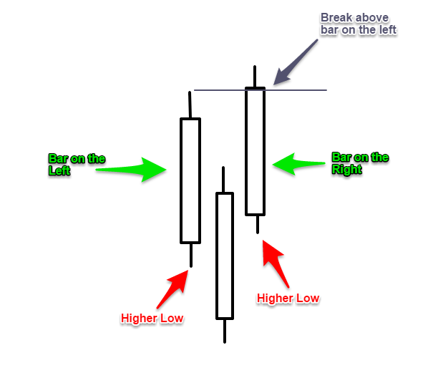

To better understand how to spot when a swing low is about to be put in place we’ve made a simple illustration (see above figure).

Now you need for this pattern to develop between 0.618 – 0.786 or between 1.0 – 1.272.

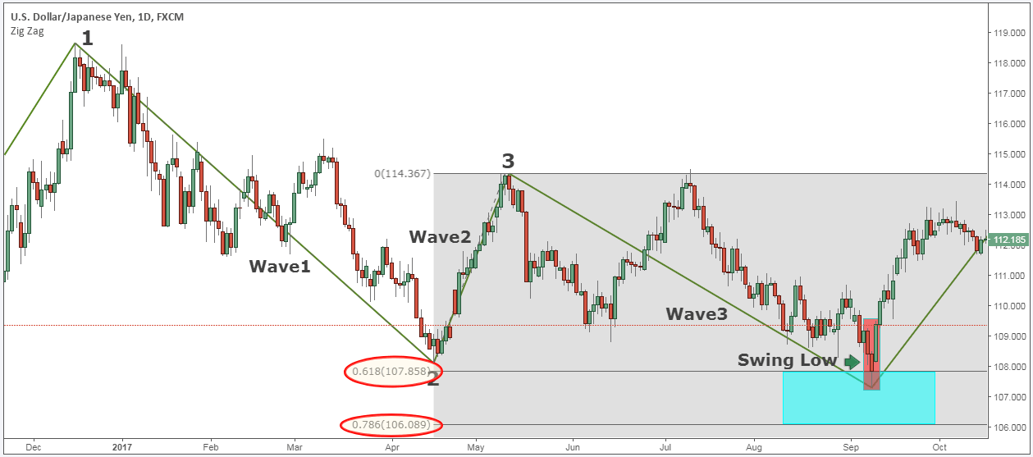

The Zigzag strategy satisfies all the trading conditions, which mean that we can move forward and outline what the trigger condition for our entry strategy.

Step #5: Zigzag Trading Strategy: Buy at the close of the three bar pattern

After the three bar pattern is completed, we don’t want to lose any more time, and we go buy at the market.

Note* We use the three bar pattern to anticipate swing market points with all of our trading strategies.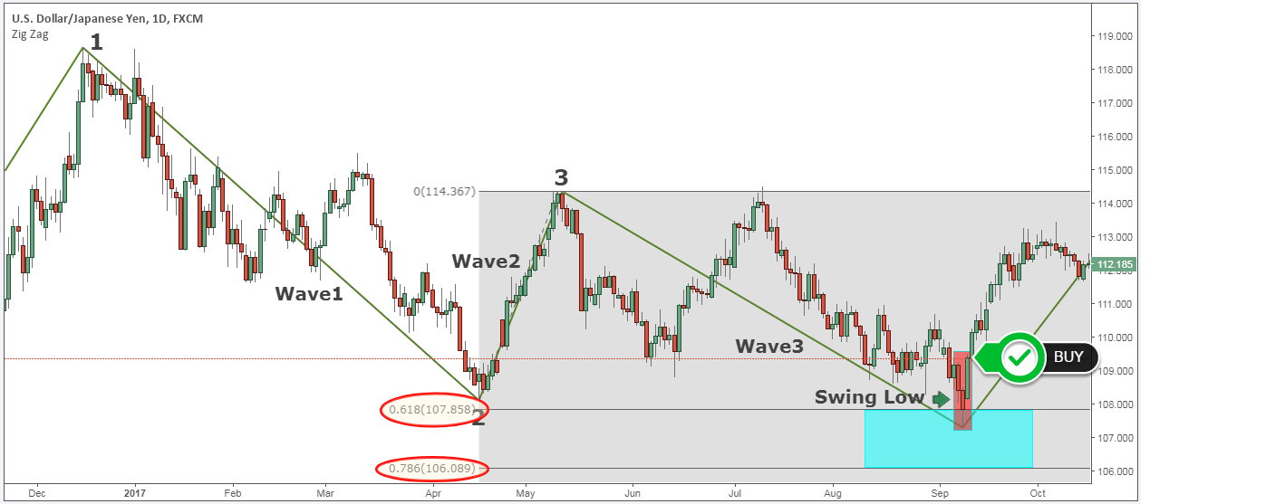

This brings us to the next important thing that we need to establish for the best Zig zag strategy, which is where to place our protective stop loss.

Step #6: Hide your protective Stop Loss below the three bar pattern.

The stop loss is going to go below the three bar pattern. Your stop loss may be a little bit bigger depending on the time frame you’re trading.

You want to make sure that the three bar pattern where your stop loss goes maintains at least a 2% risk.

You don’t want to risk more than 2% of your account in any given trade.

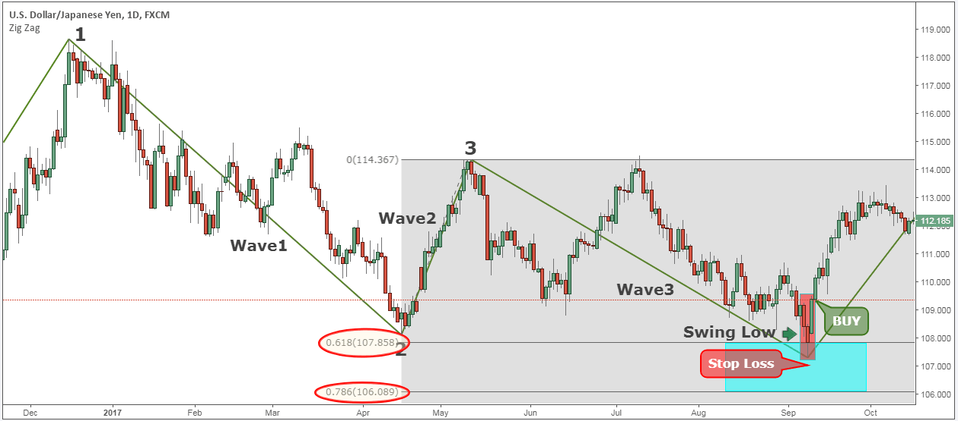

Last but not least, we also need to define where we take profits.

Step #7: Take profit equal 2 or 3 times more the Stop Loss.

Now, where’s our profit target going?

The classical ABCD pattern essentially keeps you at a 1:1 risk reward ratio. Also, a lot of the times with the ABCD pattern, you’ll see it pretty frequently that those targets areas are front runned.

However, when you trade with the Zig Zag indicator, you’re able to capture two or even three times more the risk taken.

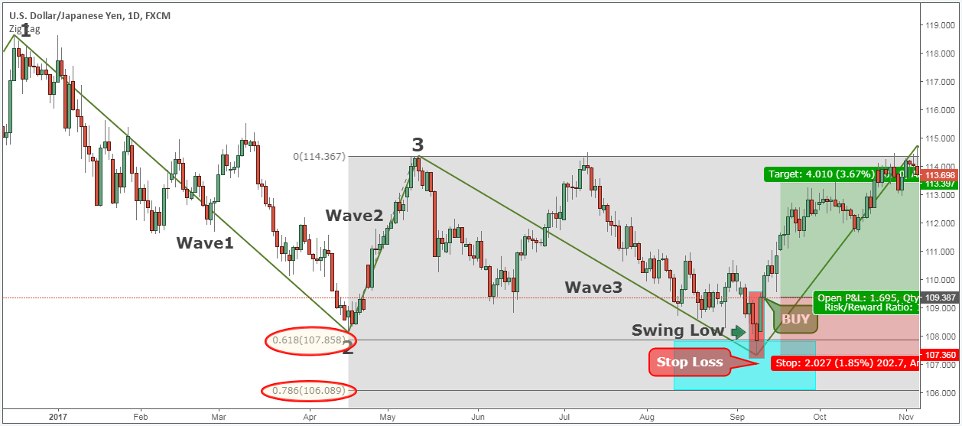

Note** the above was an example of a BUY trade using our Zig Zag trading system. Use the same rules for a SELL trade – but in reverse. In the figure below, you can see an actual SELL trade example.

